UZBEKISTAN. KARAKALPAKSTAN.

My Native Town –

NUKUS.

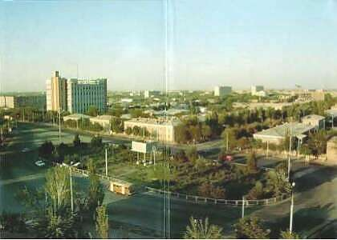

Nukus is the capital of the Republic Karakalpkastan.
It is on the right bank of the Amudarya.
The city is on 76 meters height above sea level. South and East of the city is surrounded by Kizilkum desert. North of the city is joined with the delta of the Amydarya. The Kizitketken canal passes through the city.
The residents of the city (the capital of autonomous region Karakalpakstan) number Karakalpaks, Uzbeks, Russian, Kazakhs,Korean and Tatars. In addition to Uzbek, Karakalpak is an official language here. Local culture is maintained in more that just speech habits -traditional customs surrounding food, clothing and rites of passage have all been maintained to a great extent and the extreme hospitality in this region assures guests many chances to witness these events for themselves.

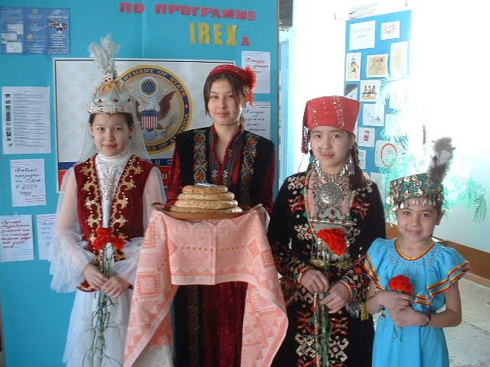

The residents of the city has its traditions. One of such traditions is “Bet ashar”. It means “open the face”. When a girl becomes a bride to the new family, her husband`s parents should open her face to local people. The bride should give greeting to her new relatives and neighbors.
Nukus’ climate is almost as diverse as its population. Seasons range from cold, snowy winters to extraordinary hot summers. Spring brings fresh rain and autumn is comfortably warm.
More industrial companies, joint ventures established in cooperation with worldwide developed countries function in the city. Metal industries are well developed. At present time companies as the USA, Germany, England, Italy, Japan, Russia, Korea, China, Turkey, Saudi Arabia, and the Ukraine.
In the city there are lots of banks, factories and business companies functions which is equipped with up-to-date equipments.

I would like to tell about one of the Saint place in our city-“Bayterek” (it`s the Saint tree) . There are the following legend about it. One day A Saint come here and put his stick in the grand. In some minutes he saw it growing up. He wondered about it and since those times that stick became a great tree and it`s going to grow up.
Before there was a Saint Palace near the tree. People wanted to destroy the Palace. It is destroyed, but they couldn`t destroy the tree. The man who did it broke his knees, the other man`s truck was broken up. They wanted to burn, but the tree wasn`t burnt. Now lots of residents of the city who has a problem with their health or have any problems come here. That`s why it is called “Saint tree”.



