LEARNING CIRCLES

2007

PROJECT BY

YAU SOOK FUN
SUNGAI DENDNG PRIMARY SCHOOL,
PERAK, MALAYSIA

WITH

ELIZABETH BOTTIGLIA
ROCCO LAURIE INTERMEDIATE SCHOOL
72.44 FERNDALE AVE.
SI NY 10314

TOPIC : AMAZING PLACES

TOPIC : AMAZING PLACES (1)

GROUP A LEADER: Jannatul Firdaus

KUALA LUMPUR

Kuala Lumpur is the capital city of Malaysia. It is easy to get to Kuala Lumpur because there are 40 international airlines serving our modern KL International Airport (KLIA) at Sepang.

Tourists will be amazed by the Petronas Twin Towers, the world’s tallest two free-standing towers. They are 452 m high with 88 storeys. My teacher tells me it is awesome.

Kuala Lumpur is an ultra-modern city but it still has majestic buildings of the colonial era.

Children love the Lake Gardens. Here there is a Hibiscus Garden, Orchid Garden, Bird Park, Deer Park and Butterfly Park.

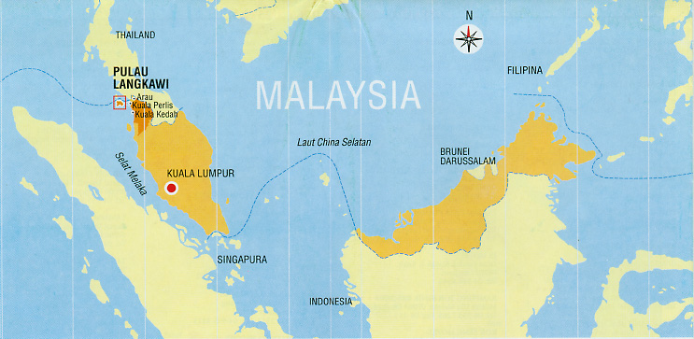

Location map of Kuala Lumpur

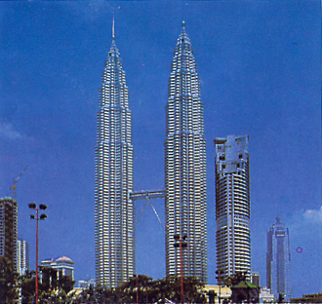

The amazing Petronas Twin Towers

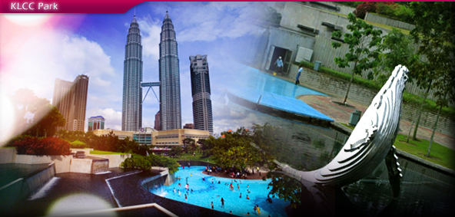

Kuala Lumpur City Centre ( KLCC)

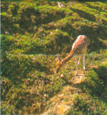

Deer Park

Location Map of Parks

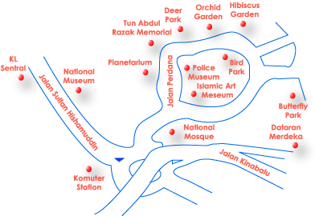

TOPIC : AMAZING PLACES (2)

GROUP B LEADER: Mohamad Zulhelmi bin Mashor

LANGKAWI

Langkawi is in the north-west of the Peninsula of Malaysia. It is famous for its beautiful, sandy beaches. Langkawi comprises 99 islands. You can visit Pulau Singa Besar which is a wildlife sanctuary, Pulau Payar , a marine park, or Pulau Beras Basah ( Isle of Wet Rice ) which is a popular spot for swimming.

Langkawi is a free port. You can get all kinds of goods for a reasonable price.

Langkawi is the venue for the exciting Langkawi International Maritime & Air Show (LIMA).

Last year my school organized a trip to Langkawi. We visited Mahsuri Mausoleum, Seven Wells, Underwater World and a crocodile farm.

Location map of Langkawi

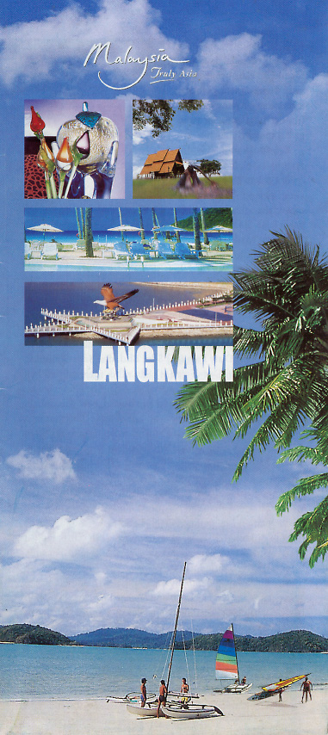

Amazing beaches in Langkawi

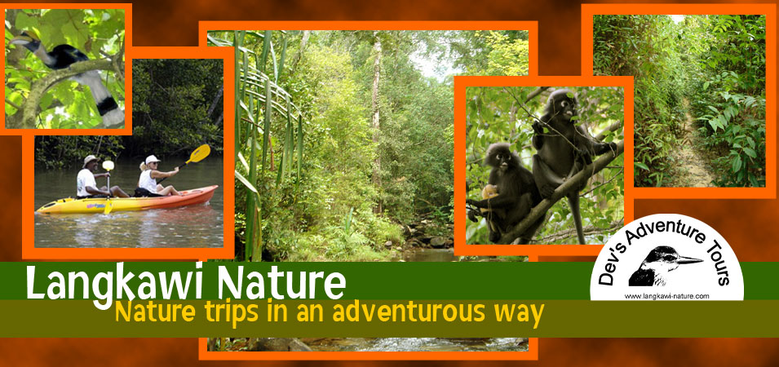

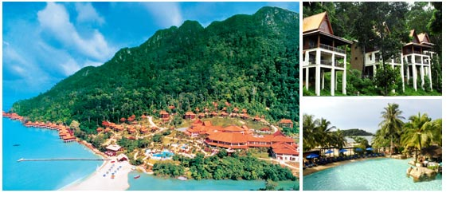

Berjaya Langkawi Beach & Spa Resort

TOPIC : AMAZING PLACES (3)

GROUP C LEADER: Mohd. Daniel Ashriel

GENTING HIGHLANDS

Genting Highlands is popularly known as the City of Entertainment. It is situated about 51 km from Kuala Lumpur, 6000 feet about sea level. We can enjoy the cool mountain air and many kinds of entertainment round the clock. It has indoor and outdoor theme parks. The Genting Skyway is the longest cable car in South-east Asia.

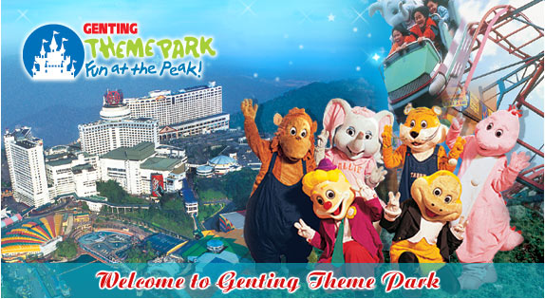

TOPIC : AMAZING PLACES (4)

NAME : KAITLYN

STATEN ISLAND

I was born and raised in Brooklyn. Brooklyn is a borough of New York City. I lived there for about eleven years of my life. My favorite thing about Brooklyn is the Italian Feast on 18th Avenue. I live on Staten Island now and I feel that it is plain and boring. It is hard to get around because of all of the street names. Many streets in Brooklyn are numbered. Also, in Brooklyn I used to ride the subway with my family if we could not drive to places. But there are no subways on Staten Island. My mom has to drive me almost everywhere!
If I moved out of New York, I would want to move to Chicago, Illinois. I have heard that it is a city very similar to New York City. It is supposedly much cleaner though! It is very windy there but that is fine by me because I love the winter. For now I will make the best of Staten Island.
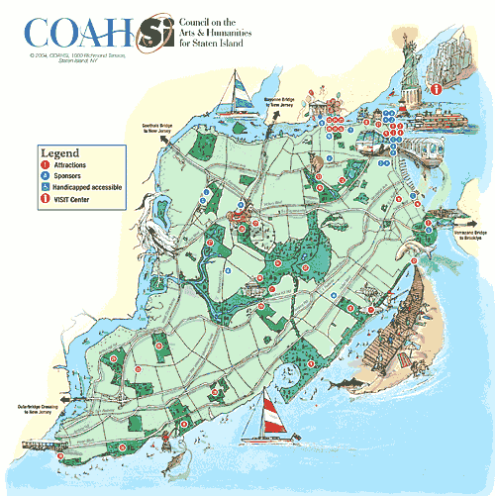

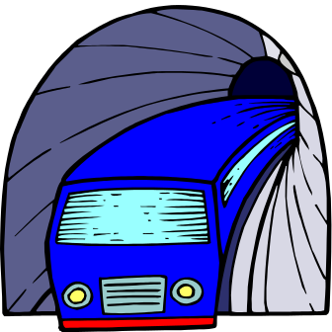



TOPIC : AMAZING PLACES (5)

NAME : NANCY

NEW YORK CITY

I live on Staten Island, which is part of New York City. I like living in New York because I feel special. Many people love to visit New York and I get to live here all the time! New York is known as the “Big Apple.” The city looks so beautiful during Christmas time. Every year, there is a beautiful tree in Rockefeller Center. It lights up the city.
Sad things have happened in New York too. On September 11, 2001, the Twin Towers were attacked by terrorists. But people still visit New York all year round. This shows that New York is the greatest city!



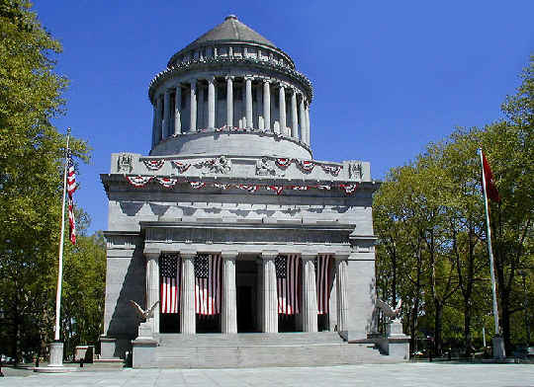

General Grant National Memorial

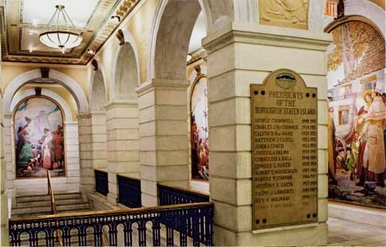

Borough Hall



The Statue of Liberty

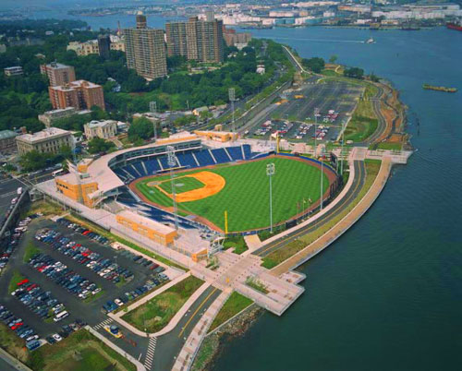

Richmond County Bank Ballpark

TOPIC : AMAZING PLACES (6)

NAME : PATRICK

WASHINGTON D.C.

I really want to visit Washington, D.C. That is the capital of the United States of America. I want to take a tour of the White House. Maybe I would be lucky enough to meet the President! I also would love to see the Pentagon and the Washington Monument. There is a huge statue of President Abraham Lincoln in Washington, D.C. I also really would like to visit the Holocaust Museum.

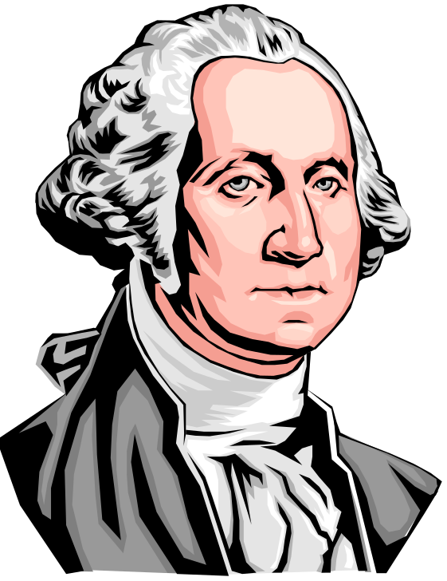

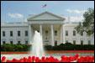

The White House

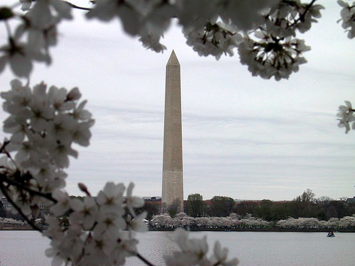

The Washington Monument

