Travel Guide and Travel Itinerary

OF
PAKISTAN , OMAN & AMERICA

Prepared by: Shazia Ferdous and 8th Grade students

Teacher: Shazia Ferdous and her students in cooperation with the Teacher and students of Oman and America

Content:

Topics: page

- Travel Guide of
- Pakistan.......................... ..................
- Oman ………………………….
- America ……………………….

- Travel Itinerary of

- Pakistan …………………………..
- Oman…………………………
- America…………………………

3) Names of schools, teachers and students

Assalam o Alaikum is the Pakistani welcome greeting _ and as a prologue we welcome all our friends from overseas to our great country Pakistan.
Visitors would love to meet Pakistan and Pakistani people. To make out the best from the tour, the foreign visitors shall find the geographical introduction very useful and help in enjoying the tour.
God in his bounty has blessed Pakistan with great physical and human resources and charms. It is the land of mighty mountains, murmuring and gurgling rivers, sparkling springs, deep and dense forests, lush green fields, meadows, and rugged high lands andparch low lands. Pakistan is famous for her folk lore, folk dances and songs. You can hear and see them on the national network of television. But you can find and discover the best on your tour.

An itinerary of tour must include a visit to the various historical places and attractive, unforgettable scenic spots and picnic points worth seeing and fit ever to ruminate and remind:

“They flash upon the inward eye
Which is the bliss of solitude”? (Wordsworth.)

.
- Overview
Learn about Pakistan’s geography, history, people, culture, cuisine
CONTENTS
festivals and holidays.

  - Exploring
Explore different places of Pakistan

      - Travel info
All the essentials you need to spend
a perfect holiday

Before describing the beautiful spots and historical places in Pakistan it is in fitness of things to introduce the land

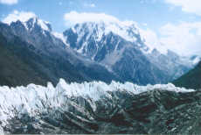
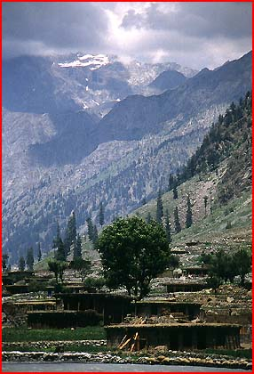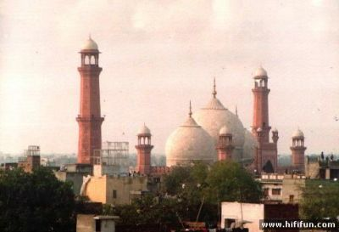

The Islamic Republic of Pakistan is situated between 23.30 and 36.45 East latitudes and between 61 and 75.31
North longitudes, sharing borders with China in the north, Afghanistan and Iran in the west, India in the east and Arabian Sea in the south. Pakistan covers an area of 805,000 sq km and has a population of about 163 millions. It comprises of four provinces: The Punjab, Sindh, North West Frontier Province and Balochistan. Islamabad is the capital of Pakistan.

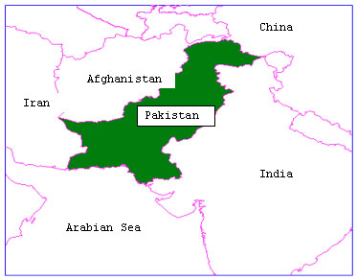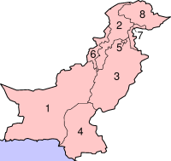

“History makes man wise”

Pakistan is proud of her great and glorious historical past. The land had been the cradle of the oldest civilization in the world. Mohenjodaro and Harappa have been the centers of ancient civilizations (5000 years old). The tourists will be impressed by the ruins and relics treasured by Pakistan near Quetta The new remains unearthed Archeological Department, are over 8000 years old and of great academic interest for the scholars. The Shah Jahan Mosque at Thatta, the ancient capital of Sindh and Bambore at a distance of about twenty miles from Karachi offer a good insight into ancient mosaic art and history respectively. On the way to Thatta is the biggest grave yard of world having some majestic graves of carved red stones that repeat the tale.

“The paths of glory but all lead to grave”

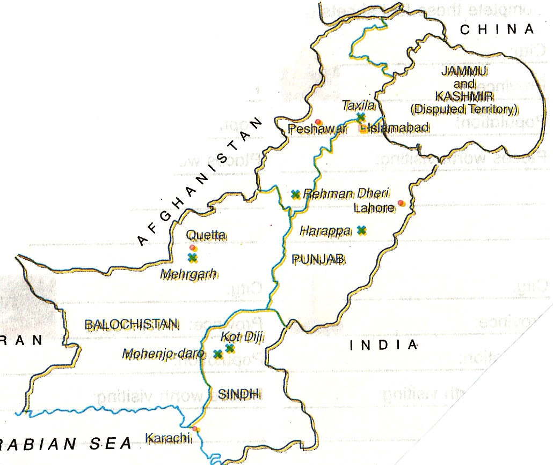
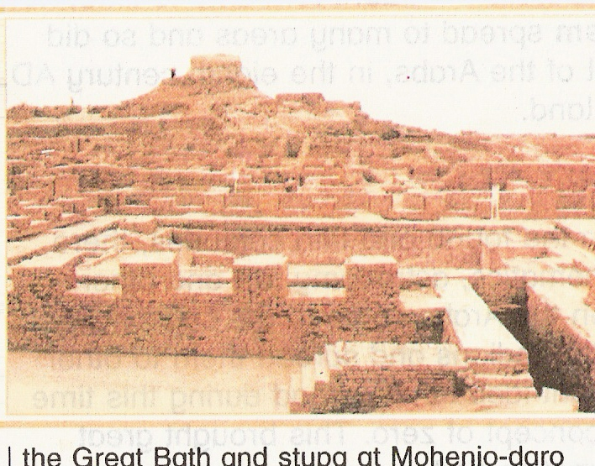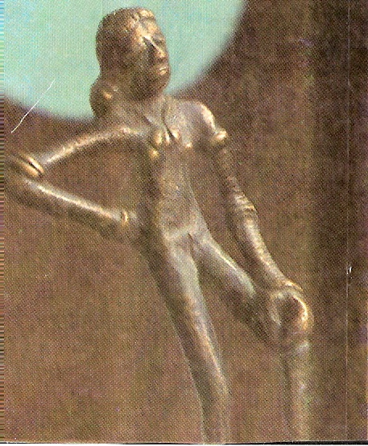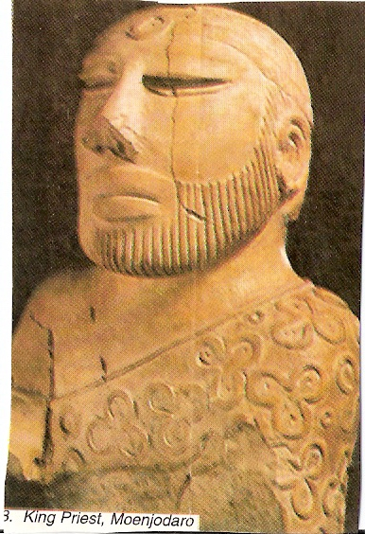
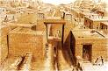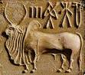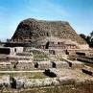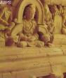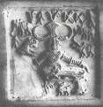

The Pakistanis are simple, hospitable, loving and traditional
People. The dawn of modernity has made the educated Pakistanis very broad minded, enlightened and socially compatible. As guests, the visitors shall be welcomed and meet with warm affection wherever they go and will not fail to appreciate typical oriental hospitability and unreservedness. Urdu is national language of the country but English is understand and spoken by the educated Pakistanis.

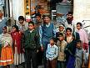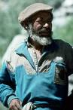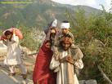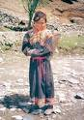
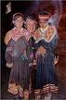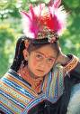

Having inherited the culinary traditions of the Moguls, the Turks, the Central Asians and the Iranians, food in Pakistan is a rich and unique experience. Meat, fish and vegetable dishes are seasoned with spices. Particularly palatable are grills and barbecues, Seekh Kebab (minced meat grilled on skewer), Shami Kebab (minched meat), Tikka (barbecued mutton, beef or chicken) and Sajji (barbecued leg of lamb). Pakistani mutton and chicken curries and the oriental rice dish called, Pulao, are also popular with natives and foreigners alike and is used both as everyday and ceremonial food.
The everyday food includes daal (lentils),sabzi (vegetables)
And dahi (yogurt), and scooped up with roti or chapattis or nan (various type of breads usually made with wheat flour). Though spices are commonly used in Pakistani food yet it is not as hot with chilies as Indian dishes. Besides local food, Chinese and European dishes are also consumed in the major cities of Pakistan. Black tea with milk & Green tea are the staple drinks of Pakistan and Chai- Khanas (tea houses) can be found everywhere in Pakistan

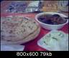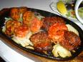

Pakistan is a multicultural country. Besides the religious festivals, there are many other cultural and festive events taking place all around the year in Pakistan.These events include exhibitions, festivals and local events. Here’s a list of festivals and events happening in Pakistan;

1: Eid- ul-Fitar
Eid-ul-fitr is the biggest Muslim festival celebrated all over Pakistan. It is celebrated after one month of fasting during the month of Ramadan. Celebrated on the 1st of Shawwal, the 10th month of Islamic Calendar, The Eid day starts with the special Eid prayers. People exchange gifts and sweet with each other and alms to the poor and the needy.

2: Eid-ul-Azha
Eid-ul-Azha is also another massive religious festival commemorating the great sacrifice offered by Prophet Ibrahim. It is celebrated on the 10th of Zilhaj, the 12th month in the Islamic Calendar. Collective prayers are offered after sunset and the sacrifice of goats, sheep, cows or camels is made and the meat is distributed among relatives, friends and poor.

3: Shab-e-Barat

Shab-e-Barat is a religious festival celebrated on 14th of Shaaban, the 8th Islamic month. The day is celebrated with special Prayers and exchange of sweet dishes.
4: 23rd March- Pakistan Day

Pakistan Day commemorates the anniversary of Pakistan’s Resolution, passed on March 23, 1940. Military parade is held at Lahore Peshawar, Quetta and Karachi. Its main feature however remains the grand parade at Islamabad.

5: Mela Chiraghan (Festival of lamps)

Mela Chiraghan is held for one week outside the Shalimar Garden in Lahore. It marks the birth day of the famous Sufi Port Shah Hussain. The festival is celebrated on the last week of March

6: Horse & Cattle Show

Celebrated at Dera Ismail Khan (DIK), the festival includes local games, folk dances, music, cattles races and exhibition of local handicrafts. The Festival takes place at the end of March till 1st week of April.

7: Eid-e-Miland-un-Nabi

The Birthday of Prophet Hazrat Mohammad (P.B.U.H.) on 12th of Rabi-ul-Awwal - the 3rd of month of Islamic Calendar. It is a very mellow festival and celebrated with humbleness.

8: Ashura

The Two days mourning on the death anniversary of Imam Hussain, the grandson of Prophet Mohammad (P.B.U.H.) on 9th and 10th of Moharram, the first month of Islamic Calendar. The event is marked by Processions, rallies and meeting.

9: Independence Day

The National day of Pakistan is the Independence Day, celebrated every year on the 14th of August. The day is celebrated with various processions, rallies, decorations and lightings, debating contests and 14 August illustrations all over the country.

10: Defense Day

Marking the great defense Pakistan held against India in the war of 1965, the Defense Day is celebrated on the 6th of September includes Parades and exhibitions of military equipment at Rawalpindi, Lahore, Peshawar, Quetta and Karachi.

11: Airforce Day

The Airforce day highlights the contributions, the strength and the bravery of the Air Force of Pakistan. Celebrated on 7th September many displays of latest aircrafts of Pakistan Airforce are displayed for the public eye. The air shows at Rawalpindi, Sargodha, Lahore, Peshawar and Quetta is another attractive highlight of the day.

12: Death Anniversary of Quaid-eAzam

Marked as an official holiday, 11th September is celebrated as the death anniversary of Mohammad Ali Jinnah, the father of the nation.

13: Lok mela

Lok Mela is a famous folk festival held at Islamabad. Folk Music, songs music contests, folk dances, craftsmen at work, exhibition and sale of handicrafts are the highlights of the events. The festival presents a unique opportunity to watch the culture and craft of the whole country at one place. It is celebrated during the 1st week of October.

14: Birthday of Allama Iqbal

9th November is celebrated as the birthday of the National Poet of Pakistan Dr. M. Allama Iqbal. The event is celebrated with a lot of debating and poetry contests held at different institutes all over Pakistan.

15: National Horse & Cattle Show Lahore

Held at the Fortress Stadium Lahore, the Horse and Cattle show is a famous event in Lahore. The event’s highlights include Cattle races, cattle dances, tent-pegging, tattoo show, folk music, dances, bands, cultural floats and folk games. It takes place on the 3rd week of November for 15 days.

16: Christmas and Birthday of Quaid-e-Azam
Celebrated on the same date of the year the Christmas and the birthday of the founder of Pakistan Quaid-e-Azam are
two famous events in Pakistan, celebrated by the Christian minority and the whole nation.

Make the best out of your tour by visiting North West Frontier Province the bullet arm of India of British days and the area of the most beautiful and enchanting natural scenes and sights a panorama of scenic charms.

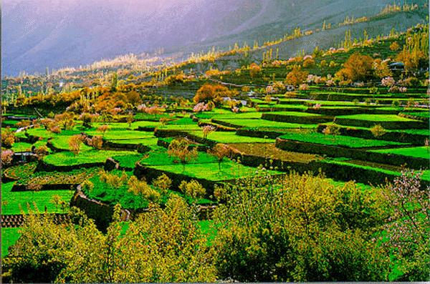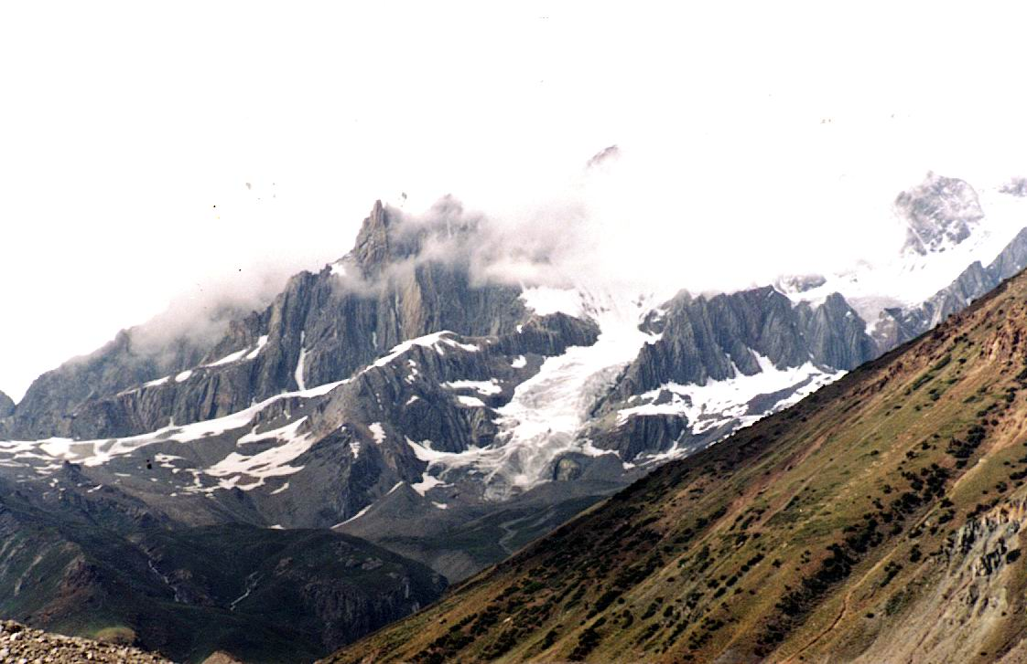

Your visit to the Khyber Pass on the great pass will tell you about the story of the inroads of the ambitious and haughty conquerors of India and the great races inhibiting the country.

For the nature lovers Pakistan’s Northern areas present a mighty feast and variety to the tourists eyes and adventures for the natural scientists and daring mountaineers. The changing terrain and the topography, the snow covered peaks and the gorges , mountains and valleys, table lands and terraces, rough and rugged tracks, the winding and narrow routes along the Malakand hills, the cataracts and the canyons, the riotous rivers, the thirst quenching springs, the brakes and the bushes, the essential like trees, chunar and poplar intermixed with fruits , orchids and well demarcated fields, will capture your imagination and make you click your cameras.

Tourists buses, private buses and jeeps will take you to Swat – the land of shy damsels. The scenic beauty is simply enchanting`.

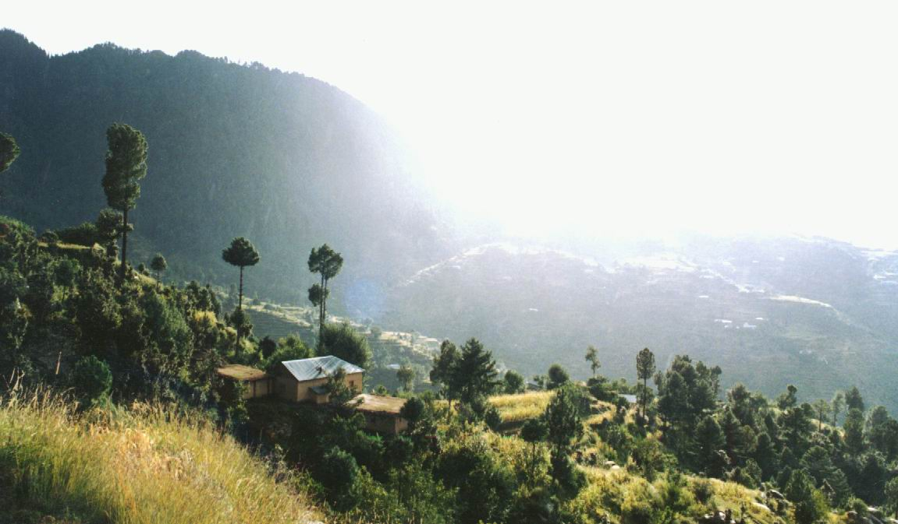

The torrential Swat river gathering speed and volume from inflowing streams, cascading water falls and melting glaciers will remind you of Tennyson’s famous lines:

“For man may come and man may go,
but I go one forever!”

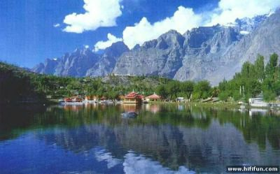

Swat is tourists paradise. You can stay in motels or firstclass hotels at Mangora and Murgzar. K alam, Madyan, Behreen attract a large number of tourists. If you want to enjoy peaceful
Or drowsy atmosphere, take detour towards Myandum and stay at first class tourists rest house. If you do not feel satiety travel further north to the state of Dir and Chitral for greater variety.

For the holders of the world tourists visa there are unending charms and sources of diversion for the tourists. Call at the Pakistan tourists Centre at Abbotabad for your next leg of journey for greater wealth of scenic beauty of Balakot, Kaghan, Narayan and the fairy lake of Saiful maluk

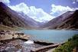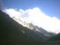
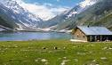

A visit to Pakistan will be incomplete without seeing the mentioned spots. The base, Abbottabad itself is a nerve soothing place. It is the kandy of Pakistan and is well connected with Rindi,Peshawar and Islamabad. The centre of tourism will furnish all the necessary information in form of printed matter for visit to Swat, Kaghan, Gilgit and Hunza.

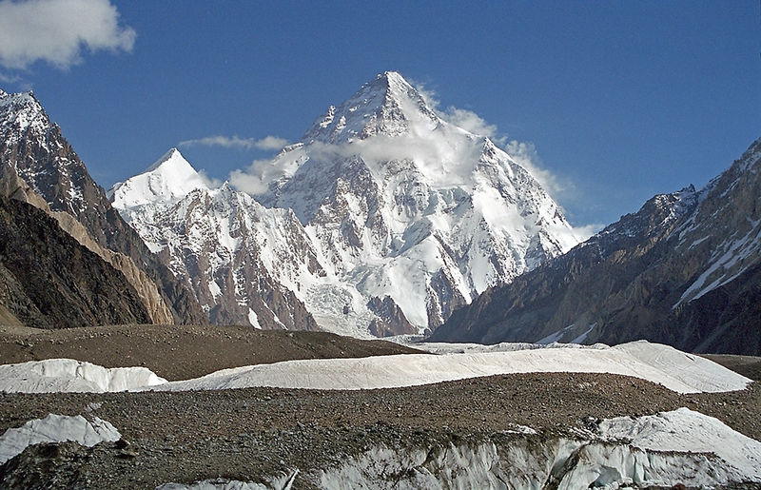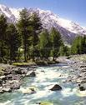
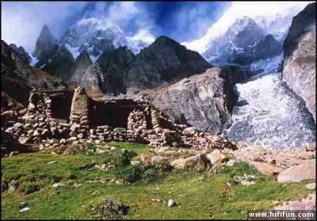

It is an unique experience to drive along the Karakoram or silk route (the 8th wonder of the world) built with the cooperation of Pakistan and China; or you can fly to Gilgit by PIA. When you travel and drive along the Zig Zag Karakoram route under the bright eye of day, you will marvel at the unending treasures offered by PAN. The winding and gliding upper Indus, the dazzling streams and murmuring brooks, the gushing springs, the snow covered peaks of Nanga Parbat, the peeping K-2 and the breath taking old mountain serpentine car route willmake you chant-

“How beautiful are Natures phases!
How wonderful are God’s images!”

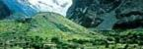
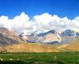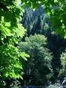

As you stop under the spreading Chunar or a walnut tree, the captivating notes of the strange birds, the cackling of the pheasants fearlessly drifting in a trail across the road and the swelling songs of the rustics will make you forgetful of the worries and hurry of city life. Gilgit, Skardu, Astore and Hunza attract tourists, hikers and mountaineers from all over the world. Gilgit and Hunza are famous for fruits – apples, grapes, peaches, pears almonds, walnuts and apricots. Park and Rakaposhi are standard hotels and offer the best variety of English and Pakistani menus.
You may choose any other motel or hotel as base for unending adventures and photography.

The three pronged routes take the tourists to Swat, Gilgit and Kaghan. From Abbottabad drive to Balakot via Mansehra. Balakot, the mountain sheltered town is situated along the banks of roaring Kunhar river. It is the gate way to the Kaghan valley. The land of dreams stretching up to 90 miles. The flora changes according the terrain, the cyprus trees, lining against the sky, the verderous valleys, the glaciers, bushes and wild flowers will put you in Wordsworthian mood of refection-

“I gazed and gazed but little thought
What wealth the show to me had brought”

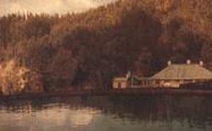

At the foot of the glacier stands Narayan, fascinating and cooling spot for the tourists. A hired jeep will take you to the fairy lake Saiful maluk. Close by is the Niglam valley full of gorgeous and smiling flowers, fill the beholders with poetic mood. Few spots in the world can match the Kaghan valley in scenic beauty and grandeur.

For a routine doze of pleasure andshort drive the nearest tourists spots from Islamabad and Abbottabad , are Murree and Ayubia famous for the electric lifts operating over the ever green hollow. You can thus enjoy the pleasures both of city and country life

For the foreign tourists, for whom the sea holds a great charm and who are accustomedto hear the two mighty voices of the sea and the land, the Arabian beach at Karachi offer beautiful picnic spots like Manora, Sandspit, Hawksbay and Paradise point for great adventure and sports.

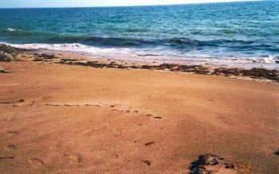

(For full and detailed information the Pakistan Tourist Department and centers are always at the service of the
tourists and national guests.)

When the students from another country arrive at Al Seeb International Airport, in Muscat, we will take them in Al Bustan Palace Hotel to have rest. We will tell them some information about Oman.

For example, we will tell them about the location and the geographical features of our country.

Oman is in the Arabian Peninsula. It covers 309,500 square kilometers with a coastline extending to 3,165km .What gives Oman its beauty is the geographical contrast between wadis (valleys), stark mountains desert sands and coastal beaches.

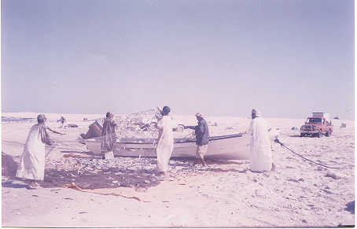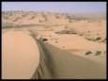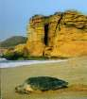

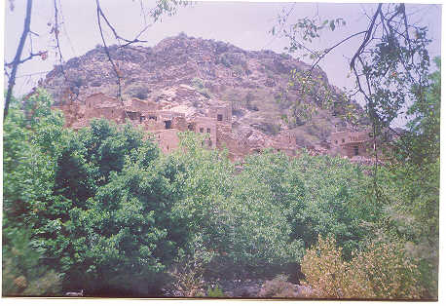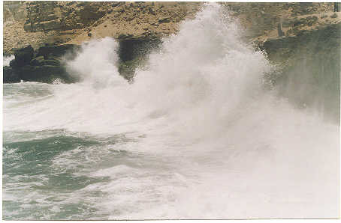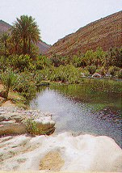

We will also tell them about the Local customs and about Omani food.

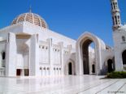
Islam is the official religion of Oman. Islam is an important aspect in the lives of the citizens of Oman. Mosques are to be seen everywhere, from the largest cities to the smallest towns, and the call to prayer is heard throughout the country five times per day. In coastal areas, the people have been exposed to outside cultures and influences for centuries due to maritime trading. Therefore, other religions and ways of life are tolerated. However, visitors should keep in mind that what may be acceptable in a hotel may not necessarily be acceptable on the streets. In public, female visitors should wear clothing that covers their shoulders and upper arms, and skirts that do not go above the knees. Most Muslim women still wear the abba, a full-length black covering.

Popular food: Rice is an important ingredient in daily eating habit. The essential ingredients in many Omani dishes are rice, curry, Qabooli, Aursia and Makbous. The most important spices used in Oman are cardamom, cinnamon, saffron and turmeric. The Omani kitchen is famous for Rukhal bread. It is usually eaten with honey.

We will also tell them about our cultural celebrations.

The main public holidays and special celebrations are:
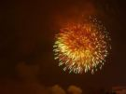
Renaissance Day on July 23: The Renaissance Day, celebrated each year on July 23 is, first and foremost, a day on which we declare our respect, admiration and gratitude to our wise leader His Majesty Sultan Qaboos bin Said, who acceded to power on July 23, 1970. The development of modern Oman is linked to the Renaissance Day.

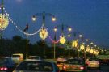
- National Day on the 18 of November: November 18th represents an invaluable day in the life of the Omani people because on this date His Majesty Sultan Qaboos bin Said, the builder of modern Oman, initiated the renaissance era 36 years ago.
- Islamic New Year. This is not an official public holiday. Note the Islamic calendar is calculated from the "Hijara", the departure of the Prophet from Mecca to Medina.
- The Prophet’s Birthday. A one-day holiday.
- Ramadhan. This is not a public holiday, but a holy month of fasting and spiritualism. During daylight Muslims may not eat, drink, or smoke. Meals are enjoyed after "Iftar", the sundown break of fast, as well as visits between family and friends.
- Eid Al-Fitr. (Eid means holiday or celebration). This is probably the main holiday of the year for Muslims, and is the first day following the end of Ramadhan. It is a time of celebration, the breaking of the holy fast. It usually lasts for a week.
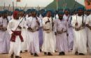
- Eid Al-Adha. Festivities which conclude the Haj (pilgrimage) period. It is a commemoration of the time when Ibrahim (Abraham), considered the sacrifice of Ismail (Isaac), so that the ritual of sacrifice and distribution of food takes place. During this time, Muslims need no invitation to call on each other and as with Eid Al-Fitr, a special prayer is offered after sunrise and sometimes spontaneous public dancing in the streets occurs, even in Muscat. It usually lasts for three days, but again the exact length of the holiday is only known at the time of the official announcement.
Travel Guide of America

Travel Cites

Parrot Jungle Island
Located at 1111 Parrot Jungle Trail. Have a great outdoor day with you kids. Your able to talk to parrots, reptiles, and other animals.
South Beach
This is everybody favorite spot . Bring you beach wear and prepare for a tan!
Casino Princesa
Great place to gamble. Located at 315 Biscayne Boulevard, gamblers be ready to lose or win some money!

Leisure Activities

- Everglades Tour with Airboat Ride
- Miami Kite Surfing Adventure
- Fort Lauderdale Water Bus
1. http://travel.travelocity.com/flights/AirSearch.do?SEQ=11616198247399232006
2. http://www.expedia.com/pub/agent.dll?qscr=tshw&stat=1&flag=e&loid=&locn=miami%20florida&date1=&date2=&&zz=1161876685925&

3. www.skypic.com/miami.htm
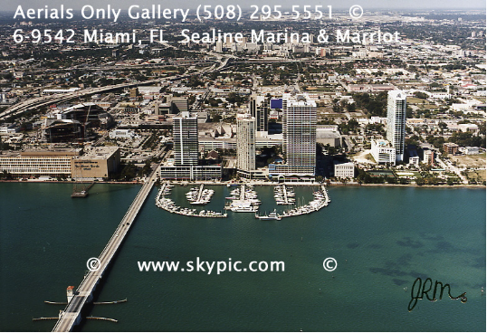

What Are You Waiting For!
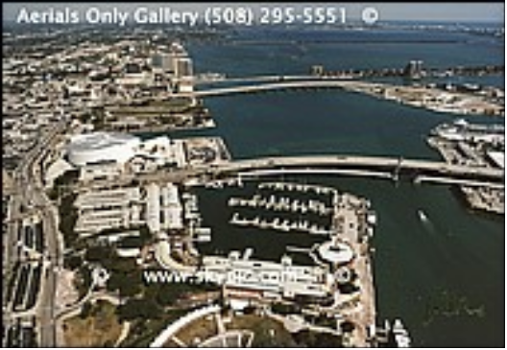

Miami, Florida
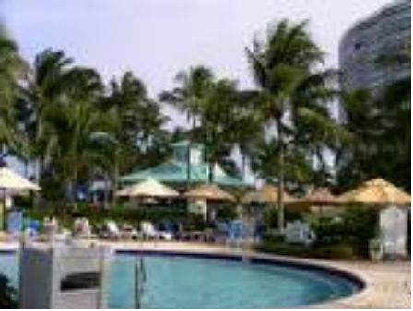

Angel Sanchez
Places To Stay

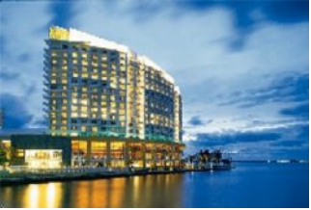
The Mandarin Oriental is located on 500 Brickell Key Drive and only cost $325 (a night) and allows you to have a view of the shore. There is much to do in the inside of the hotel and on the outside. There’s a swimming pool, hot tubs and more. This hotel also allows you to bring any type of pet inside. There’s lots to do inside the hotel.

The Quality Inn is cheaper than the one above( cost is $ 88 a night). It is located 14501 S. Dixie Hwy and is a pretty far distance from the beach but is closer to get hear from the International Airport. (exact 15 miles) There’s a swimming pool, pets are allowed, and more!
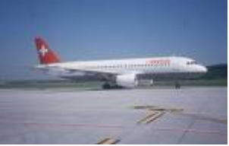
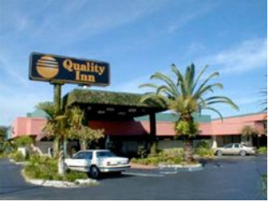

Travel Prices

The travel tickets ranges from $206 to $308 per person. There is a package where you fly from Philadelphia, PA to Miami and gives you 7 nights in an Hotel. All the tickets include taxes and fees. All the tickets are roundtrip and will give you 8 days in Miami with 7 nights trip.

Climate/Weather Conditions
Miami’s weather is very warm. The average high is in the 80’s and the average low is in the 60’s. You will never see snow in Miami so you wouldn’t need to bring a shovel. The annual average of precipitation is about 52 inches of rain. You will have a great time and wouldn’t have to worry about the cold, breezy, air.
Foods and Restaurants
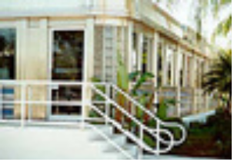
This is the Gourmet Diner located on 13951 Biscayne Boulevard. They have everything from Escargot in garlic butter sauce to cheeseburgers with fries. This is a great place were everyone in the family has different tastes.

This is the Mambo Diner located on 401 Biscayne Boulevard. Latin Music is played throughout the Diner, through big loud speakers. The food here is mostly Hispanic (mostly of dishes are from Puerto Rico) Makes you feel like your eating at home!



