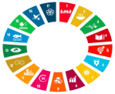
My Hero Project Plan 2022 . “The AICHAS”
Goal4:Quality Education/Goal5 :Gender Equality
Week 1 : (This week)
- Designing the logo of our Peoject (We are open to Omar’s suggestions, Khalil, Taha and Rim’s suggestion ,too.) Anyone else is welcome
(I’ll explain more in a vocal message. So Stay tuned)
- Designing an online questionnaire (Anissa / Khalil and Kmar)
(We will send you a link to do a very short survey, do it please and send it to anyone else you want him/her to take part in it)
- Watch and react! You will watch a video and give your feedback about it on a Padlet (Anissa)
The video Link
Week 2: Meeting Next Friday (29/04/2022) For 1hour and a half or 2 hours
- Setting the questions for the interviews that you will conduct with random people, film them and then at the end we will select and pick some of them.
- Design the play that will portray AICHA’s Story ; Deciding the text, the roles and the scenes.
Week 3: We will film the play.

- A suggestion: A short film showing our own reactions after dealing with Aicha’s Story: How the story has impacted us + coming up with our own SLOGANS)
- Khalil and (Si Wael) will play a part of Sia’s song “Unstoppable”
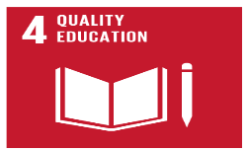
- Rim’s choice of “Me” will be the cover song of our final video.
