Different Lands, Different Lifestyles
Frederick Douglass Elementary School
Winchester, Virginia, United States of America

1. Describe the year-round weather in your area. How does the weather affect the things you do and your lifestyle? Does it prevent you from doing things or help you to do certain activities?

Well, our weather right now is freezing because it is almost winter! We get snow in the winter. Winter is so much fun because we can play in the snow. We can also go ice skating. The cold and snow sometimes prevents us from going outside. School can be canceled because of snow, or we can have a two hour delay.

Sometimes there is snow in the spring. In spring, it is warmer, windy, and rainy. Spring can be cold and also hot too. In the spring, we plant gardens. Tornados can happen in the spring. We can go to another place like a basement when there is a tornado.

ln the summer, it is kinda hot! The pools are open for swimming. In the fall, the leaves change colors and fall off the trees. It starts to get windy and cold, and we wear jackets. We also jump in piles of leaves after we rake them.

And what kind of seasons do you have? Do you have winter, summer, fall, and spring?
Loammi V.
2nd Grade

2. What is the defining geographic feature of your area? How does it affect the development of your region and what do people think about it?

The defining geographic feature in our area is the Appalachian Mountains. The mountains limit where we can farm. We plant our apple trees and other plants in the valleys where they grow better. Maybe some people come here to go hiking on the weekends on the Appalachian Mountains. Or maybe some people come here to see what type of view there is on the Appalachian Mountains. Or some people might come here to take pictures of the Appalachian Mountains to show their family or hang on the wall.
Bradley S.
2nd Grade

3. Are the houses in your area designed to be compatible with the environment? What are the specific features of houses that make them suited for your region of the world?

Some houses in my area have pools, so in the summer they can go in the pool and play. To not get a sunburn you could put on sunscreen which is a type of cream that protects your skin from getting red. We also use air conditioning to cool off in the summer. In the winter, our houses have heat.
Michael T.
2nd Grade

4. If you could change the style of house you live in, would you change it? What would you change and why?

I would change my backyard because it is not the size I wanted it to be. Then I would put a trampoline in my backyard, even though my mom says that it is too dangerous. And I would change my basement to be bigger so I could fit a bigger TV and a bigger Xbox, which has Just Dance and Cook, which is a game where you cook food without the time running out.
Michael T.
2nd Grade
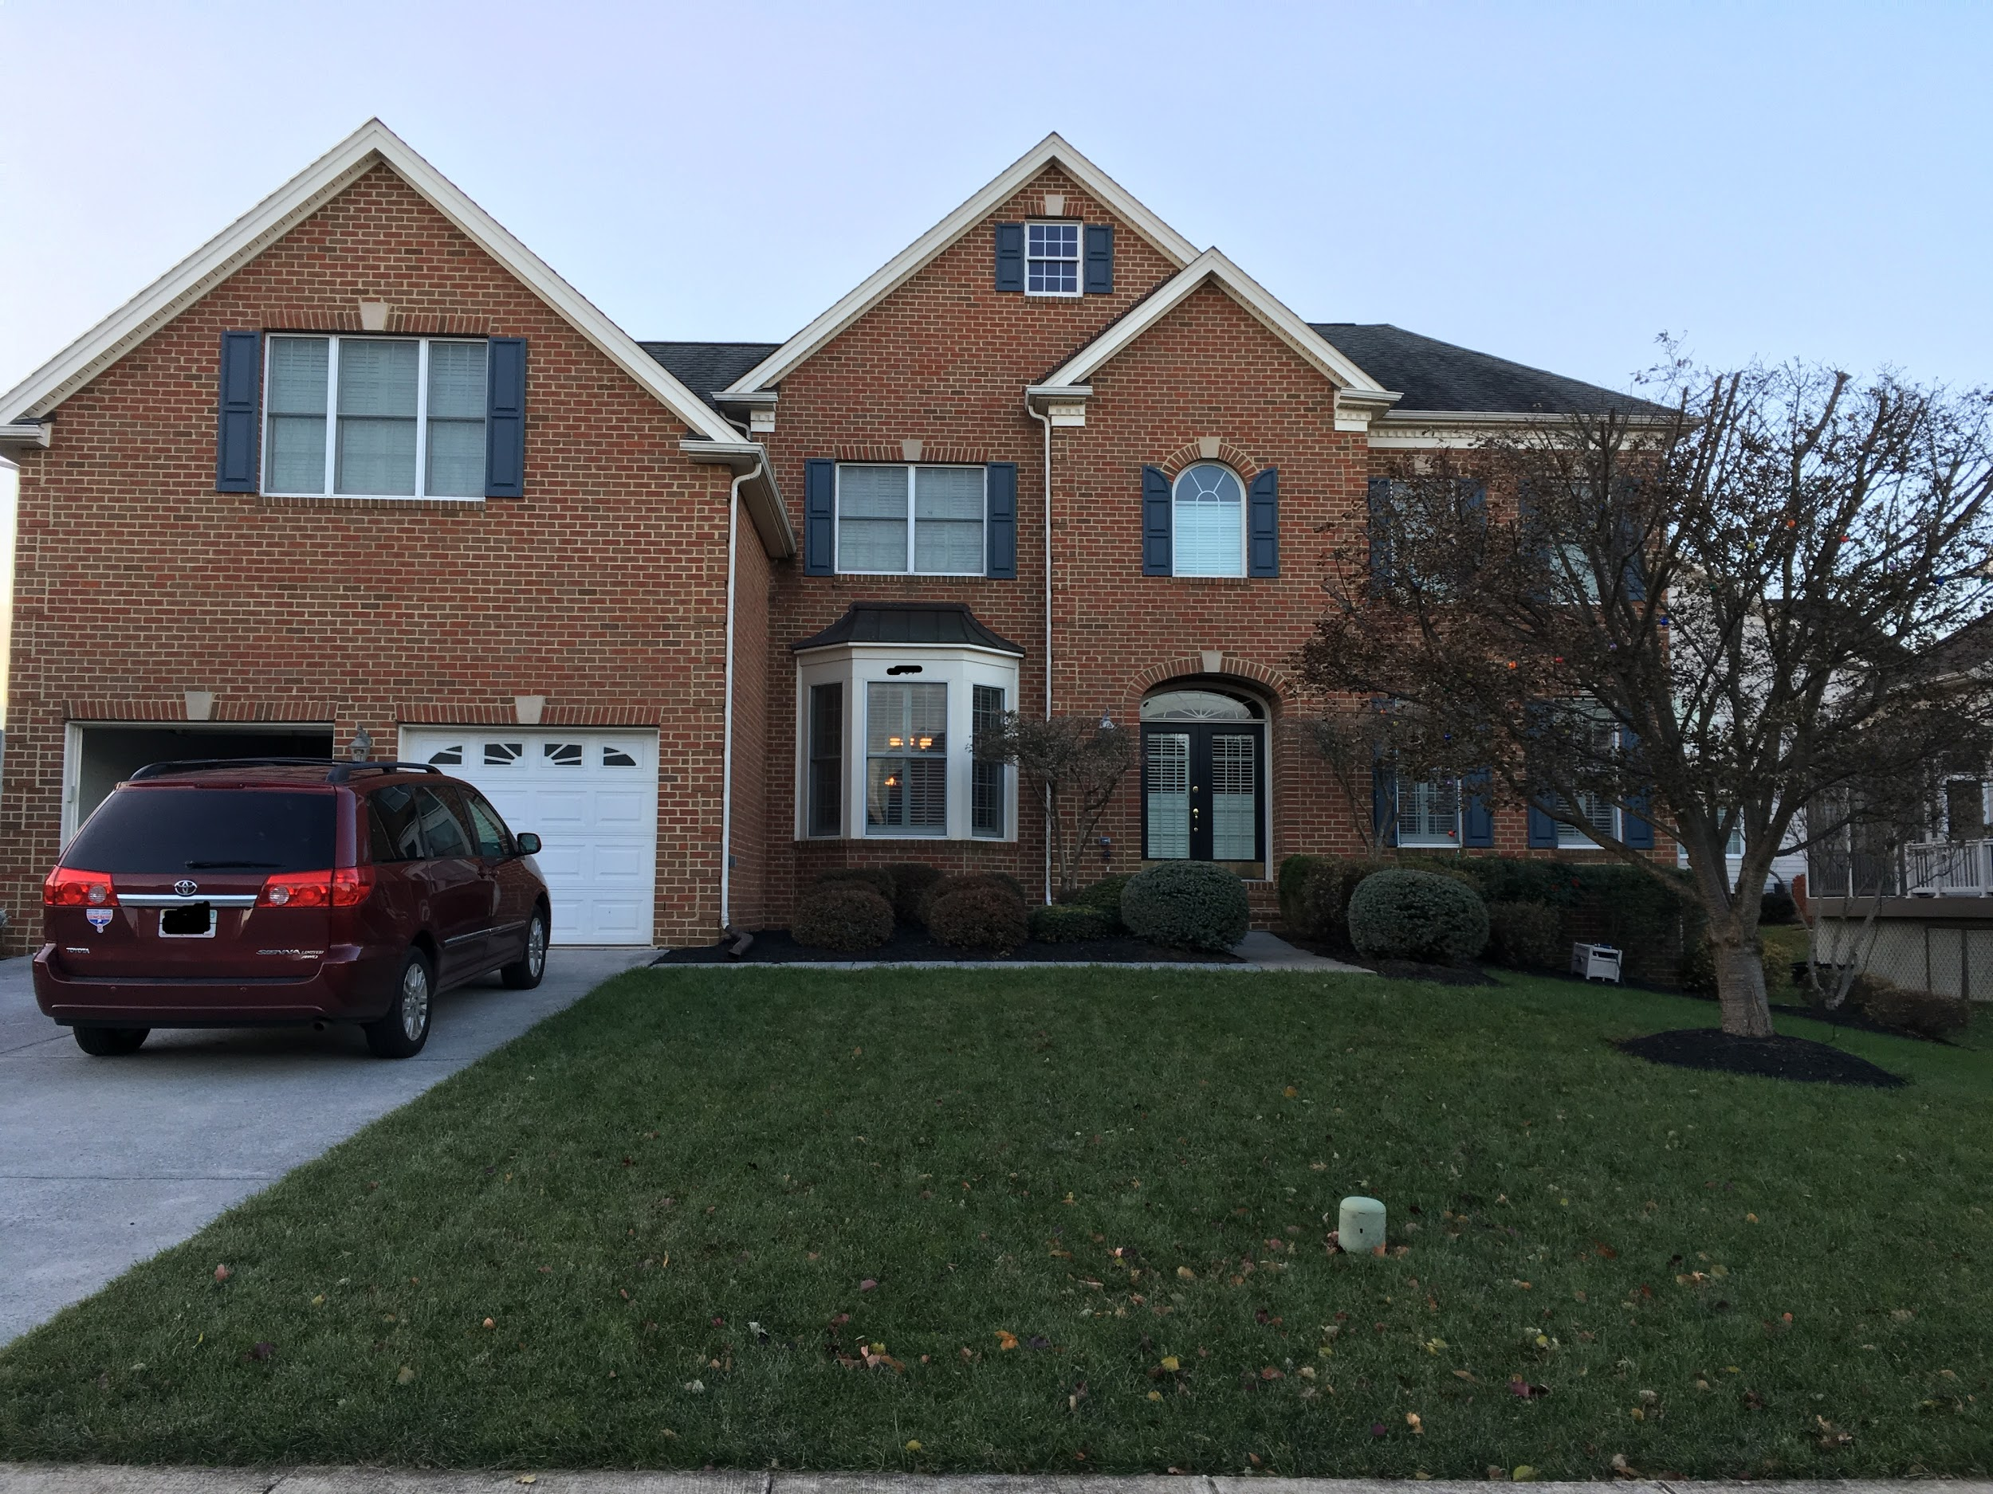
House in Winchester, Virginia, United States of America

5. Describe what people in your area do for fun. What kind of places do you visit? What kinds of attractions are available? What is your favorite thing to do and why?

My favorite thing to do is go to the Smithsonian museums for fun. Last time my family and I went to see the Air and Space Museum and the Natural History Museum. Some people like to play games outside like tag or hide and seek. People also come to this area to go shopping,= and to visit the Appalachian Mountains.
Ninah G.
2nd Grade

6. If you could change one thing about the area where you live, what would you change and why?

I would exchange my neighbor’s house with the San Francisco mint because I am a coin collector so I could get more San Francisco coins which is the most rarest mint now. The San Francisco mint did not make a lot of coins, so they go for a lot of money. Plus they do not mint San Francisco coins any more. And I don’t have to go all the way to the bank to coin roll hunt. Then I do not have to go with someone.
Bradley S.
2nd Grade

7. Are there foods in your area that are unique to your area of the world? Why do people eat them? Why are they found in your area of the world? What is your favorite local food and why?

Apples are not unique to our area, but Winchester and the Shenandoah Valley are often called “The Apple Capital of the World.” We even have an Apple Blossom Festival every year at the end of April/beginning of May. Lots of people come to the festival, and there are lots of apple foods, like apple fritters, apple dumplings, candied apples, apple pies,etc. We have an Apple Blossom parade with floats and the Apple Blossom Court, including the Queen, princesses, and maids. People eat apples because they are healthy. The apple trees grow in the valleys.

8. If you could move to another area of the world that has different geography, where would you move. Why would you move there?

I would move to Colorado because I really like skiing and playing in the snow. I like skiing a lot there because the mountains are very tall. It is a lot colder in Colorado than in Winchester. The reason why it’s much colder in Colorado is because it is much higher than Winchester, Virginia.

The mountains are called the Rocky Mountains and are taller which makes them better for skiing. It snows a lot more in Colorado than in Winchester.
Allison R.
2nd Grade

