Victoria Comerzan

“Holidays and Events that We Celebrate in Our City/Town”

The 8th form

High School “Mihai Eminescu”

Country: Moldova

The goal of our project was to share information and ideas about many holidays and events that people celebrate in different towns/cities.

I am grateful to all teachers that encouraged their students to create wonderful projects about holidays and events from theirs towns/cities. I want to publish some interesting information from their projects.

*Mutruc Irina* from Balti

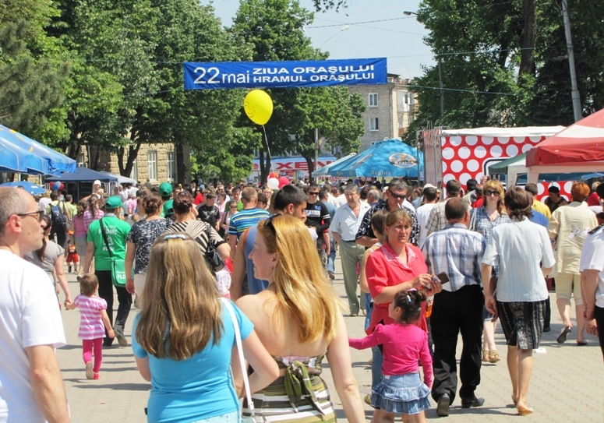

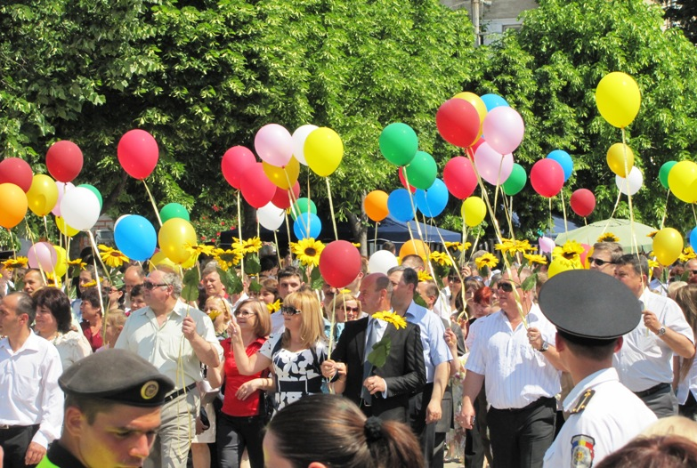

*Mariana Boldisor* form Orhei

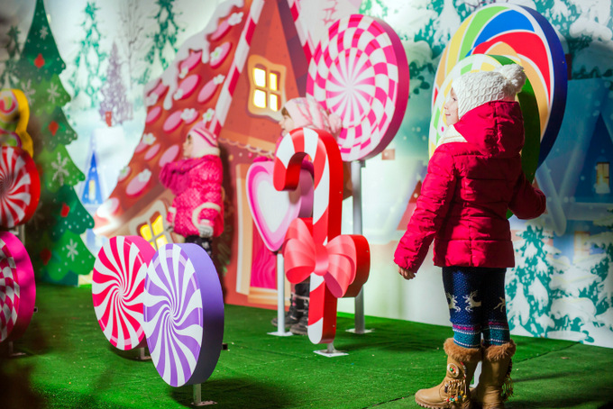

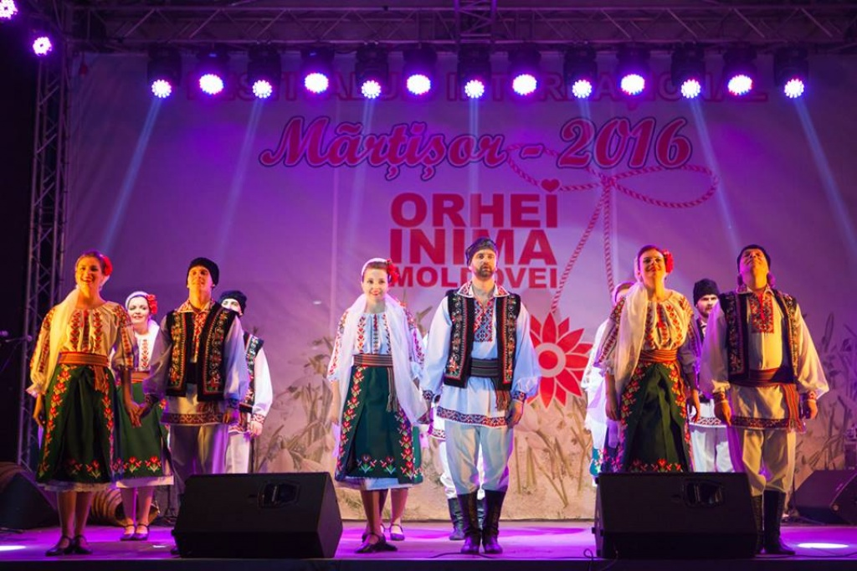

*Olga Prokhorenko* send us interesting projects about New Year, Easter holiday



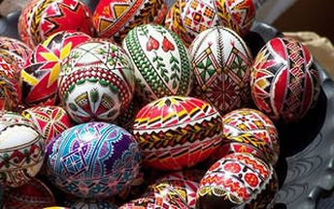

*Elena Aginskaia* shared information about Festival in Bobruisk