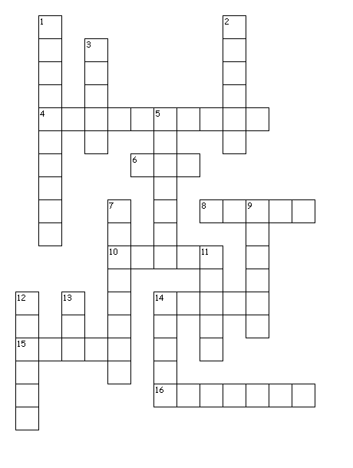

Across
4. Things that some people like to play for fun
6. A domestic animal that is a popular pet
8. Where you find received emails
10. something people listen to
14. A device used to talk to people from far away
15. A large animal that people sometimes ride on
16. An instructor and authority figure in a school
Down
1. another thing people watch for entertainment
2. A pretty plant, often smells good
3. A sweet treat that many people like to eat
5. Something some people use to see better
7. A device you are using right now
9. Something that helps straighten people's teeth
11. Something that tells time
12. A place we go to every week day to learn
13. Something that people use to get around without walking
14. A person who flies planes

Answer Key
Across
4. videogames
6. cat
8. inbox
10. music
14. phone
15. horse
16. teacher

Down
1. television
2. flower
3. candy
5. glasses
7. computer
9. braces
11. clock
12. school
13.car
14. pilot

