The Interview
By: Amy , Sebastian, Jacqueline , Claire , Asher, Ryan

1.Did your school ever have a fire or a dramatic change? In our school only about 50 years ago there was fire that changed everything. We had only one room that had survived the fire. Many kids did not have school for a many years. After that the school was beautiful again.

2. We use Ipads and have own netbooks for education

3.In Highland park we have a tree that we light every year. Many people come to this tree lighting to socialize, sing with friends and family, and have fun. Each year the mayor comes, gives a speech, and welcomes everyone. The tree that we light is 150 years old and still it’s standing. People have taken off a branch and grown a sister tree for later on in the years.

4.There are 4 public elementary schools in Highland Park U.P, Armstrong, Hyer, and Bradfield.

5.Armstrong is older than Highland Park!

6. Armstrong was made on the year of 1914.

7.The founder was John S Armstrong.

8. Our school name is Armstrong because our founders’ last name was Armstrong.

9. Armstrong’s 100th birthday was 2 years ago!
10. Armstrong opened it’s doors on October 1914.
This is U.P. (lower image)
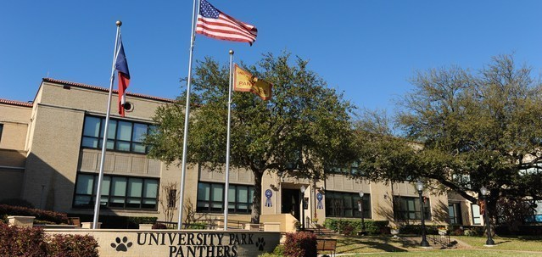
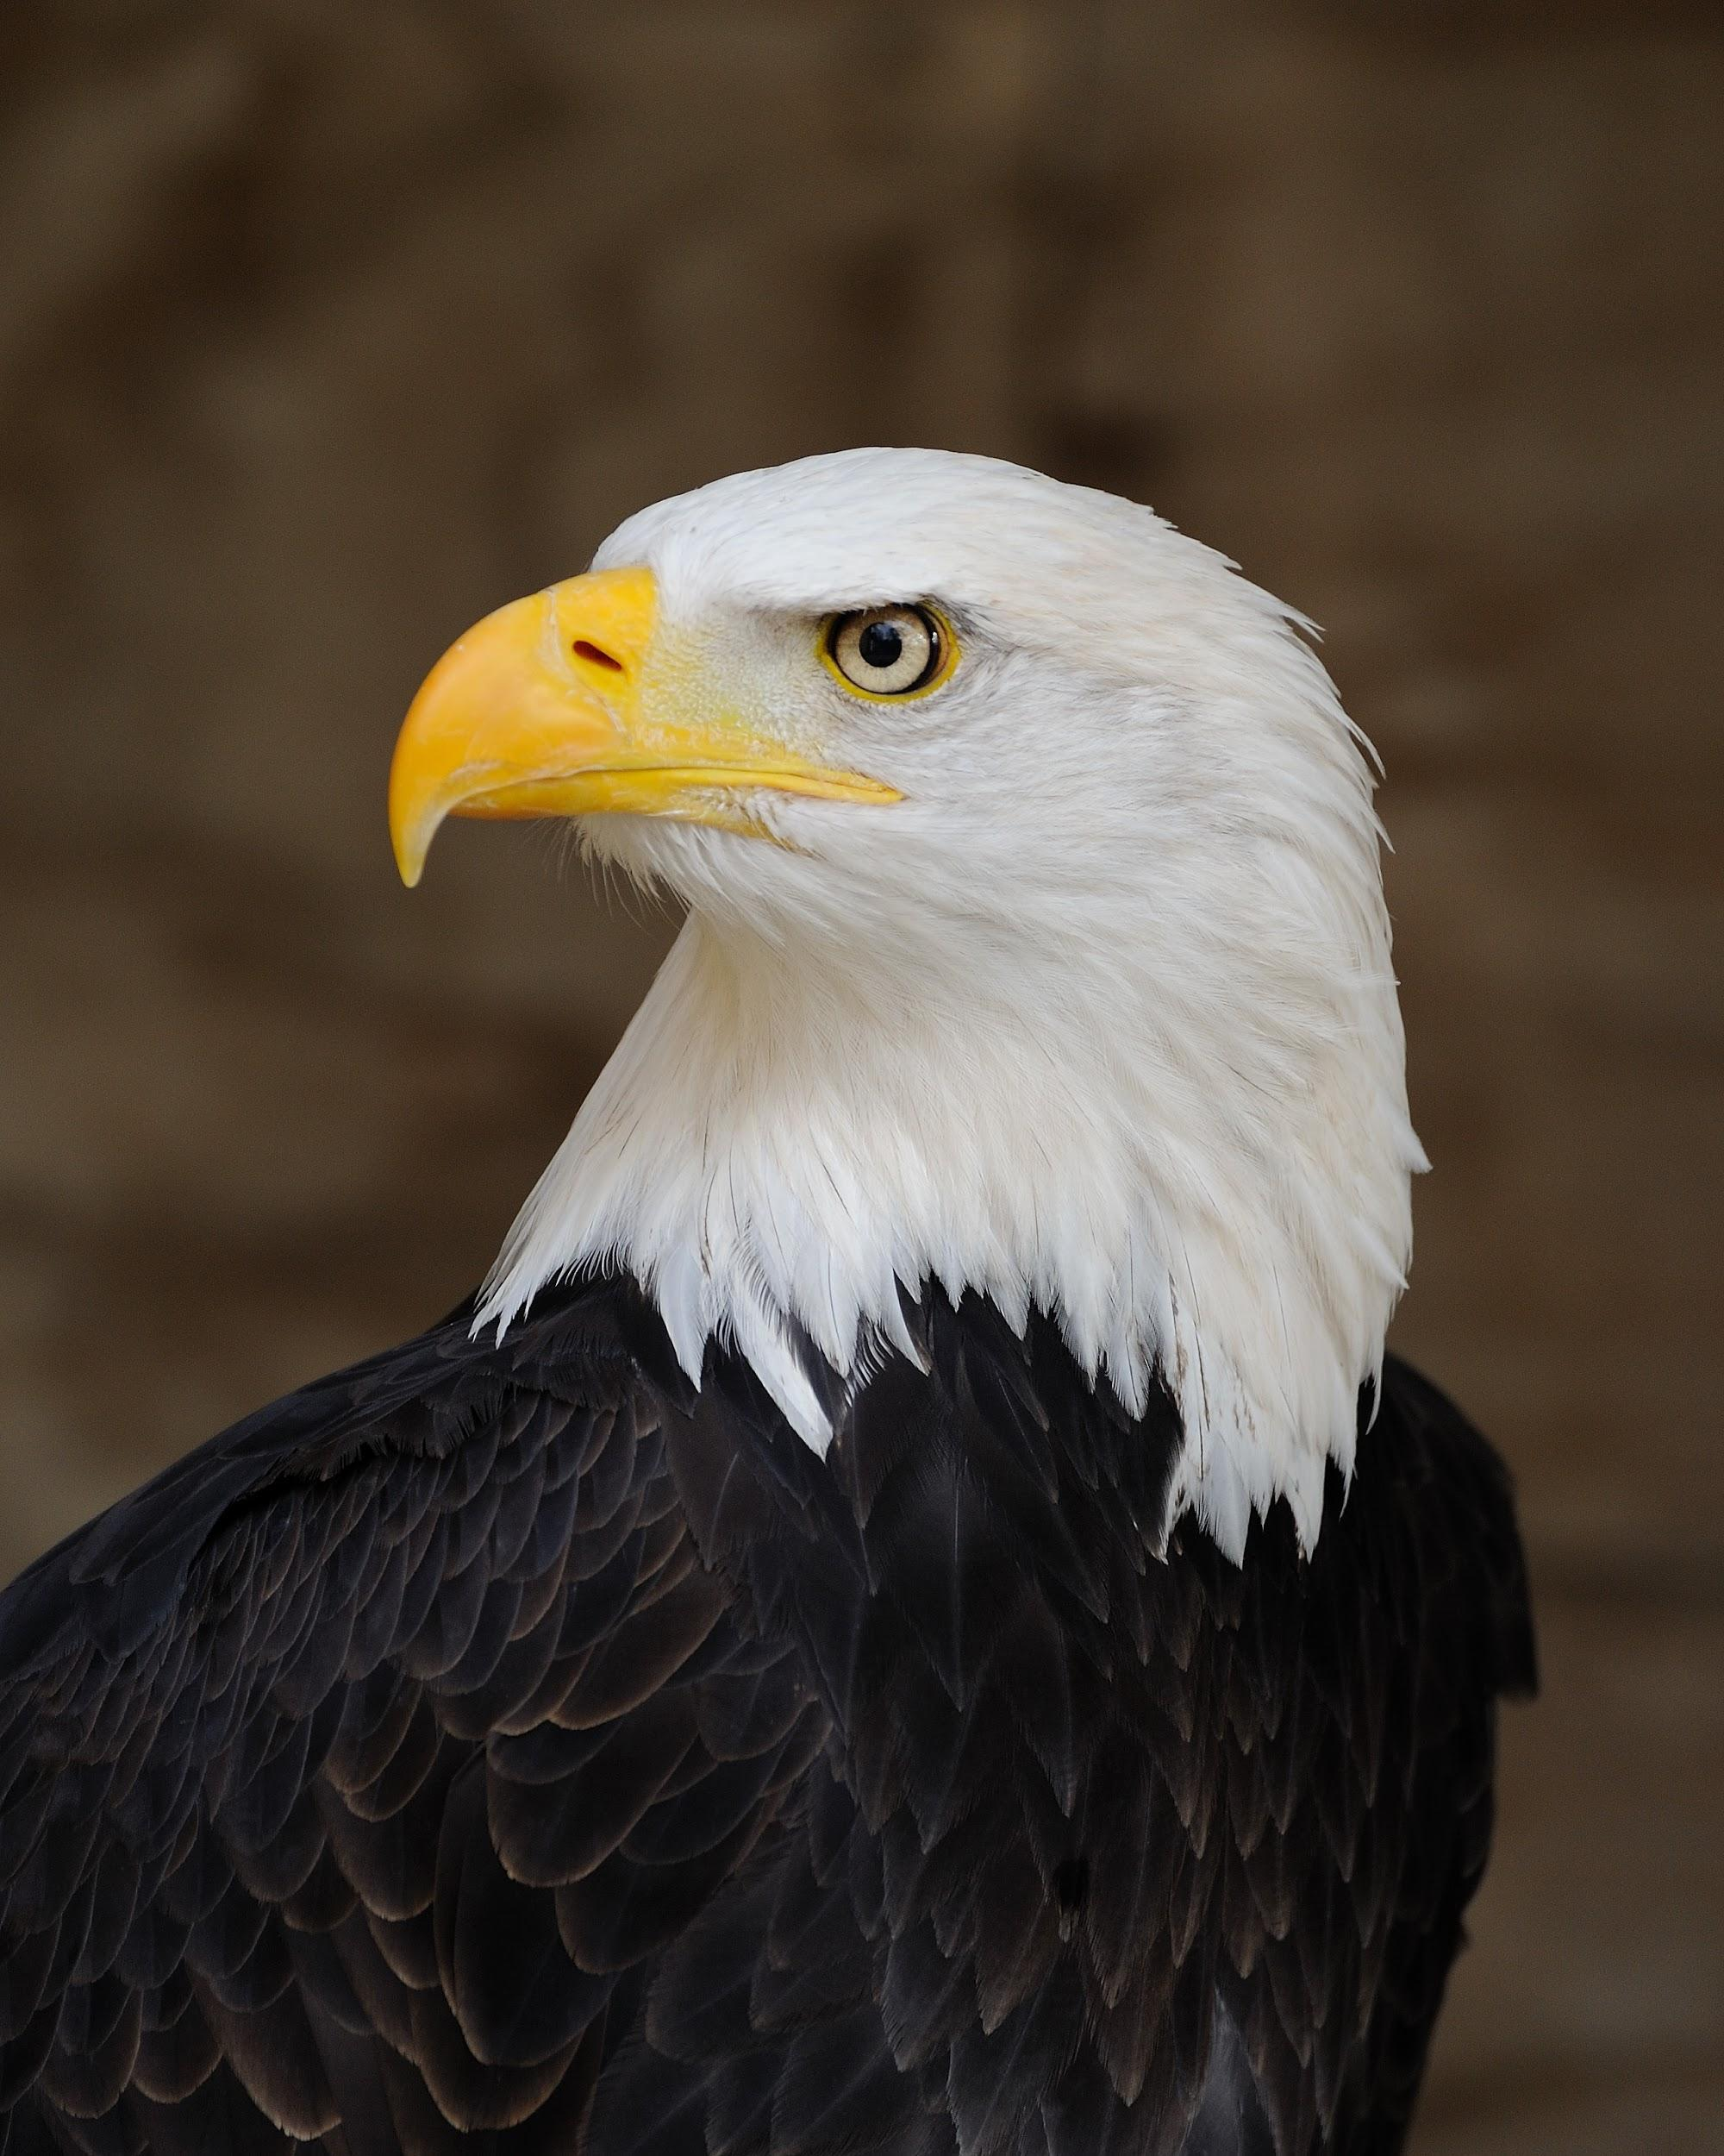
Armstrong’s mascot is a bald eagle. Our mascot makes everybody feel proud. We got our mascot by freedom.Our mascot’s name is Goldie the eagle. We are very proud to have a such a great mascot.

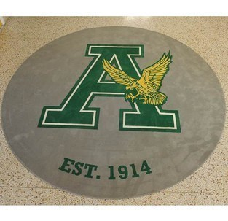
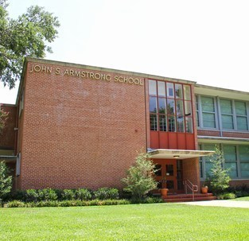
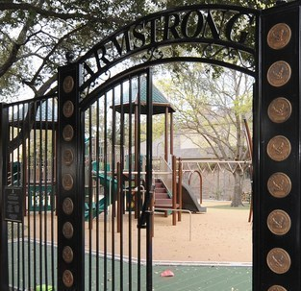
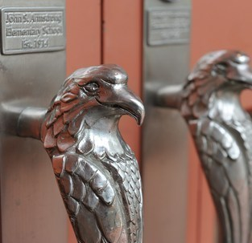
Armstrong Pictures

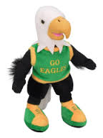
Our school colors are green and gold and we are proud to be eagles.

Armstrong school

