The Classroom Survey --Getting to Know You!

Circle Name: My City and Me
Class Name: 11th graders from Labschool Cibubur Senior High School-Indonesia

PART I. INTRODUCING THE CLASS
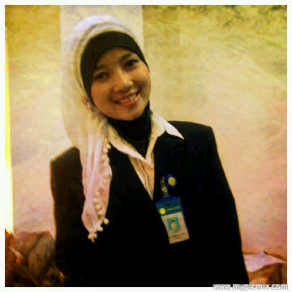
The name of the teacher is Tri Purba Dharmastuti. My nickname is Arma. When my students were asked to do the classroom survey, they wrote their opinion about me. “She’s the English teacher, she teaches Grade 11. She’s very strict when it comes to rules and disciplines, but kind and sweet on the other side.”

Favorite Music Groups
Class favorites begin with top 5 favorite music groups. The first one is Maroon 5, because the students love the songs. They don’t have any bad songs, all of the songs are great and ear catchy. The second is One Direction, which is very hip among teenagers at the moment, especially for girls. The third one is The Wanted, and then Blink 182, and the last one is Paramore. They are all great in their own music genres.
Favorite Authors
The students don’t have favorite authors, because some of them don’t remember the name of the authors so that they replace it with their favorite books. The first one goes to Diary of A Wimpy Kid. This book is genuinely hilarious and there are many funny illustrations in it. It’s just very amusing, perfect for the cure of boredom. The second is Harry Potter series, the legendary series. The third is The Hunger Games trilogy, the new series but soon to be legendary. And the last one is Twilight Saga series.
Favorite TV Programs
The first one of students favorite TV programs is The Voice. Moreover there is “The Voice” ‘Indonesia’ now. It’s a new TV show so that it becomes their current favorite. The second is How I Met Your Mother, this is an adult teenager TV show that is very funny and enjoyable to watch. The next favorite comes to Glee, a musical TV show. People could learn many things from the stories since the story deals with our daily life. Besides, good songs and soundtracks turn the teenagers to love it. After Glee, students love CSI (Crime Scene Investigation). And the last one is MasterChef, the cooking show.
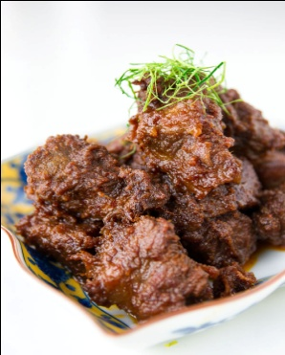
Favorite Foods
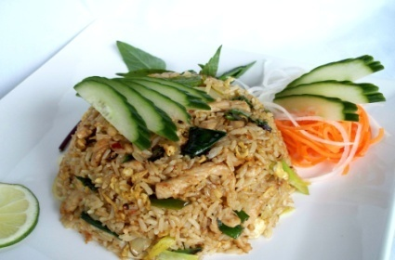
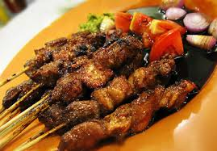
Then, their top 5 favorite foods are rendang, sate, fried rice, soto, and fried chicken. They’re all incredibly delicious, no doubt. Rendang is made from beef slowly cooked in coconut milk and spices for several hours until almost all the liquid is gone, leaving the meat coated in the spicy condiments. Satay is one of the favorite street foods in Bali and Java. Sold from smoky street-side carts, this snack of barbecue meat on bamboo sticks needs no advertising, you can smell it a block away. A truly authentic nasi goreng or fried rice in Indonesia is plain and simple, consisting of leftover rice stir-fried with a flavoring paste.
Fried Rice
satay
Rendang
Favorite Subjects and Sports
Most favorite subjects of my students are Chemistry, after that English, then Geography, Physical Education, and the last one is Mathematics. And then their favorite sports are swimming, basketball, jogging, football, and softball.
Favorite Video or Computer Games and Websites
Their favorite videos/computer games, are only Grand Theft Auto, World of Warcraft, and The Sims. The last one is about their favorite websites. Of course, the first one is Twitter. For teenagers these days, it’s not enough if you don’t have a Twitter account. The second one is Instagram. This is where students can upload photos easily and then share it. Before posting it, they have to make pictures that they post as interesting and creative as possible. The third is Path. Path is like the mixture of Twitter and Instagram, but this one is slightly different, people could post the song that they listen to, movies that are watched, shared-videos, and many other things. But Path is kind of new, so it hasn’t been really familiar like Twitter or Facebook. Students well actually like Facebook and Tumblr too. After all, they’re all similar to each other. Those are results of the classroom surveys that I and my students did.

PART II. INTRODUCING THE SCHOOL
Name and Address of class and school
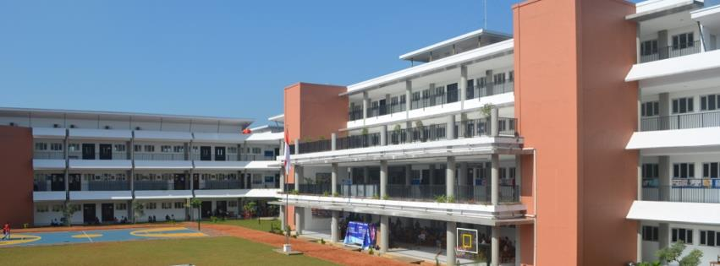
Labschool Cibubur Senior High is in Bekasi of West Java. It located on the eastern border of Indonesian capital city, Jakarta, and the population is approximately 1,500,000. It is Indonesia’s most populated suburb, also in the city, industry is developed. Labschool routinely joins some student exchange programs every year in Taiwan, America, Japan and some other countries.
The main building of Labschool Cibubur SHS
Number of students in class and school
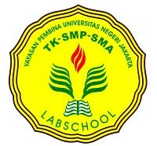
There are five classes of the eleventh graders and six classes of the tenth graders, in total of 11 learning classes (excluding science labs and computer labs). In each class there are about 34-36 participations, which adds up to 500 students in result. Telling from how many classes and students that we have in Labschool Cibubur, the size of its building is an average like other schools in Indonesia. We haven't had any school emblems yet, though. Labschool provides a Computer Laboratory for its students that contain 40 Desktop computers engaging us to browse for researches that is given from teachers to their students.
Labschool has seven basic values of characteristics for future leaders (labschool's students). The seven basic values are; devotion to God, high integrity, perseverance, personality intact, noble character, independent and high intellectual. Labschool's learning activity are oriented to students which are packed with humanistic, holistic, meaningful, fun, and still refers to its motto; Faith, Knowledge, Charity.
School Emblem
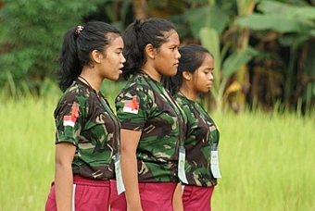
School Programs
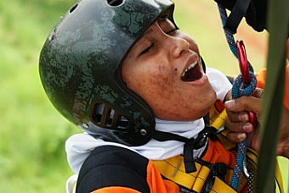
Labschool Cibubur has its own way to make it different. Annual programs aim to build our characteristics, varieties of extracurricular aiming to sharpen the capability of our non-academic, and an interactive way of teaching and learning process. The first annual program held by Labschool yearly is called SKUADRON. Labschool cooperates with the national wings air forces to support the program. SKUADRON teaches us how to be discipline, how to manage time and indirectly builds up our characteristics physically and mentally.
SKUADRON

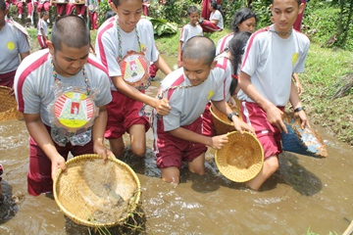
The second annual program is called “Trip Observation.” Trip Observation is a trip that observes the little things called natural livings around us that we haven't been paying much attention to. In a trip observation we are located to the hinterland where people are still traditional also are accustomed to the absence of electronics. We live with house parents for 5 days and 4 nights. In each house there are 10 people, 1 senior (student council) and 1 teacher (advisor). We are taught to be independent, courage, and discipline.
Trip Observation

Last but not least, an annual program that's been through for years is LALINJU. LALINJU is an annual run to commemorate Indonesia's Independence day (17 August), the participants are the upcoming generation student council and class representatives and the previous generation of student council and class representatives. They run from “Taman Makam Pahlawan” to Labchool Cibubur, a total run of 17 kilometres.
LALINJU
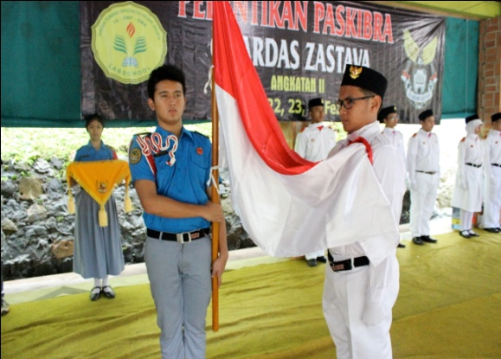
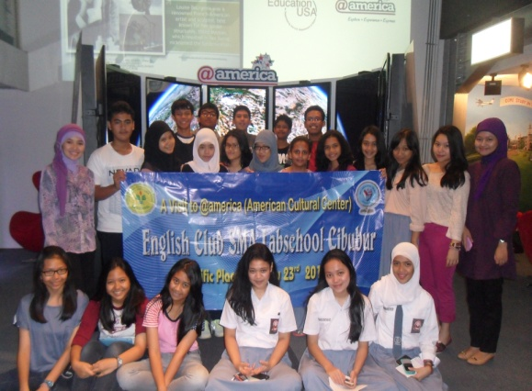
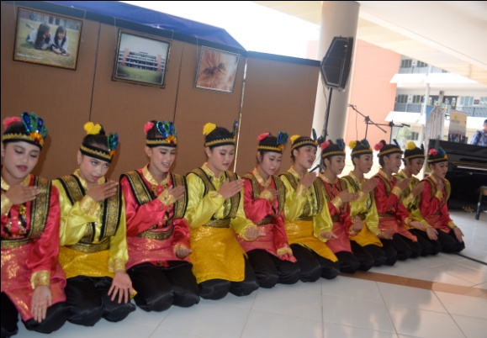
Extracurricular in Labschool aren't a few, there are about fifteen of it, such as; traditional dances such as Aceh's traditional dance (Saman), tari Betawi (Jakarta's traditional dance) they not only have fun but they have preserved Indonesia's traditional dances that can be taught to their grandchildren in the future. English Club they practice their English skills of speaking, writing and listening. Photography is a non-academic activity, which is liked by many students who have hidden talent that they actually have which they can hone by participating in this extracurricular. Palabs, a group of people that loves the nature, the activities that they do are rock climbing, camping and hiking. Soccer and Basketball is an extracurricular activity for healthiness, they compete against other schools to test their ability that they have practiced with their coaches. Labschool also has an interactive way of teaching. As an example, we go to the laboratory to examining acid, they also have games that can teach us lessons. Most of the teachers in Labschool have their own way of teaching, they make their students active in every lesson.
Extracurricular Activities
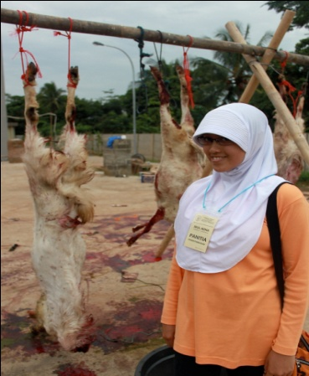
Eid al-Adha is a celebration for Muslims around the world to appreciate of what we've gotten through the whole year by slaughtering a goat or a buffalo and give 2/3 of the meat to the unfortunate in our surroundings. And to celebrate it, our Labschool team slaughter the goat and buffalo in the field and give it to our unfortunate surroundings around school.
Eid al-Adha

PART III. INTRODUCING THE COMMUNITY
My Community
We live in a city named Bekasi. Bekasi, or as we usually call it ‘Kota Bekasi’, is a city in West Java, Indonesia, located on the eastern border of Jakarta within the Jabodetabek ( Jakarta, Bogor, Depok, Tanggerang, Bekasi) metropolitan region, as such it serves as a bedroom and factory town for Jakarta. To the south is Bogor Regency, east is Bekasi Regency. It is Indonesia's most populated suburb, and one of the most populated worldwide, but still trails the likes of Incheon and Yokohama. Substantial urban areas surround the city. It serves as a commuter city for Jakarta, although it has notable trade, business and processing industries. These are primarily clustered in the area of Karawang. Bekasi is divided into 12 subdistricts: West Bekasi, East Bekasi, South Bekasi, North Bekasi, Medan Satria, Rawalumbu, Bantar Gebang, Pondok Gede, Jakasampurna, Jatiasih, Pondok Melati and Mustika Jaya.
The city’s coordinates are 6°14’0”S 107°0’0”E / 6.233333°S 107°E. It has an area of 210.49 km^{2.} Having position as Jakarta's buffer zone in the east, Bekasi accommodates urban people who commute to and fro between Jakarta and Bekasi. This condition has made the city populated with around 1.9 million (precisely 1,993,478) people in 2005, and 2.4 million (precisely 2,378,211) people, last checked on the year 2010, and becomes the fourth biggest city in the country.
Special Characteristic
There are reasons why people usually visit this city of ours, one of the reasons are that there are two highway connections from the Jabodetabek urban area. The first is the Jakarta–Cikampek Toll Road, which has four exits in Bekasi. The other is the Jakarta Outer Ring Road, which provides access to Tangerang, Jakarta, and Bogor. The other reason is that there are several shopping centers in Bekasi. The largest is Mega Bekasi Hypermall (anchor tenant: Giant), Other shopping centers include:Metropolitan Mall. Grand Mall (anchor tenant: Hypermart), Blue Oasis City (anchor tenant: Carrefour), Bekasi Trade Centre, Bekasi Cyber Park(anchor tenant: Hari Hari Swalayan), and Bekasi Square (anchor tenant: Carrefour). And the last most important reason is that there are lots of housing estates that you can live in, and all of these housing estates are usually near a giant shopping mall, so you can easily restock on supplies, or even go shopping without spending too much money on transportation.
In addition to its numerous residential areas, there are several important industrial areas in Bekasi. These include the Jababeka and MM 2100 districts. Many large companies, such as Honda,Converse and Samsung, have factories in Bekasi. Approximately 500,000 laborers live in Cikarang, the capital city of the Bekasi regency.

PART IV. OTHER INFORMATION
I have been teaching at Labschool Cibubur for almost two years. I teach English. I like travelling, eating, listening to music, and meeting new people. I like getting involved in some projects cooperated with other countries around the world. In this project, I will involve 3 boys and 9 girls.

