2013
Teacher: Tri Purba Dharmastuti
LABSCHOOL CIBUBUR SENIOR HIGH SCHOOL
INDONESIA
LEARNING CIRCLE PROJECT

SPORTS DEVELOPMENT

Taking part in any kind of sports is good all rounding for teenagers physically, socially, and mentally. There’s a research shows that middle-school teenagers who are physically active and play on sports teams are more satisfied with their life and feel healthier. Sports have a large influence on young people lifestyle. They improve health condition in various ways, help the organism to utilize the calories better, which helps in reduction of the fatty mass of the body. The beneficial influence of sports on health mood doesn’t raise any doubts any more. There’s also a research that reveals the regular training among the youth (and by people at any age) is an important factor improving the health. However, too little popularity of physical activities among the young people is a huge problem.
Sport
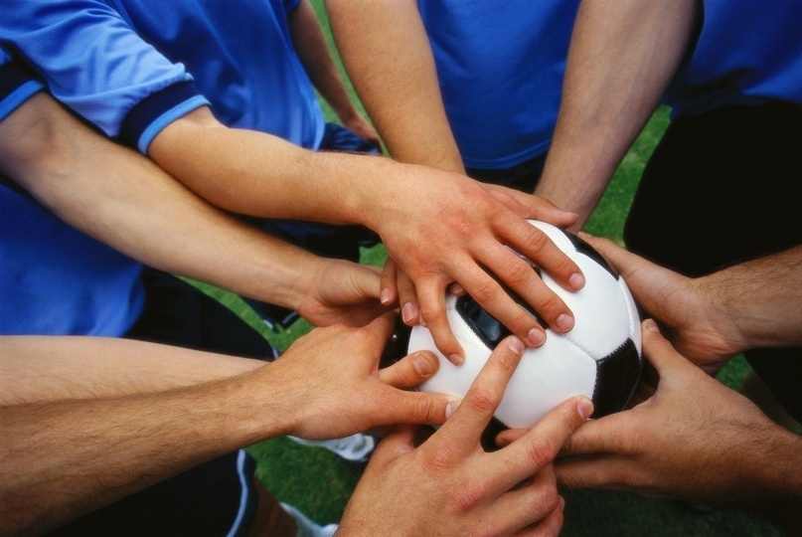
There are so many things we can learn from sports too, like for example teamwork. Not only does this benefit the person in developing a better game, but it actually helps in all walks of life, to lead a better life. While these days people can easily play sport video games on their computer or other electronic devices, almost every sports out there involve interaction with other people. This can enhance the social life of a person.
Teamwork

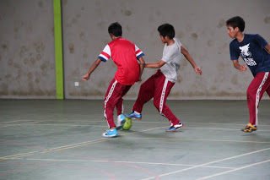
Our school, Labschool Cibubur has sport tournaments, competitions, activities, and clubs such as basketball, baseball, softball, and badminton.
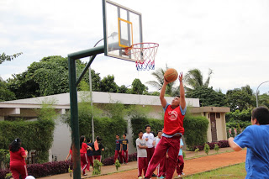
The football club practice sometimes takes place on the football stadium at Senayan. Senayan is actually far from Cibubur (our school area), but that’s a proper place for a proper training. And Senayan area has big different fields or stadiums for different sports. The football club sometimes practices at school too, but not so often.
Football Club
Meanwhile, the basketball team only practices on the basketball field after school time. The team often joins basketball tournaments or competitions outside school. This club is the most active sport club in our school.
Basketball Club
Besides basketball, we have badminton club. This club is actually not very actively joins competitions outside the school, but they still practice a lot at school. The last one is softball and baseball club. They have practice on the baseball field at Senayan, and also practice at school. The club joins many softball and baseball competitions too. Other than the clubs, all of the students in Labschool Cibubur have an early morning run that starts at 5.30 AM every Friday. It is a must unless you’re sick or absent that day. So it means that basically, all of us here do sport besides sport clubs and PE lesson.

The student council also made this event called “Labsaga” a few months ago. The event was held after the 1st term examinations. The participants were only from our school, competitions between Grade 10 & Grade 11 and classes. It’s a sport competition, and there were various kinds of sports. There were rare kinds such as handball and “tarik tambang”.
Tarik tambang is actually more like wrestling than sport, because it relies on our focuses and strengths. But it is somehow a part of sport too. Here are some of the pictures from Labsaga event:
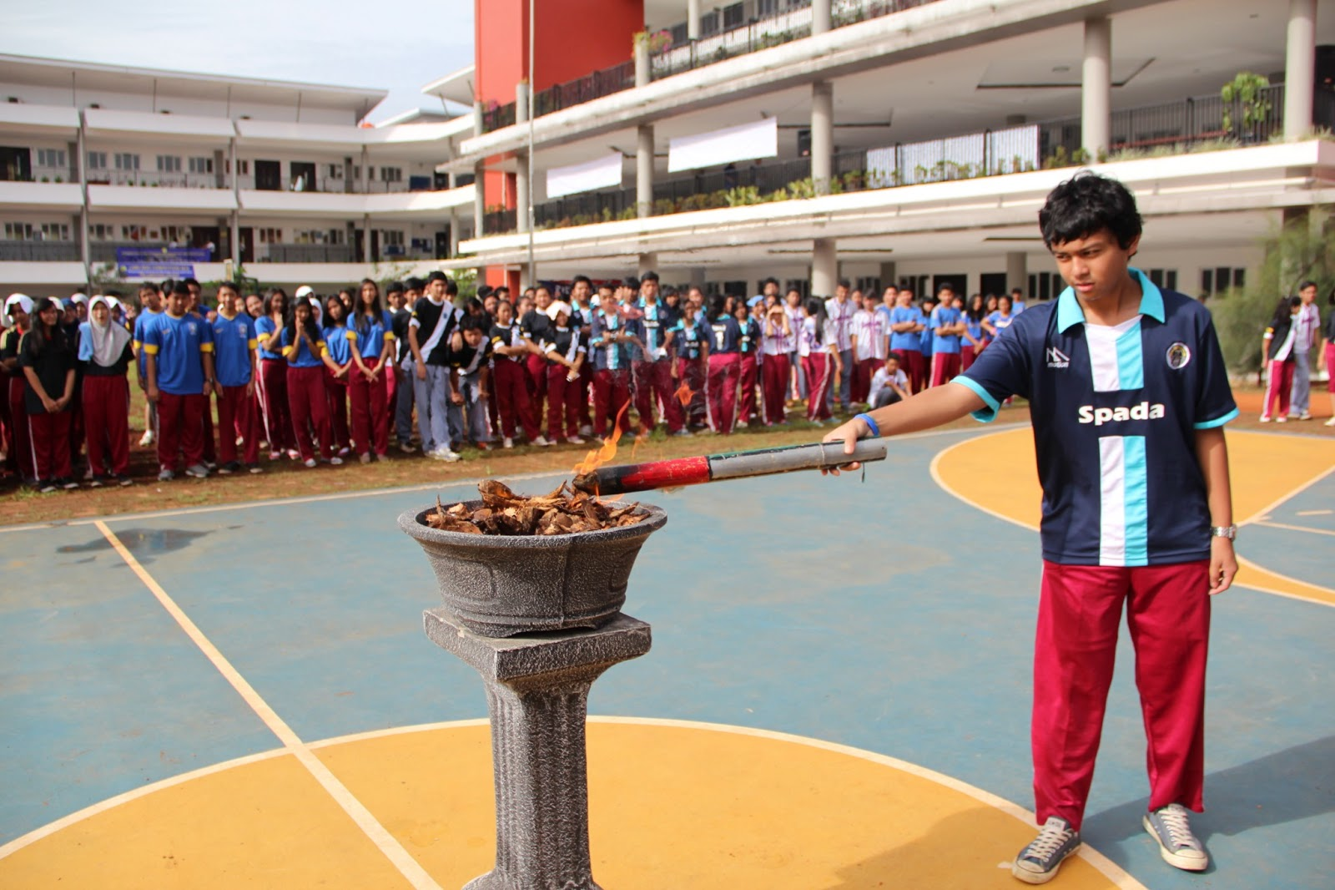

The Opening of Labsaga
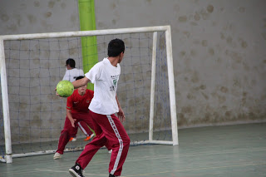
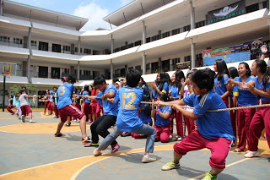
Handball
Tug of War

By: Elke Cynthia (Student)
VOLUNTEER WORK
Hello there! Yea indeed, Labschool Cibubur has participated in many kinds of volunteer works. These are the lists of volunteer works that Labschool Cibubur Students have participated in:
- Scholasticare
- Cyhere
- Flood Relief Center
- Qurban & Ied Al Fitr

Just like the motto of our school; 'faith, knowledge, benefaction', volunteer work for us are like benefaction. As a good citizen, we have the knowledge and faith to give a benefaction for the ones who needs help.
SCHOLASTICARE
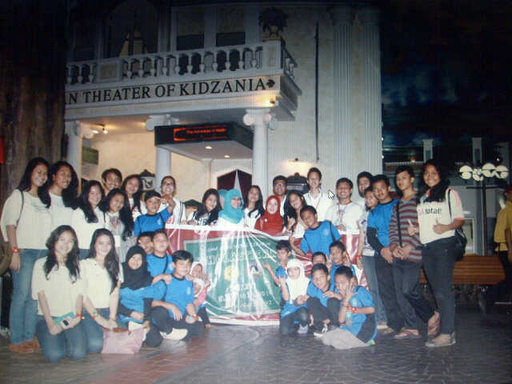
Scholasticare is a volunteer work from the student council where they invite foster children to go to an indoor amusement park located in the center of Jakarta. The students of Labscool Cibubur want those foster children to have the experience of their life. In that indoor amusement park is loaded by every career jobs, try can try every single of the career jobs practicals. Intends them (fosters) to lead to a job where he/she wants for the future, and of course, for fun.
CYHERE
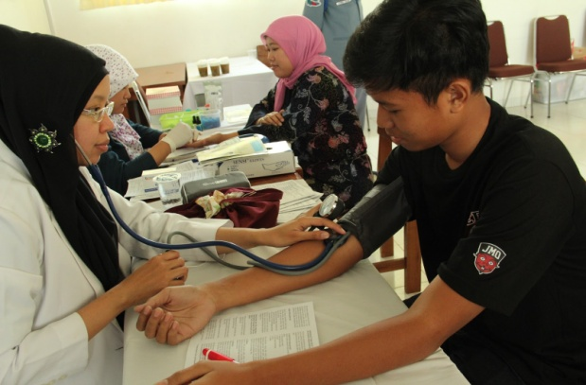
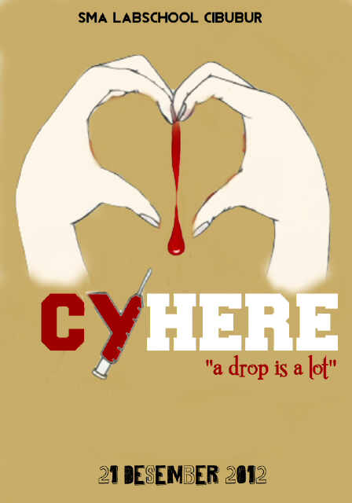

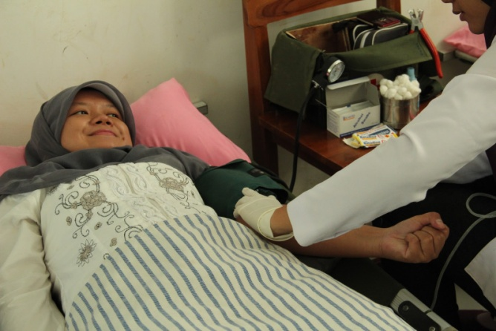

Blood donor activities
Cyhere is a yearly volunteer work from the students of Labscool Cibubur. Cyhere is an activity of blood donors that is usually held on the parent teacher conference. Students held it during the parent teacher conference is due to the amount of adults that are coming to the school who could volunteer as tribute, it could be a driver/parents/students 17+ who can volunteer to donor their blood. The blood that has been transferred are going to be given to the needy. We believe that every drop of blood is worth it and because sharing means caring.

FLOOD RELIEF CENTER
Flood Relief Center is a volunteer work from students where they help victims of the flood incident. Students bring food supply to them by barging in through the 1.5-3 meters high of water flood on a rubber boat. Not only giving food supply, students of Labscool Cibubur raised money and gave them our wearable clothes. The volunteers said that it was an honor to help them, they learnt how to appreciate things more at home more as they have before that they know that the possibility of flood stricken is minim.

QURBAN
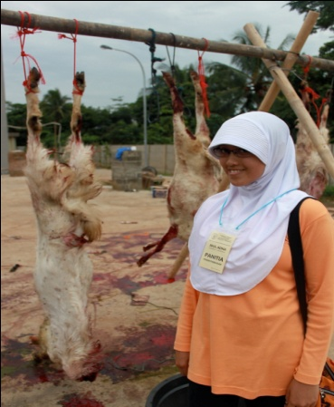
Qurban is a religious volunteer work where Muslims citizen donate sheep/cows to give the beef to the needy. Students also held a cheap bazaar where food supply and clothes are sold by big amount with little spring out of money. In Ied Al Fitr school usually invite an orphanage to Labscool Cibubur and spend Iftar with us. We share things with them on everything they want to know and make them as comfortable as they can, make them feel like home. At the end of the volunteer work, students donate money in an envelope for the orphans.
A volunteer work that is necessary for my city and the way to organize it is to make a mutual aid around the city and neighborhood. Mutual aid is a volunteer work that needs an amount of citizen to work together to make an attractive euphoria in the city and a few hours of their day once a month. Kinds of mutual aids are like sweeping the rubbish and putting it in the right place, moan the long grasses, plant trees and flowers. A win-win resolution of the volunteer work on organizing the city and an efficient way to make local citizens closer together by gathering once a month changing the city's environment to a good vibe. The participants of this beneficial volunteer work could be anyone and everyone around the neighborhood block/school/city.

By: Zhalsa Dianora Ayu Limagara (Student)
Everyday Heroes and Their Influence to the City
There are two people whom actually considered as a hero, first is a cartoon character, and second is a real person in our government. The first person will be Batman or known as Bruce Wayne, a billionaire who wish to protect the poor, second it is Jakarta's governor Mr.Jokowi. Jakarta is Indonesia's Capital city.
They help their cities at the difficult time with their own special way, first is Bruce Wayne, he helps Gotham city which is full of fugitive by being batman as a symbol of resistance against crime, murder and persecution, it's kind a cool when he tries to catch bad guys using his fancy gadget made by himself. The second is Mr.Jokowi. People know him as one of the best governor in the world because he is very kind to the poor, to students, you can even enter a local hospital without worrying your bills because he made policy to give no charge to all Jakarta's citizen for medication, it's a free medication, so it really helps the city through difficult time.
They influence peoples live in many way. Me myself in my opinion, batman influence my life by teaching me not to be greedy for all assets we have, it's the kindest to share some of our stuffs to the people who needed the most more than we do, and Mr.Jokowi influences many people because he is so humble, he willing to walk through the crowds without bodyguards and protocols just to talk face to face with the people of Jakarta, hearing their thoughts let them speak, the willingness to change is how he influence people.
We can follow them by being nice to people, not being greedy, humble and trying to give our best in every single we work we do. Sure it will gives us a lot of benefits, I bet we could make friends easier and helps us to socialize anywhere.
Fears is a big word, but those small actions can make us realize that we have powers to erase those fear of us,batman saves lives, Mr.Jokowi tries to save Jakarta, seeing them every day in tv, newspaper, their actions in daily life, the impact that they gave me, it helps me to get over my fear in life.

By: M. Fajar Aulia Ansela Akbar (Student)

