THE CASTLE ON »KOZLOV ROB«
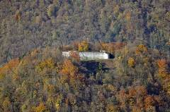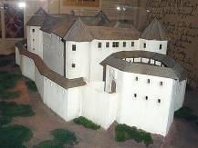

The castle as it was in the past The ruins of the castle today

The castle is situated on the top of a small hill in the middle of the Tolmin basin in south-western Slovenia. The local people also call it the Castle on Kozlov Rob above Tolmin (Grad na Kozlovem Robu nad Tolminom). Actually it is a fortress ruin even though it has been partly restored, but that is not the reason to minimise its importance. Since the 12th century it has had a very important role in the culture of Tolmin region. In the Middle Ages it was a symbol of feudalism and the power of landlords but also a sign of the Tolmin rebellion, that took place in 1713. During the 1st world war, when the Soča front ran through this area, it represented the crucial strategic point for the defence of the Tolmin Bridgehead.
The castle was mentioned for the first time in 1188. The east and north towers appear to have formed the original core of the fortress. Another two hexagonal towers were added later. The north tower had an extensive basement for the storage of supplies, which along with two wells and rainwater cisterns served to withstand sieges.
The castle was held in fief by a long series of masters: the Patriarch of Aquileia, the Counts of Gorizia, the city of Cividale del Friuli, the Venetian Republic, and finally the Habsburg family. It appears to have functioned as a dedicated fortress rather than a residence, and had no permanent civilian population in peacetime. It was used as a military post, therefore it also housed a prison. The structure was severely damaged in the earthquakes of 1348 and 1511, but was repaired each time. It was finally abandoned in 1651 by its last owners, the Coronnini family. They moved into a new manor in Tolmin centre. Nowadays the Tolmin Musem offers its exhibitions in the same facility. The castle though remained sufficiently intact by 1713 to play a role in the great peasant revolt of that year.
In recent years, the ruins of the castle have been gradually restored. So far, parts of the castle wall and the Sv. Martin chapel have been reconstructed.
A historical and natural science education trail leads across the southern slopes of Kozlov rob. At fourteen points along the trail, plaques describe the typical vegetation, the composition of the forest soil and stone, and various historical events.
In my opinion, the castle is a pleasant sight to see. It offers a combination of a beautiful natural environment, recreation and also a magnificent view from the top, that pays off the 20 minutes of walking towards the top. Along the way you can also find information about flora and fauna and also about the castle itself. I visit the castle on Kozlov rob very often, since I live just below the hill. To me it is an almost every-day recreation and it offers me relaxation after my daily activities at school. The path is also nicely kept and I love the path around the hill, which offers some sort of a manual of exercises which you can do during a walk.
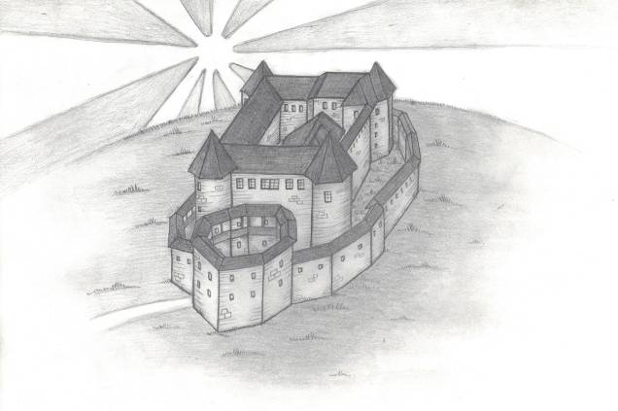

THE LEGEND OF THE COUNT THAT WAS EATEN BY THE LICE
In the middle of 16th century in Tolmin, a count, whose name was forgotten, ruled with a heavy hand. He was so cruel, that he was simply evil and very rich. He decided to build a castle on the top of a small hill in Tolmin, called Kozlov Rob. His inferiors were residents of Tolmin, poor farmers, who had to work for him. They were made to build a castle for the count, where he would live.
When the castle was built, he settled there. He was drinking quality wine, going hunting in the woods, and doing nothing but complaining and swearing all the time. After a while, he lost all his friends, no woman cared for him and he even banished all of his servants. He became very lonely, was moody all the time and he even stopped washing himself. People were saying that when he went through a village, the whole village smelled bad.
One day, when he was walking in the woods, sad and lonely, something bit him on the neck. He started swearing at ants and was scratching himself all the way back home. Day by day, there were more and more bites and stings on his body. The count became even moodier and eventually people found out that he got lice. After a while there were so many lice on the count that they were falling of him and he was leaving them everywhere he went.
When he realised that he can’t get rid of them, he called a few inferiors and ordered them to bring him a big glass cage in a shape of a bell. The count had been put in the water and washed properly. The water was completely black when they were done, because of all the dirt. But the lice didn’t want to leave the count’s body just like that. So the count was put under a big glass cage, but that didn’t do any harm to the lice. They were still happily crawling all over the count’s body.
The next day, when people came to look what happened to the count, they found nothing under the glass cage. The lice ate everything, even his clothes. After that the lice ran away and nobody has even seen them.
