1. Does your city face environmental issues?
- Novouralsk citizens do face environmental problems regularly. (Novouralsk)
- In New Delhi, we do face environmental problems everyday in our lives. (New Delhi, India)
- Yes. Very often it is air pollution, forest fires, water pollution and other. (Moscow, Russia)
- The thing is that Gomel region faces the consequences after Chernobyl catastrophe. This issue is severe as the air and the ground were contaminated by harmful elements that got into the air after the explosion at the atomic power station in Chernobyl. (Gomel, Belarus)

2. What are the environmental issues that your city faces?
- Our city Moscow faced with such environmental problems as water pollution, air pollution, soil pollution and some other pollution. These problems are very dangerous and they can lead to ecology degradation and human health degradation. Atmosphere of the city polluted by the plants’ waste, cars and dumps and others. There was a great fire around Moscow this summer. This led to the deterioration of ecological situation in the city. There are signs of global warming in Moscow. (Moscow, Russia)
- Our town faces such environmental problems as rubbish, industrial waste, air pollution, forest fires (in summer) and water pollution. (Novouralsk)
- These environmental problems are the different kinds of pollution, smog, electronic and industrial waste disposal problems faced daily by the city. (New Delhi, India) 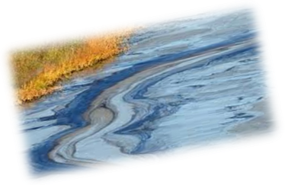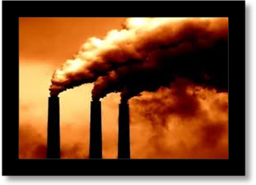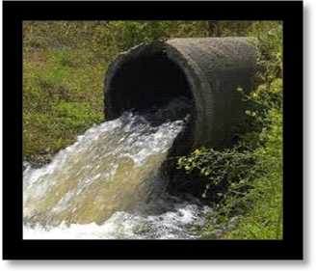
- Gomel and Gomel region face the consequences after Chernobyl catastrophe.

The aftermath will last long as some chemical elements that got into the ground with the acid rain need a great period of decay. So, it is not recommended to eat mushrooms and berries picked up in forests.
Milk from village cows is also considered dangerous as they eat grass that grows on the contaminated ground.
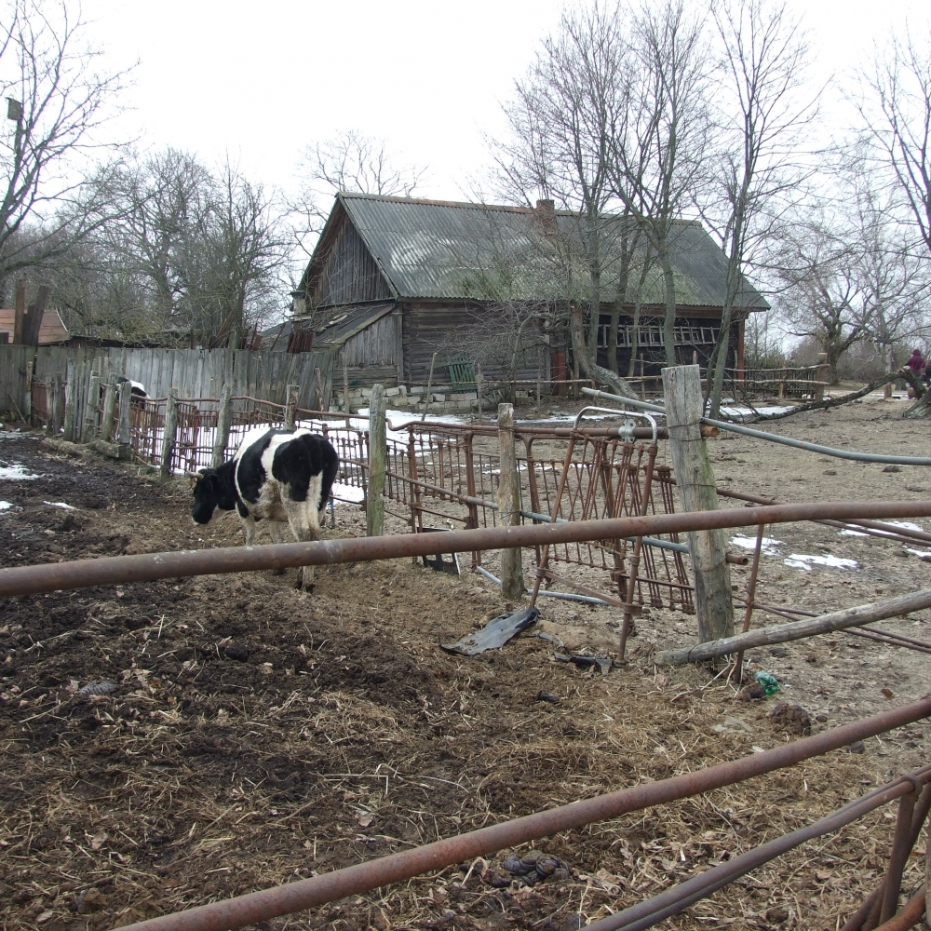
But the greatest issue
connected with Chernobyl catastrophe is
numerous health problems.
Cases with cancer have increased,
more people have heart problems,
and more babies are born with different disorders

3. How severe are the issues?
- Ecological problems in Moscow can be called serious. They can be solved at the state level. (Moscow, Russia)
- Ecological problems in Novouralsk can be called serious. The environmental issues have a high level of severity. They are the main causes of diseases and other discomforts that are faced every day. (Novouralsk)
- These environmental issues have a high level of severity due to which many these problems have become life threatening. They are the main causes of diseases and other discomforts that faced everyday. (New Delhi, India)
4. What are the causes of the issues?
- Cars, factories, dumps, chemical means. Their use is the reasons. Problems – the relation of people to environment. (Moscow, Russia)
- A few causes for such environmental issues are lack of awareness amongst people, lack of education in the rural areas of India and lack sensitivity towards the nature and environmental. The rapid growth of population leading to industrialization and urbanization has also led to such environmental issues. (New Delhi, India)
- The causes of the issues are lack of awareness amongst people about environmentalsituationinthe town, lack of education in this sphere, cars, factories, dumps, chemical means. But the main reason is the scornful relation of some people to the environment. (Novouralsk)
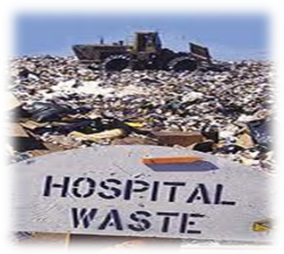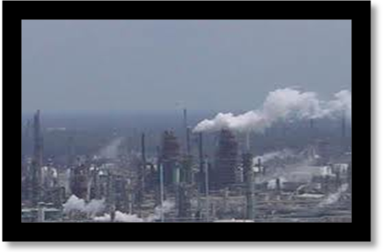
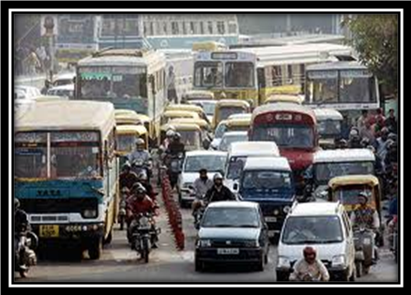

5. What are the consequences of the issues?
- Consequences are very sad. There are destruction, air pollution and environment. We kill ourselves and we do not want to think about our future. (Moscow, Russia)
- Such environmental issues have led to global warming and diseases such as respiratory disorder, cancer, allergies, heart problems, etc, depletion of natural resources, the loss of biodiversity. It has made the environment of the city unhealthy and unfit for human survival. (New Delhi, India)
- The consequences of the issues are considerable. Nowadays many people aren’t conscious about their future. They slowly kill themselves and their relatives by simply throwinggarbageonthe streets. Many local environmental issues have led to global ones.(Novouralsk)
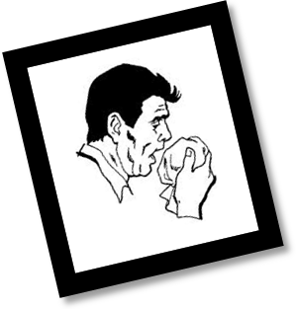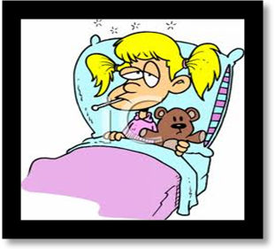
- What are the consequences of Chernobyl catastrophe?(Gomel)
The aftermath will last long as some chemical elements that got into the ground with the acid rain need a great period of decay. So, it is not recommended to eat mushrooms and berries from forests. Milk from village cows is also considered dangerous as they eat grass that grows on the contaminated ground.
But the greatest issue connected with Chernobyl catastrophe is numerous health problems. Cases with cancer have increased, more people have heart problems, and more babies are born with different disorders. One of the solutions to health problems is to go regularly to the seaside to breathe the sea air full of iodine, and also to take necessary vitamins.

6. Suggest ways and means to solve the environmental issues.
- We can clear our water, recycling trash or remove it. We can take more care about animals, protect them or build reserves for them. We must limit factories in their production because it pollutes our nature and habitat. (Moscow, Russia)
- A few ways to decrease the intensity of such problems are by creating awareness among the people to take care of the environment, and also by motivating and encouraging people to participate in environment awareness programmes. Proper education must be provided in the rural areas to educate people about the threats faced by the planet. There are also a many people who dedicate their life doing their bit to save the planet from such problems. Such people must be rewarded for their dedication and hard work. Also there are laws for the protection of environment. But there are also people who break such laws. Therefore we require that the laws must be strict as well as empowerment to those who are implementing it, by means of imposing fine or arrest of the offenders. (New Delhi, India)
- There are different ways to solve the environmental issues. At first we should change our attitude towards environment. We shouldappreciatethe nature of our world. Then we can start clearing water, recycling garbage or at least somehow processing it. We can take care of homeless and wild animals and birds. Due to factories’ pollution our nature is in danger and because of it we also must limit factories in their production.
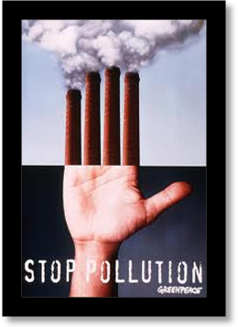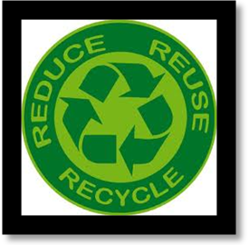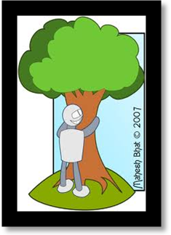
- Older people often compare young people`s health in the past and at present, and they say that now young people are weaker physically. The consequences after Chernobyl catastrophe can be neither denied nor avoided, we have to live with them. But young people CAN and NEED take care of their health to leave after them a healthy generation.

Also, within their community young people can popularize environmental protection in the form of planting trees, cleaning the surrounding area and holding different activities with the purpose of drawing attention to the possible consequences of man`s activity and preventing another catastrophes like the Chernobyl one. (Gomel)

7. Write a short article (in about 100 words) what is the role of the youth in solving environmental issues.
- The youth plays a very significant role in the environmental issues. Many young children are vulnerable to environmental risks. Moreover, young people will have to live longer with the consequences of current environmental decisions than will their elders. Future generations will also be affected by these decisions and the extent to which they have addressed concerns such as the depletion of resources, the loss of biodiversity, and long-lived radioactive wastes. By engaging themselves in politics, the youth can bring out policies for the betterment of the environment and also make their presence felt in politics. Young people are often the target of commercials, not just because of any disposable income they may possess, but because corporations aim at establishing high-consumption patterns that will last a lifetime. This kind of targeted advertising can be resisted, especially if its consequence is to draw youth into a lifestyle characterized by excessive consumption. Environmental education is one way of equipping young people with the necessary cognitive skills to recognize and withstand the pressures of advertising. Another solution is that youth must take lead in promoting active participation in environmental awareness programmes. Apart from the political action, youth can also contribute their time in environmental projects. Their active participation can lead to a lot of difference. Also if environmental education is provided to students in all schools as a subject, the students will then realise the importance of maintaining the balance of environment. An important but generally overlooked aspect of environmental education is environmental political education, which stresses how changes can be achieved via political activism directed at Governments, international organizations, and even corporations.Therefore youth definitely has a very important role to play in achieving the goal of eradicating the threats faced by our environment. Youth has to survive the consequences of environmental issues but with their active participation and determination, the youth surely has the power to face and diminish all the environmental problems faced by the world. (New Delhi, India)
- We believe that it is up to us, the young generation, to take on the responsibility of dealing with the current issues concerning the environment that exist today, and do our best to prevent even more pollution and other negative effects on the nature and the environment.This isn’t because earlier generations are less responsible or less serious, they simply weren’t aware of the existant issues, and have never thought of the effects that various production facilities and people’s behaviour have on the environment. We, however, are aware of this, and should take an active role in dealing with such issues. Afterall, we will be the ones living in this world, and it is up to us to make it cleaner and better.There already is a number of organizations, started by the youth, that are dealing with litter and making a difference in people’s behaviour and attitude, that are developing more severe environmental standards for production facilities and making sure that companies follow those standards. (Novouralsk)
- In our city everybody works hard to protect and keep clean the environment. It is not an easy job but we do it for ourselves, to make it a better place to live in and that’s a strong motivation. I myself did not care so much about the environment until I got accepted into my highschool Gr. Sc. C.A.Rosetti, where I saw a lot of kids my age that were really concerned about the littering that was going on in the place that they studied and wanted so badly to change that . In time more students gave a hand , myself included and tried to clean our highschool.
After that when we saw what we achieved and how we succeeded in changing the people in our institution, we set out a new goal.
We wanted to change the city and the way it looks. So in association with other institutions we started to clean the city up . Many people really liked our point of view and helped us with anything they could, of course many tought it was a waste of time and that the litter will be back the next day , they were wrong. Our message got through to the people and they started to think more about not littering the city, they started taking out their trash , plant trees and flowers, it was really great. Now I live in a nice and clean city thank’s to my highschool and the people of Constanta.
Student:Craciun Eduard Ionut
(Constanta,Romania)
To make my city a cleaner and greener city I have shared flyers with rules that have to do every citizen for the city, to be more beautiful ,and so we informed the citizens of the city.
To have a greener city we have planted trees in parks and around playgrounds for children, after the classes ,with my colleagues and other volunteers that helped us.
What can we do to be our city more beautiful? I have decided to save the city by making more environmental information campaigns, to plant trees and make the citizens understand that WE are our environment.

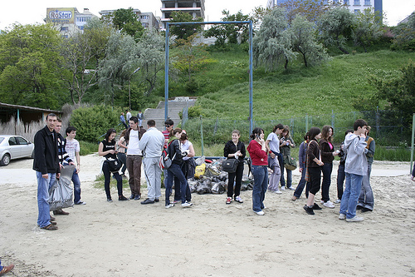

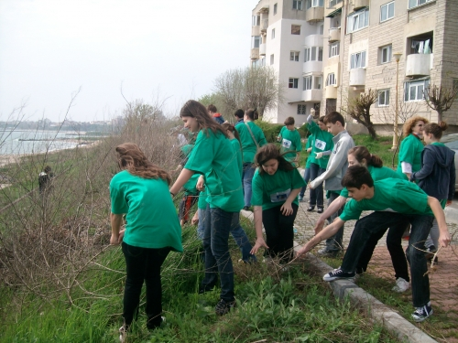
Student:Olteanu Bianca ,Constanta,Romania
Co-ordinating teacher:Cornelia Nicolae

Love and respect nature!

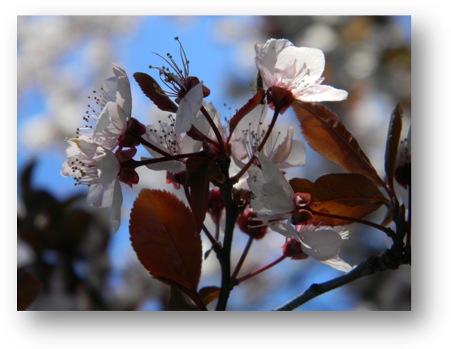
The concern towards the health of the environment is a modern collective attitude that has its roots in the conscience of the fact that you can`t talk about an individual`s or a group`s health disregarding the environment and the existence of ballanced relations with the environmental factors.
Each of us has his or her own stock of knowledge and behaviour that enriches as we grow and receive education. In order not to turn them into flaws, our inborn qualities need to be headed towards what each of us can do. We mustn`t wait for the global or local problems to solve by themselves, without our contribution or without our active involvement in solving these problems.
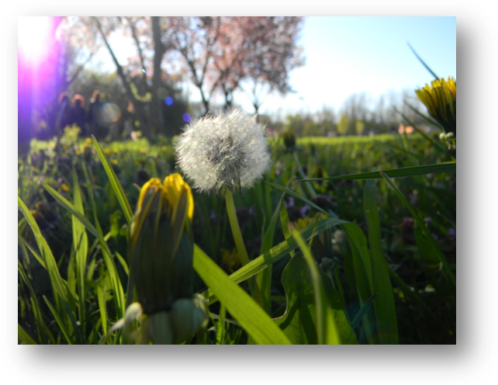
The environment is an ensemble of factors that interact all the time and interfere with human activities which, most of the times, are not eco-friendly.
Water represents the source of life for all the organisms in all the life environments.
Without water there`s no life, that is why its pollution threatens all life forms on earth.
Through this project we want to signal the negative effects of water streams pollution.
These effects have repercussions on the health of the entire community. Children, as part of the community, should protect the green spaces, they should stand against and try to stop the water streams pollution. A clean, drinkable water shows a clean and healthy environment, as well as a healthy community.

Who has planted a tree has not gone through life unnecessarily!
"A good tree and a man is known by its fruit after the fact"

Do not cut, shred or remove the roots of trees, seedlings or sprouts!
Do not leave waste in the woods, but throw them in special places!
Do not damage plants!
Do not catch and injured animals of the forest!
Do not burn tree bark with the knife!
Do not destroy the nests of forest animals!
Do not fire in the forest or near forest!
Help the Earth!
Lupu Florentina
Clasa a XIIa B
Grup Scolar C.A.Rosetti Constanta,Romania
Co-ordinating teacher:Cornelia Nicolae

8. Finally, compare and contrast the environment as it was a few years ago,as it is now and as it maybe a few years hence.(Talk to your grandparents,parents,teachers to get your answers)
- Pollution was less noticeable 10 years ago, because world’s progress was less developed and we have less cars and factories. For example, we had a little road near our school with a few cars but now it is a huge road with many cars and, certainly, it pollutes our air around school and our habitat. The government of our district built 5 big business-centers on our natural reserve’s territory and it was a great problem for habitat. It pollutes our district very much because the number of cars increases very much. (Moscow, Russia)
- Environment of India in the past had been much greener and there was abundance of natural resources. Moreover, people had a greater awareness about how to take care of nature. There were definitely more trees around and people knew the importance of trees. People were more close to nature as there was less of industrialisation compared to the present where we see many cities developing and becoming metropolitan cities. There were les vehicles on the road so less petroleum and diesel was used resulting in less pollution. People were depended on forests only for their need and not for their greed. As the population was less, the demands and needs of people were less. Therefore, our past was much greener and eco friendly.On the contrary, the present is on the verge of a disaster. We are facing environmental problems like pollution, population increase, and many others like waste disposal problems. Vehicles have increased at a very alarming rate resulting in more and more pollution. Forests are being destroyed at a very large scale which has left many animals homeless. Many animals and plants are on the verge of extinction. The increase in fossil fuels has resulted in the green house effect which has led to global warming. Pollution in the air has resulted in many respiratory problems and diseases such as cancer, heart diseases and allergies. The pollution of soil has led to the contamination of ground water. All this has led to the depletion of natural resources and loss of biodiversity. Therefore at the present we need to look at the problems faced by earth on the environmental front.But if things continue like this, the natural resources will continue to deplete and animals and plants will become extinct. Due to global warming, large pieces of glaciers will melt and turn into water and the land will gradually submerge. Population will increase at an alarming rate and more and people will be suffering from deadly diseases. These are some of the life threatening consequences of the present. But there is always a hope. If at present we realise how much damage has happened to earth till now and will continue to happen, and also the importance of maintaining an ecological balance in nature, then we might save the earth. The need of the hour is awareness among people and active participation of people especially youth in achieving the goal of saving the earth from the deadly consequences. (New Delhi, India)
- It is obvious that in the few past decades the world’s production has gone up a lot, and since there weren’t any issues with environment before, nothing was done to make that production less polluting r dangerous for humans and wildlife. Therefore, the environment has struggled a lot, and its state has worsened over the years.After humans started realizing the arising issues, the attention to the environment pollution has risen, and consequently the pollution has slowed down, but not yet stopped. This way, at the moment we are polluting the environment less quickly than few years ago, but we are still polluting it.And again, it is up to us to decide what kind of environment our kids will be growing in – either in a more polluted, and maybe destroyed, or in a healthy and clean, like it was when we were kids. If nothing is done right now, our environment will be destroyed quite soon. However, the active position of many individuals and groups, as well as our own participation, give us hope that we will make a change, and help the environment and nature recover to the state it used to be in. (Novouralsk)

