Food for Life 2011
from
Bashkortostan, Belarus, Russia, Ukraine,
Washington State (US)

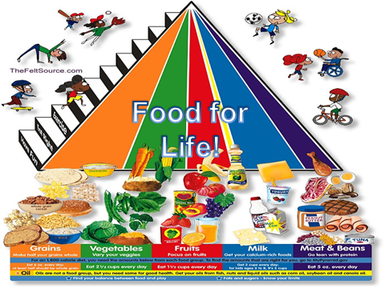

Issues with Food
How do we know which food is good for us?
How do we know which food is not good for us?
Why do we sometimes eat unhealthy food?

"
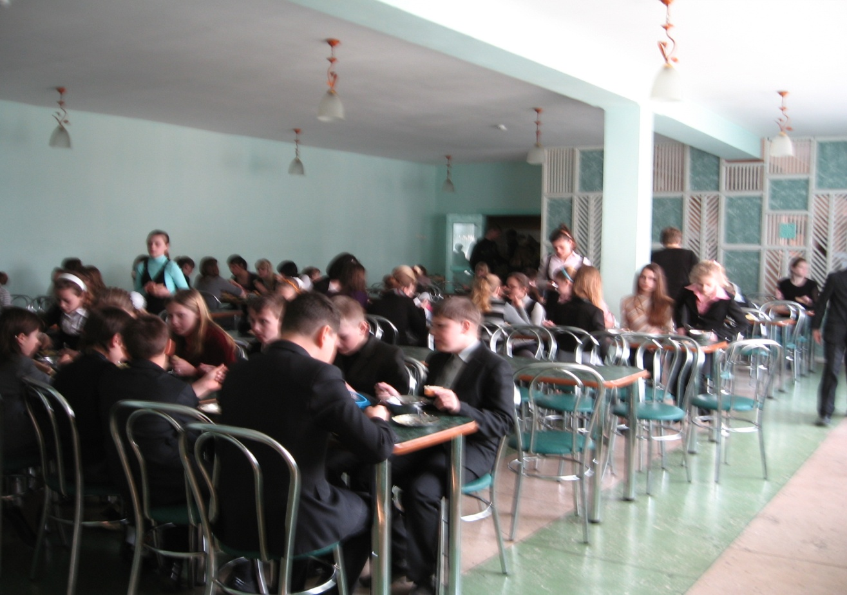

*

You need:
- Onions
- Carrots
- Potatoes
- Tomato ketchup
- Salt
- Pepper
- Spices
- Dill
- Oil
- Meat broth or water

* Pork cut into pieces, fry lightly in butter.
* Add finely chopped onion and carrot. To Fry.
* Add finely chopped tomatoes, fresh or canned in their own juice.
* Add your favorite spices. Extinguish 10 minutes.
* Potatoes cleaned, cut into large cubes. Pour over meat.
* Pour the broth, many, but not to lay the potatoes.
* Salt, sprinkle with dill (can be green onions add).
* Cover, bring to a boil (do not mix!).
* At the slow-fire bake until cooked potatoes. You can to a large fire, will be faster, but so tasty not work.
* For 5 - 10 minutes prior to readiness to mix.
* BON APPETIT !!

And bread goes well with soup anytime!
Ukraine has a wonderful tradition of bread-making.

Borsch is popular in Russia, too, as this recipe from the Rostov region shows.

Another popular hot soup in Russia is Shchi.

And this hearty soup is popular in Starye Dorogi:
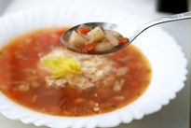

Products of prescription | The Quantity (on prescription, g) | Special comments
Parsley | 5 | to taste
Vegetable oil (sunflower refined, crude) | 75
Black pepper | 2 | to taste
Tomato paste | 75
Carrot | 70
Onion | 60
Salt | 3 | to taste
Potatoes | 300
Beans | 200
Celery (root) | 100
Garlic (Allium sativum) | 4
Bay leaf | 1

What you need:
- ▪ Potatoes
- ▪ Beans
- ▪ Onion
- ▪ Garlic
- ▪ Celery root
- ▪ Carrots
- ▪ Tomato paste 3-4 tbsp.
- ▪ Salt
- ▪ Black pepper
- ▪ Dried or fresh chopped parsley
- ▪ Bay leaf
- ▪ 3-4 st.l. vegetable oil
What to do:
1. The beans to boil in the added some salt boiling water for 40 minutes, then add the chopped potatoes, celery, carrots. Continue to cook for another 30 minutes.
2. Fry the chopped onion and the crushed garlic cloves. Garlic need to fry no more than a few minutes and immediately remove from the frying pan, that he has to give its fragrance oil, and has not had time to start bitter. And bow to continue to fry until golden color.
3. Before removing from the heat, for a few minutes to add the water roasted onions, spices and tomato paste.

Cold soups help to cut the summer heat!
Perhaps some potatoes would be welcome.

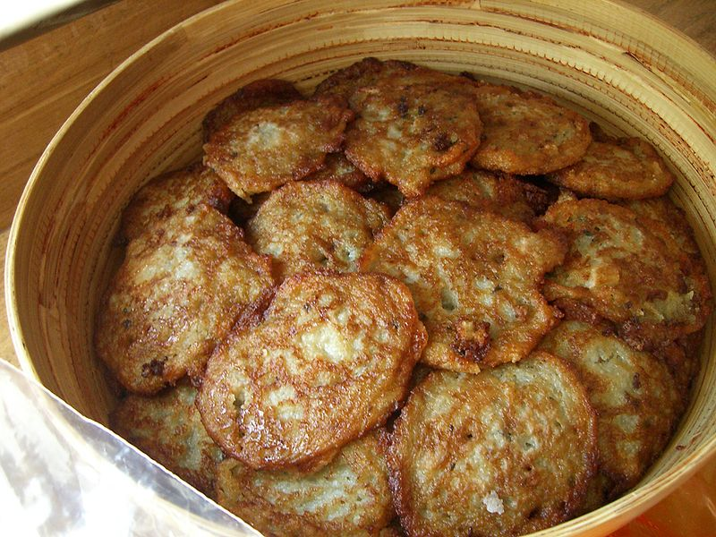,
kolduny (potatoes pancakes with meat), potato pies (babka)
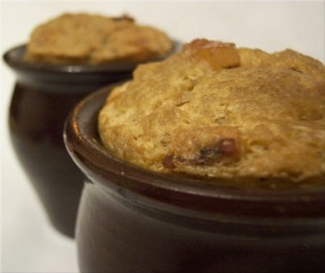

Healthy Foods in Bashkortostan Lead to
Healthy Eating and Lifestyles:
Russian Foods are also popular in the United States, especially:

AND

Perhaps we could treat ourselves to a second dessert!

With honey on top!

Salo is the Pride of Ukraine

Salmon is the Pride of Seattle

With Crumble Pie for Dessert!

Many thanks to all of our friends from
Bashkortostan, Belarus, Russia, Ukraine,
and Washington State (US)
for your wonderful contributions
which are represented in this presentation.

We are very grateful for your enthusiastic participation in the
2011 Learning Circle!

