«The city I live in»
( e-excursion)

- Kirov Teachers’ Training College

- Klepinina Olga

Kirov City, 2010
Vocabulary
- the Saviour- Спаситель
- To be erected and sanctified –возводить и освещать*
- Provisions- съестные припасы
- earthen- and woodenware crockery- глиняная и деревянная посуда-
- flax seed- льняное семя
- linen- холст
- marten, beaver furs- куница, бобр
The Monastery of St. Trifon
- Vyatskii Assumption Trifon Men Monastery.
- The address is the Russian Federation, Kirov region, Kirov, Gorbachev Street,4.
- The date of the foundation is 1580.
- This monastery is one of the ancient monasteries in our region. The founder of the monastery was famous enlightener Trifon. He even had to visit Moscow and our tsar to ask the place and money for the temple. So the place on the old graveyard was given . Trifon continued to work hard for the prosperity of it up to his death in 1612. In 1689 the temple became stony.
- You can see the spring near the temple, the main symbol of our region. The water of this spring gives body and emotional health. A lot of people use it.
- The ensemble of the monastery includes the temple itself, some churches, towels, the chapel, cells.

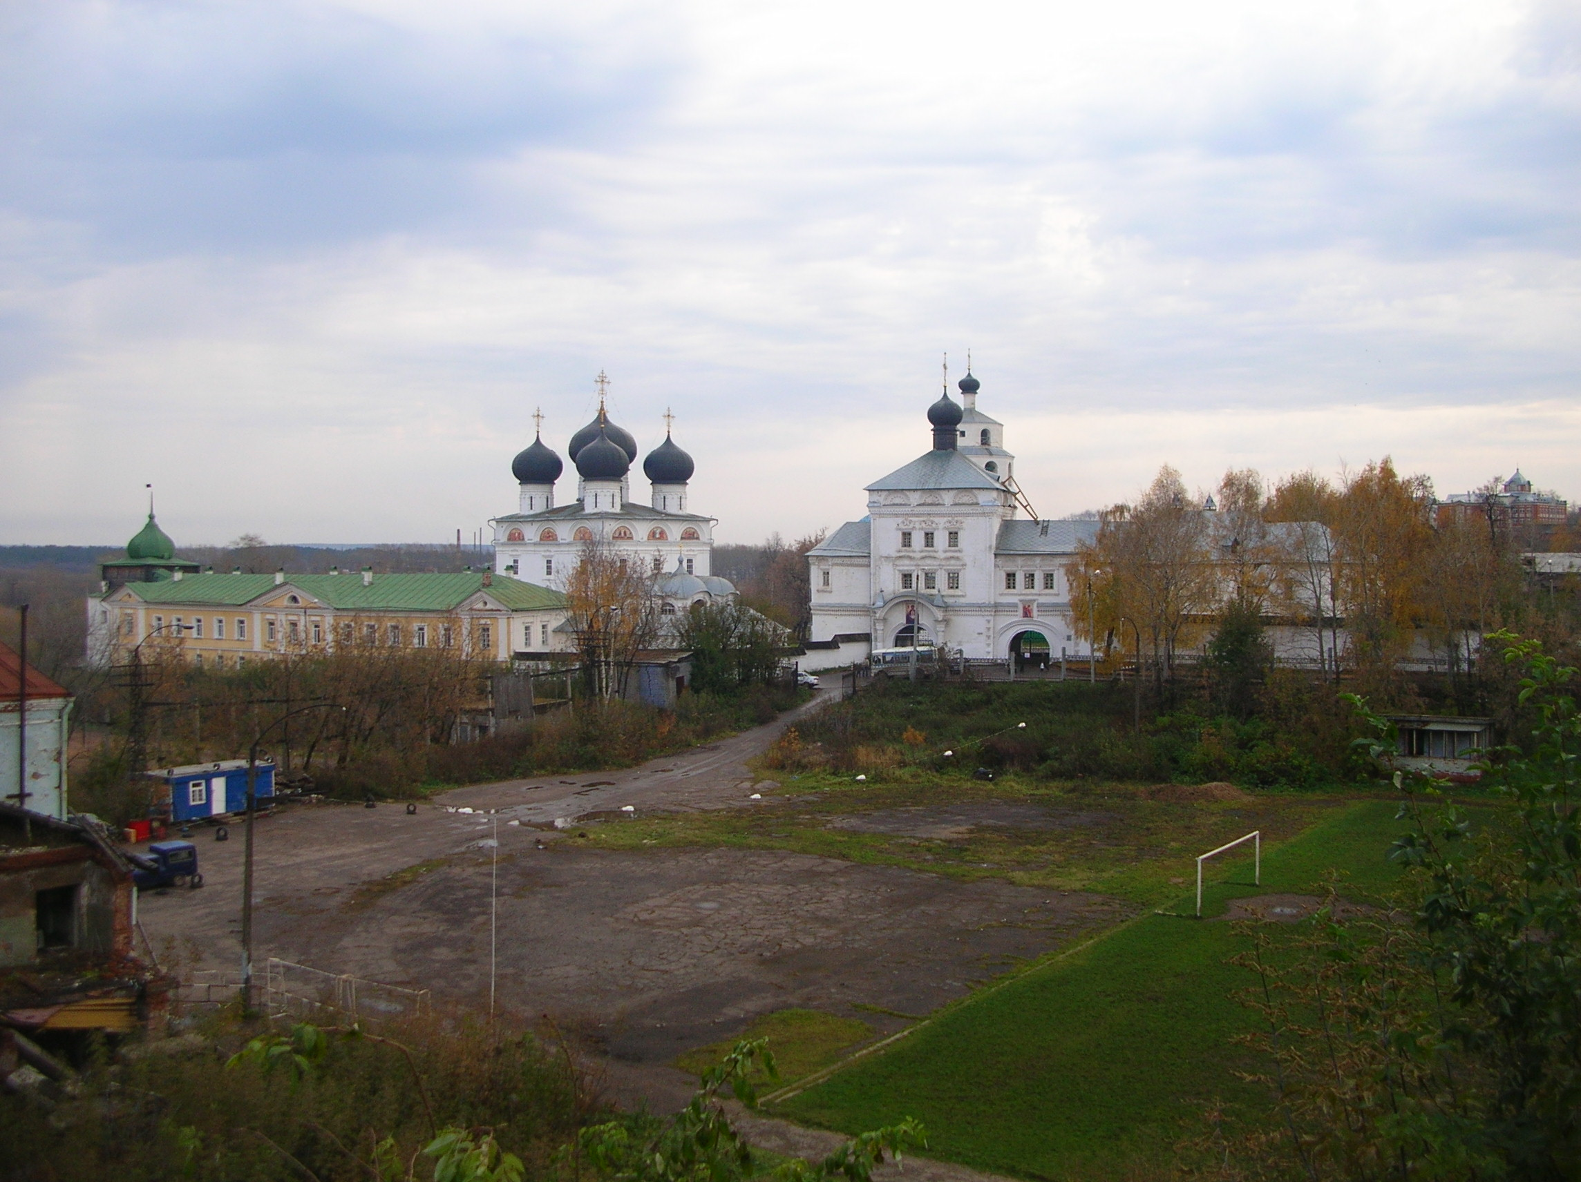

- You’ll love this building painted brown
- In Old Vyatka’s downtown.
- It was an office of V.I.P.s
- Where they wrote their decrees.
- Now it hosts exhibitions
- Of Vyatka’s customs and traditions.
- Each connoisseur of crafts enjoys
- Garments, utensils and clay toys.
- Here you’ll view nice-looking things-
- Fairy birds with wooden wings,
- Fabrics and home-made textiles,
- And old Vyatka’s fashion styles.
- You’ll see convenient Vyatka shirts,
- Blouses, dresses and wide skirts,
- Your charming guide will help you trace
- Secrets and history of lace.
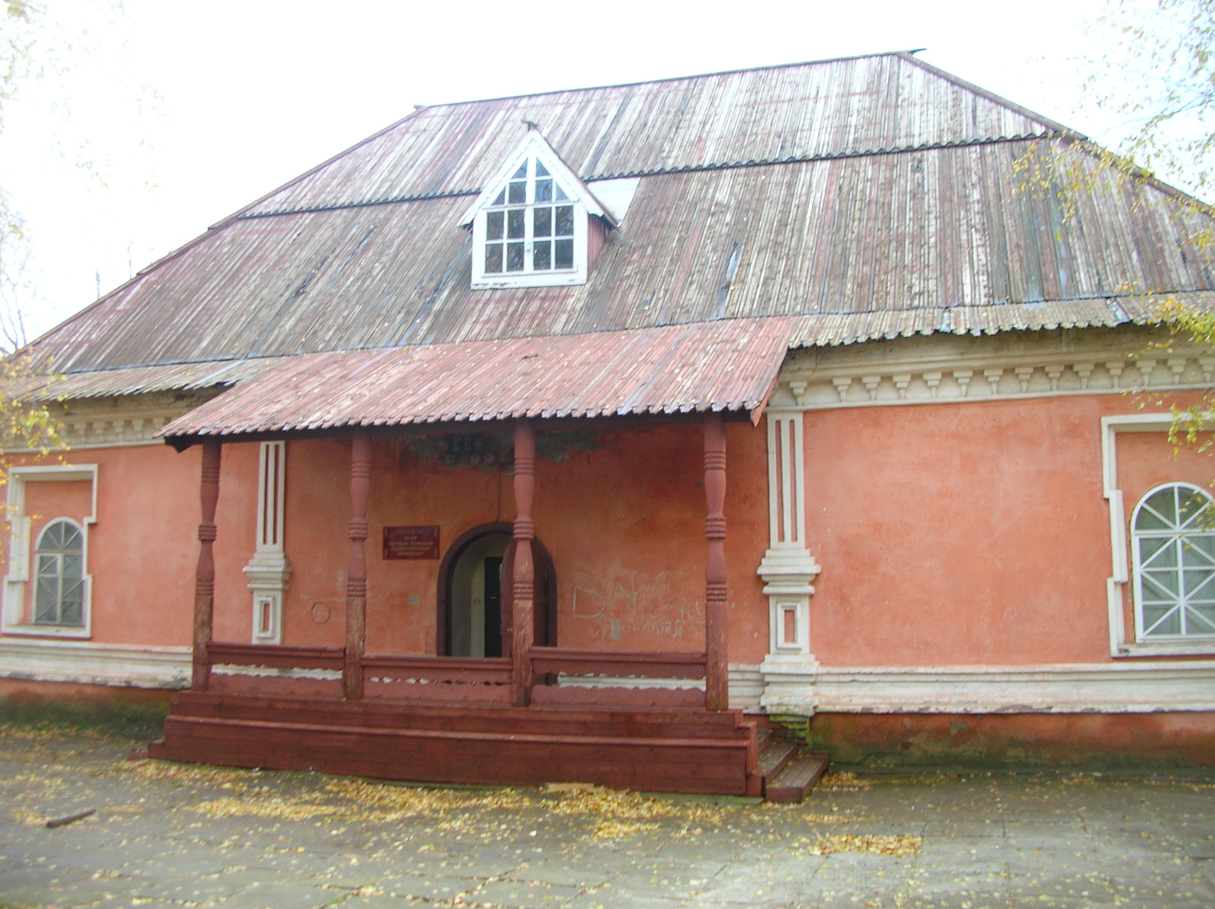

St. Spass Cathedral
The Cathedral of the Saviour
- At the intersection of Bolshevikov and Spasskaya streets there stands the cathedral of St. Spass (the Saviour), which was one of the most beautiful and magnificent buildings of old Vyatka.
- In ancient times on this site there stood a woooden church of St. Trinity. It was burnt down to ashes in one of the great fires. A new church was erected and sanctified in 1693 in honor of Spass-Not-Made-With-Hand. In 1797 a stone edifice was built.
- A legend says , in 17th century on the central façade of the wooden church there hung an ancient icon depicting Spass.


