IEARN LEARNING CIRCLE

SPRING 2008

Participants

CHRISTINE HOCKERT - Hixson, Tennessee, United States
ANNE LAMBERT - San Diego, California, United States
JENNIFER SABAN - Calgary, Alberta, Canada
MORGAN COTTLE - Ashland, Oregon, United States
ECATERINA RUPESAC - Constantza, Romania
RIMMA ZHUKOVA - Miass, Russia
BARRY KRAMER - Quakertown, New Jersey, United States

Project (Idea) status:

Christine Hockert – Amazing Animals and My Dream of Peace
Student work sent from Rimma at Miass, Russia
Student work sent from Canada
Student work from NJ
Student work sent from California

Anne Lambert – Sports Games
Student work sent from TN
Student work sent from Russia
Student work sent from NJ
Student work sent from Canada
Student work sent from Romania

Jennifer Saban – Life in 2025
Student work sent from TN
Student work sent from CA
Student work sent from NJ
Student work sent from Miass, Russia
Student work sent from Romania

Morgan Cottle – not yet-Voice Thread Book Reviews-Top Ten
Morgan’s project proposal seems to have gone astray but her students focused on literacy; what do kids like to read, favorite books, that kind of thing
Student work sent from California
Student work sent from NJ
Student work sent from Canada
Student work sent from TN
Student work sent from Romania
Ecaterina Rupesac – My Favorite Flower
Student work sent from Ann at John Muir School, CA
Student work sent from TN
Student work sent from Canada
Student work sent from NJ
Student work sent from Miass, Russia

Rimma Zhukova – Weather
Student work sent from TN
Student work sent from Canada
Student work sent from California
Student work sent from NJ
Student work sent from Romania

Barry Kramer-Entertainment
Student work sent from TN
Student work sent from Canada
Student work sent via voice thread from Oregon
Student work sent from CA
Student work sent from Miass, Russia
Student work sent from Romania

MCCONNELL ELEMENTARY
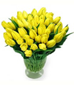

Dandelions are pretty yellow flowers but they are actually weeds with pretty yellow flowers that turn into seed balls. Dandelions are beautiful.
Brionna

My favorite flower is the rose. I like to give it to my mom as a symbol of love.
Olivia

My favorite flowers are roses because they are very pretty. The flowers are in bloom right now. I love roses when they are in bloom. There are many different colors of roses. I also like daisies, lilies, and zinnias.
Baylie

Sunflowers are my favorite flower. I like them because they smell nice. The sunflower reminds me of stars. I protect sunflowers by giving them good soil, water, and a lot of sun. I want to share my flower with my friend Justin.
Cameron

Flowers are sweet
Not good to eat!
I hope you like my poem about flowers. I love them because they smell nice and are very beautiful.
Grace

When I get older I am going to plant a flower garden. When I was six years old I got to help my Dad plant a garden and I planted so many flowers. My favorite flower is a daisy. It is tiny and pretty. I would give flowers to my best friend Katy.
Destiny

My favorite flower is the California poppy. To me it is the most beautiful flower in the world.
Cayden

Flowers need water, good soil, and a lot of sun. My favorite flowers are roses, daisies, lilies, and zinnias. Did you know that bees like flowers? Bees help flowers pollinate. Flowers are in different colors and are very pretty. I love to give flowers to my mom and dad.
McKenzie

JOHN MUIR SCHOOL
SAN DIEGO, CALIFORNIA, USA

FLOWERS, BY JOHN MUIR SCHOOL, GRADES 1-4

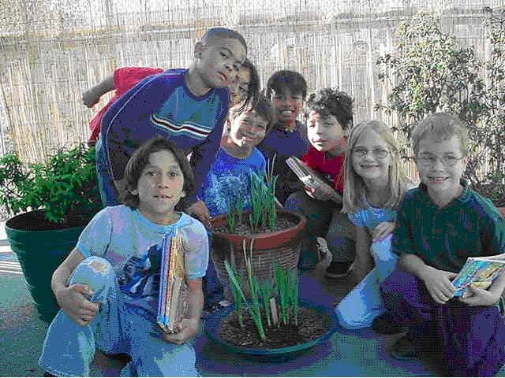
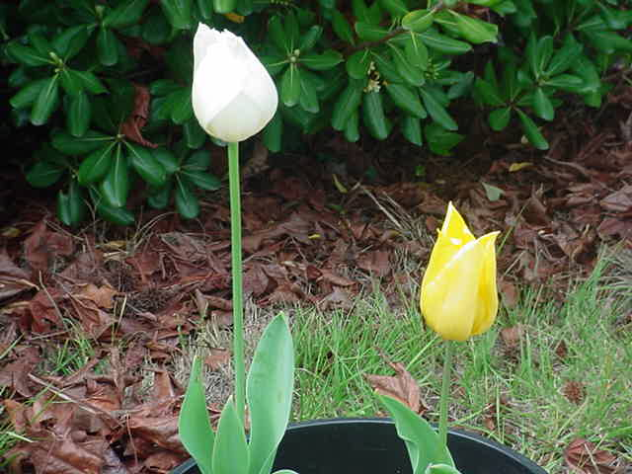

These first two photos are from our IEARN Tulip and Daffodil project in 2006. We really only grew two tulips but a few more daffodils.

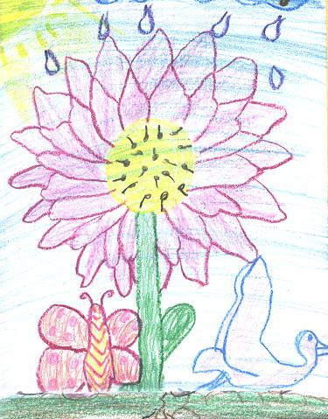

Our favorite flowers are roses, daffodils, purple flowers, roses, dandelions, sunflowers, violets, and barberra. Some of us like all of them. We like them because they are pretty. We give flowers to moms, teachers, friends, poor people, and dads. We offer flowers to people because it shows gratitude and appreciation to people, and eventually we will get something back. To protect our flowers, we put some poison around it so no insect could bite it, we put new dirt by it, we water it, and we never let anyone pull it out of the ground. Grades 1- 2

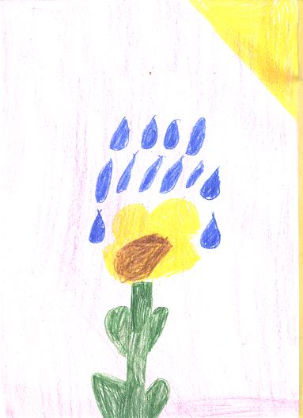
If I talked to a flower, I would say,
"Do you want some water?"
"I'll protect you."
"You're my best friend."
"Would you like some seeds?"
Grades 1- 2

I like roses because they are pretty & come in lots of colors. I don’t give flowers to people. A rose comes in lots of colors like green, red, white, pink, purple and yellow.

I go out every day into my garden and spray bug killer on them to protect them. I would say to them, “ How are you rose? I hope you think that I take care of you well.”

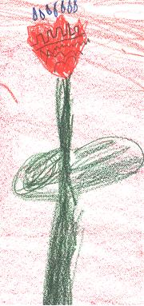
My favorite flower is the rose. It comes in many different colors, mostly white and red. It is beautiful. I don't give flowers to people, but they symbolize love and beauty. I water, plant, and don't pick a lot of them.

My favorite flower is a tulip. It is blue with ticklish hair on the stem. I put tulips in sun light and give them lots of carbon dioxide! I like this flower because it is very beautiful. To make someone happy, I give them flowers. They mean L.O.V.E.

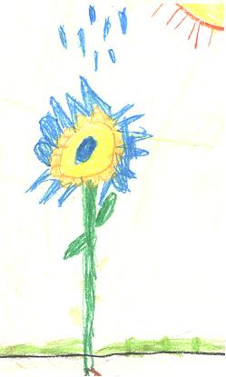

My favorite flower is a daisy!!! I like this flower because it's pretty. I would give my mom a daisy, I don't think it represents anything.

Daisy is my name! I would take good care of it.

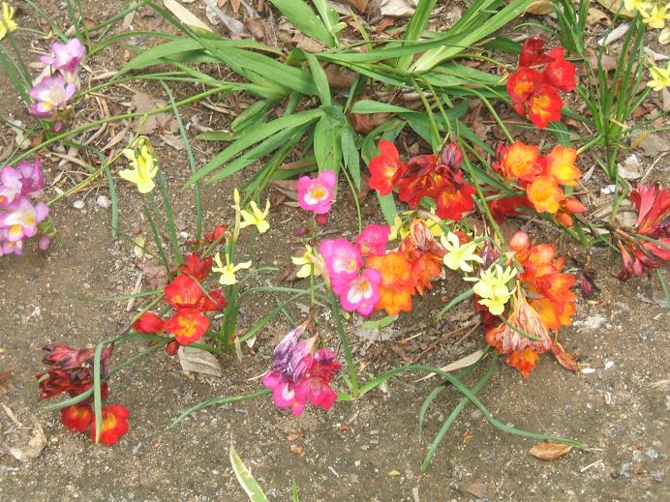 Freesias at our school
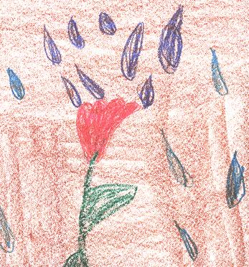
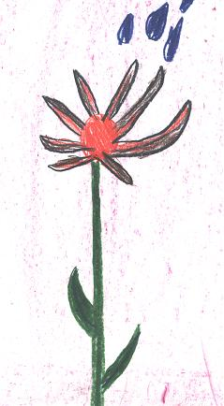
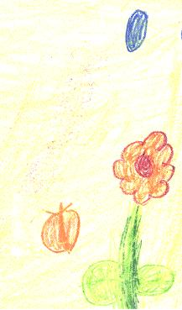
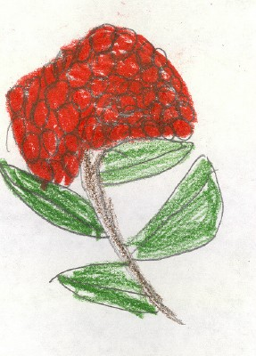 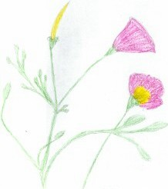 California Poppy

