Travel Guide
to
Lynnwood,
Washington,
USA

Cascade
Mountains
By
Amy
Neha
Dar
Connor

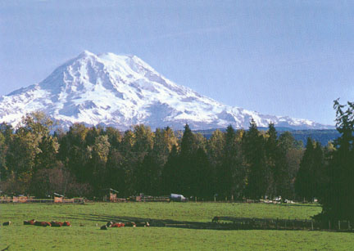

Mount Rainier is very big and it is 14,410 feet tall and 4,392 meters. The Cascade Mountains have vacation houses, Starbucks, diners, restaurants, and bars. There are parks and Camps. You can go camping at camps, play at the parks, and you can also go skiing on the mountains. In the cascades there is a Longmire Museum, visitor Centers, a fast food restaurants, and Hotels and Inns. Paradise Inn is closed for renovations and will reopen on May 2008. Mount Rainer I the tallest volcano in Continental United STATES OF AMERICA. Also in the cascades, there are some gas stations in case you run out of gas for your car. There are lots of cities such as Leavenworth, and Darrington. There are landforms such as Mountains and Volcanoes.

The biggest bodies of water we have in the Cascades are Lake Chelan and Lake Wenatchee, but there are many smaller lakes.

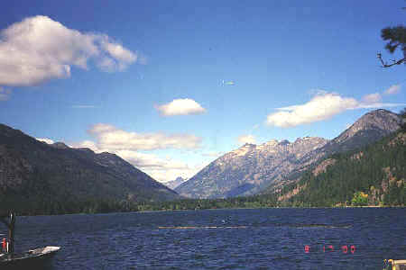  Lake Chelan in the summer | 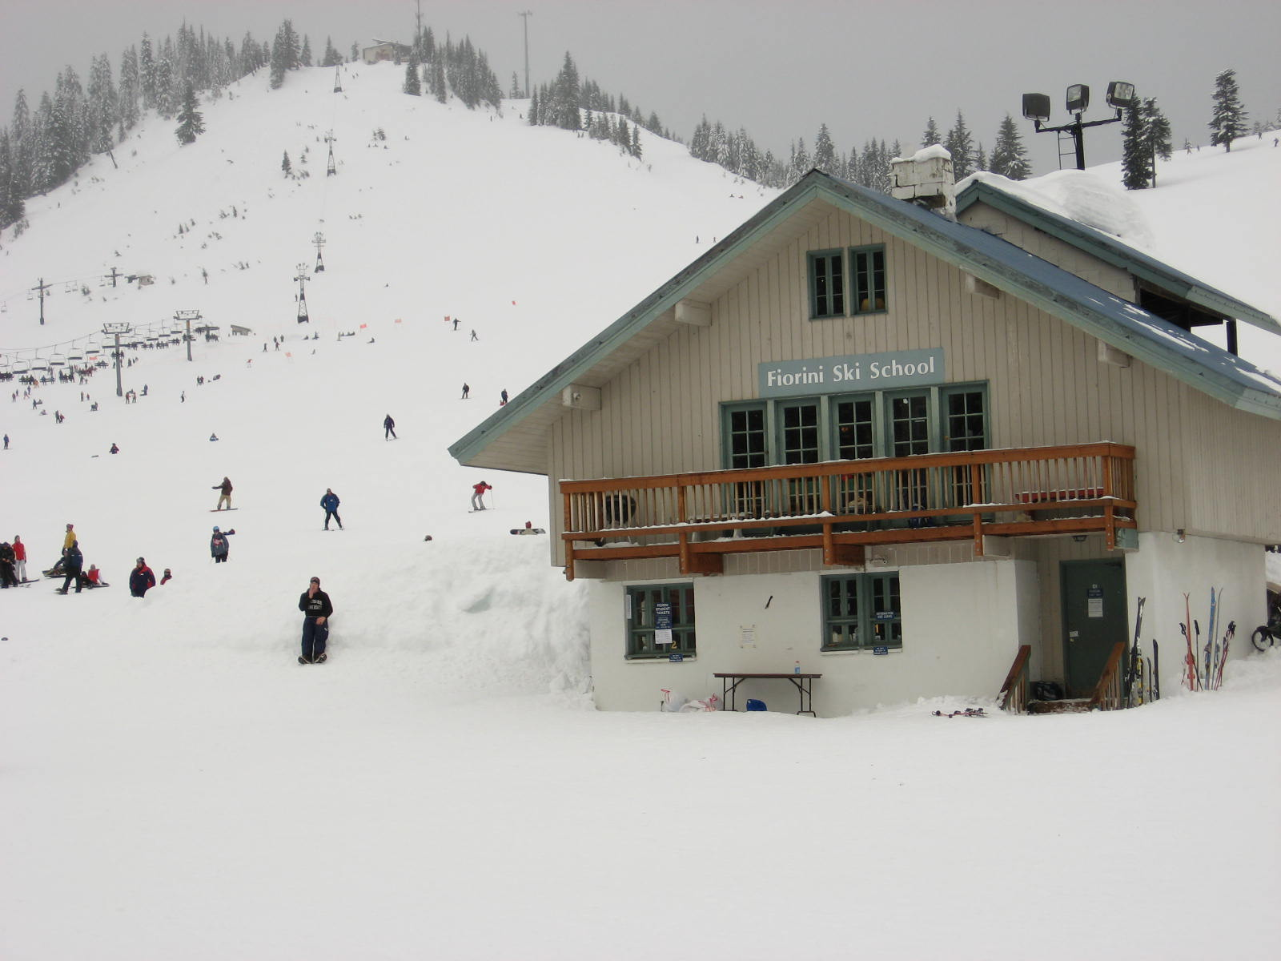  Snoqualmie Pass in winter

In the Cascades, in the winter it will be icy, snowy, wet, and very cold. You can go skiing, snowboarding or just play in the snow. When it is summer, the Cascades can be cool and wet and sometimes very slippery. Douglas-fir trees grow in the Cascades. There are also nice days when you can go hiking and fishing.

Mount Rainer has waterfalls and major glaciers that are very exciting to watch. National park INN is one year round nestled in the forest of Longmire Historic District. You can see picture of the Historical Inn at this site: http://rainier.guestservices.com/

During the summer you can go hiking around in the Cascades or even go camping overnight. You can find more information about Mt Rainier National Park at this site: http://www.mount.rainier.national-park.com/info.htm
In the South of Washington State is Mt St Helens: the volcano blew up its top on May 18th 1980. A lot of ash fell over the city of Seattle and a lot of people still keep some of it at home in a container. This volcano can still show some activity and it is still changing. You can see pictures of Mt St Helens eruptive history at http://volcano.und.edu/vwdocs/msh/

Further north are Mount Baker and the North Cascades. The North Cascades is a National Park. You can go camping, hiking, climbing, boating, fishing, horseback riding or just look at the beautiful scenery as you drive by.
http://www.nps.gov/noca/

Columbia Plateau
By
Joe
Yafet
Hannah
Rylee

Grand Coulee Dam is the eight wonder of the world. It also griddles the Columbia River with 12 million cubic yards of concrete stacked one mile wide and 46 stories tall. Grand Coulee is part of the massive Columbia basin!
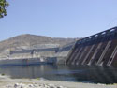 | Grand Coulee dam forms Lake Roosevelt extending upstream 151 miles to the Canadian border.
It has a 600 mile shoreline and a surface area of 82,000 acres.

One great place to stay while you are in the plateau is Best Western; that hotel has 161 rooms and it is has one seasonal heated swimming pool. If you get hungry just stop by Dominos pizza, it is a great place to eat pizza. If you’re looking for some where to take your family Moses lake Water Park is the place to go. People make a living by growing and selling corn, carrots, potatoes and mining.

The Plateau is also the home of the Colville and Spokane Indians
For more information on Native Americans you can go to the link
http://www.kstrom.net/isk/maps/wa/wamap.html

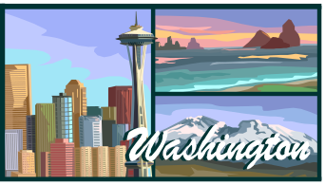
Puget Sound I-5 Corridor
By
Jackie
Laura
Josh
Colin

Puget Sound transportation is by ferry boat, car, or bus. Puget Sound is mostly covered by water. Puget Sound is busy with boats all over filled with cargo going place to place. Did you know that Puget Sound is 100 miles long and has a depth of 180-925 feet? Puget Sound is surrounded by the downtown area of Seattle. Seattle has a picture perfect view of Puget Sound.
This is a view of Seattle from the ferry.
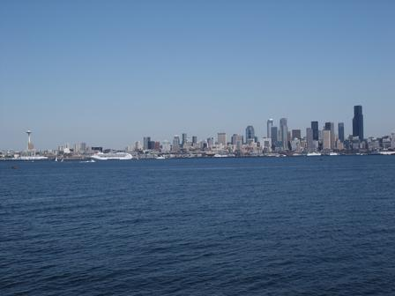

Puget Sound is a beautiful place! There are lots of fun activities around the Puget Sound area, from rock climbing to scuba diving or even sailing. There are lots of theaters and nice places to eat. If you go to Puget Sound you would like it very much!

Seattle has a marine climate which means that in the winter it’s pretty warm! Some people make a living by working at Boeing, Microsoft etc. Lots of flowers grow around I-5 corridor, like tulips, daisies, roses and lots more! The Seattle aquarium has animals that can be found in Puget Sound such as cucumber, jelly fish, crabs, fish, and starfish, also some other things like squid and octopuses.

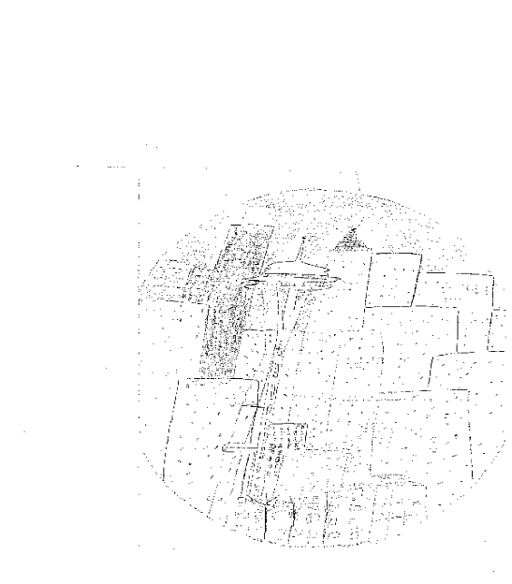 | 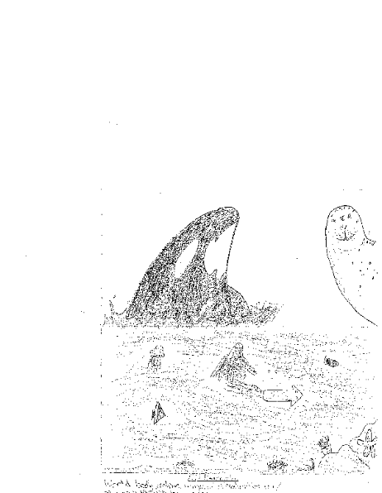

Some places to visit include: the Space Needle, the Aquarium, the State Capitol in Olympia,
The Washington History Museum in Tacoma and the Boeing Museum.

Lynnwood is located north of Seattle. Our school is in the Edmonds School district.

You can also take a ferry from Edmonds to Bainbridge Island.

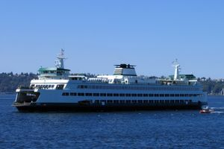

SE Washington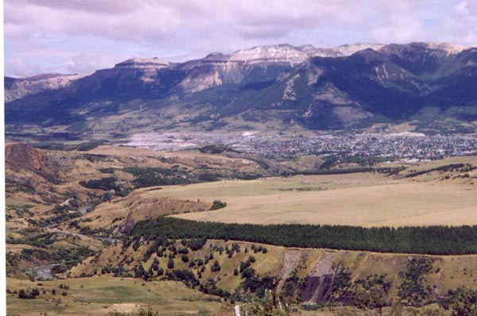
By James,
Daniel,
Jocelyn,
and Jemayka
Major Cities
Walla Walla, Kennewick, Clarkston Pasco, Richland, Pullman, Pameroy.
Pullman is the home of Washington State University
Bodies of Water
Snake River, Columbia River, and Grande Ronde River.
The Columbia river is a natural border between Oregon and Washington. The Snake river is the main tributary of the Columbia river. You can see a picture at http://en.wikipedia.org/wiki/Columbia_River

Businesses in Walla Walla
The Walla Walla Valley chamber of commerce has been active since 1875. They have over 730 members and they are growing. Walla Walla Valley is home to many small businesses that totally make a huge impact on the local economy. The upstarts in Walla Walla are promising due to the recent interest in the valley driven by the wine industry.
Lakes
Lake Kahlotus, Lake Wallula, Lake Rock, Lake Herberet.

One common animal is the crow.  Size: 18in. (45cm)  Nest: platform.  Eggs: 4-6in the color is bluish to olive green, brown markings.  Food: fruit, insects, mammals, fish, carrions, seeds, and suet feeders | 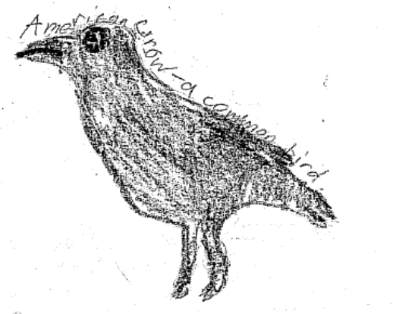
.
Climate
Desert conditions moist alpine conditions.

Travel Guide
to
Quakertown,
New Jersey,
USA

Here is the travel guide of Hunterdon County, New Jersey. There are some celebrations here in Hunterdon. We celebrate Christmas, Hanukah, New Years, Halloween, Thanksgiving, Easter, Labor Day, Cinco De Mayo, Lent, and so much more. If you want to celebrate some of these holidays that you never experienced or heard of, then come down to Hunterdon County, New Jersey.
There are sports here that people use for activities. They are basketball, baseball, softball, and more. People enjoy playing these kinds of sports because it’s not work, you get to be with your friends, and it’s like an exercise for you. There is also fishing here too. It’s so much fun to fish too because it makes you very active and it’s a good way to not do drugs. These are the recreational activities in our area.
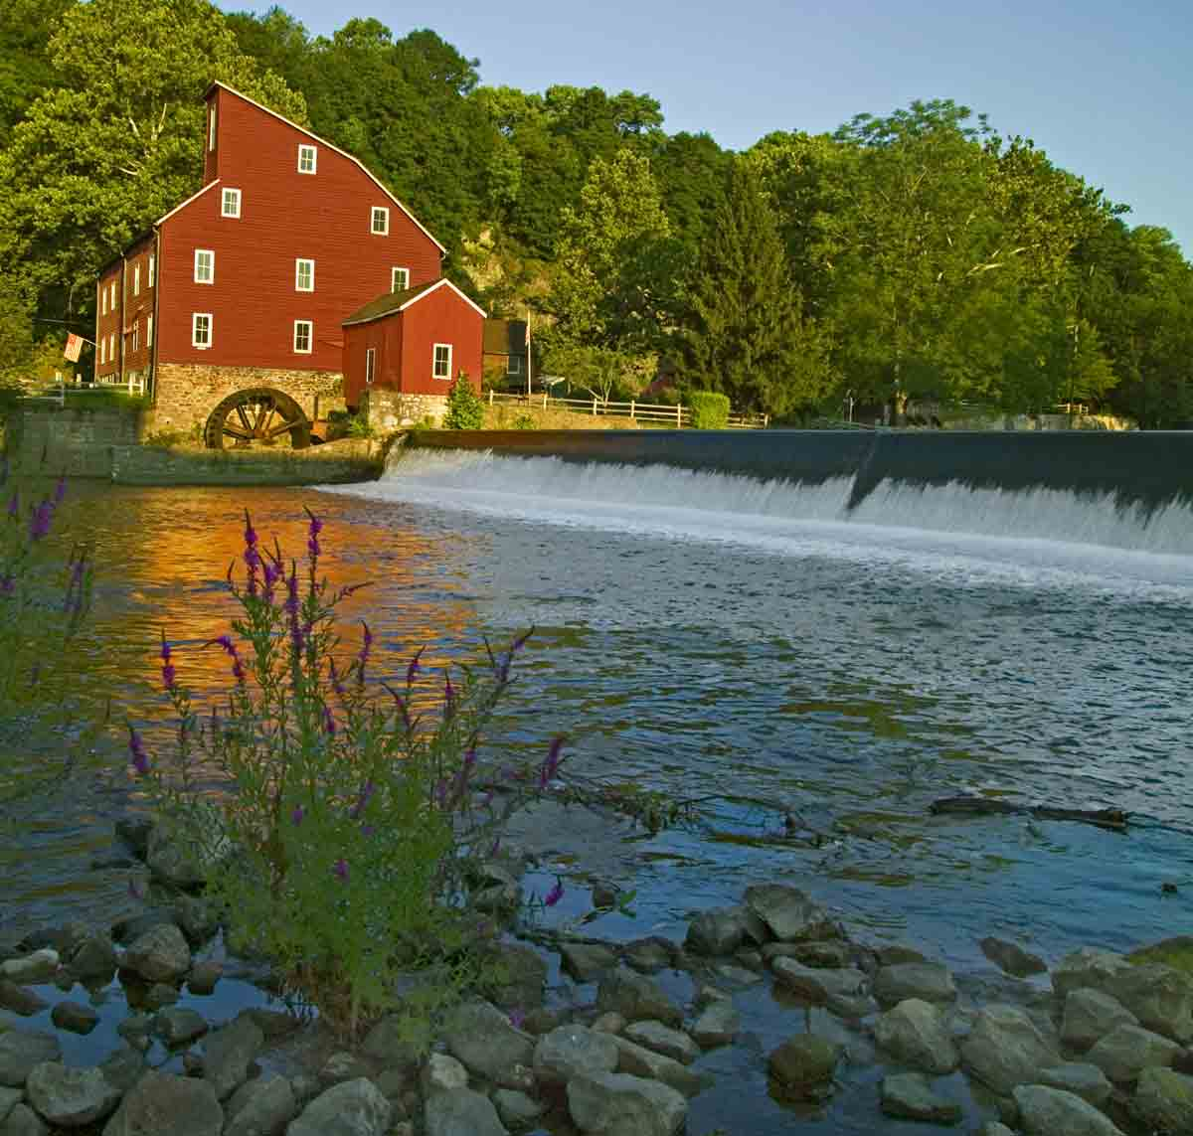
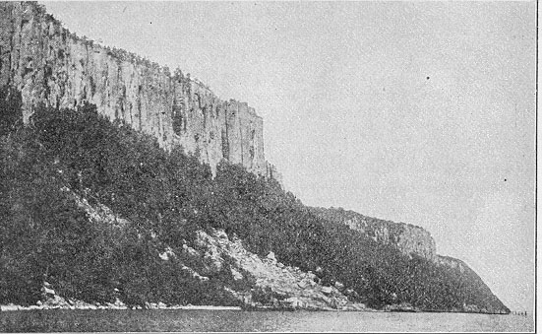
The museums and historical sites in our area are some of the cemeteries here. Some of them go way back. There is also a museum here too. The museum is called The Museum of Art. It’s fun to look at all the art and to see other people you know. Another historic site is The Haunted Mill. Here is the description of the mill: Historic Red Mill Museum Village comes alive with the eerie sights and sounds of Halloween. Haunted hayride also included. The biggest, safest and best-haunted event in the area.
There are unusual geographical features in our area and they are The Watchung Mountains. The Watchung Mountains are a group of three long low ridges of volcanic origin, between 400 ft. (122 m) and 500 ft. (152 m) high. The ridges, known as Orange or First Watchung Mountain. The discontinuous ridge was formed by Long Hill, Riker Hill, Hook Mountain, and Packanack Mountain. Packanack Mountain is sometimes referred to as the Third Watchung Mountain.
The highest point in the Watchung Mountains is High Mountain in Wayne, which is over 1,000 ft. Other mountains are Garrett Mountain in Paterson, Hilltop in Verona, Cedar Grove, and North Caldwell.

There is our Travel Guide and I hope you visit any of these places. Bye.

By: Alicea Foran & Matthew Prior
Grade 5
Mr. Kramer
Quakertown, NJ, USA

Travel Guide
Local Area
Clinton, New Jersey


If you visit our town in New Jersey a good museum to visit nearby would be the art museum in Clinton. It has many elaborate, amusing, and fascinating pieces of artwork created by all ages. They’re made of silk, wool, pastels, paint, glass, pottery, wood, and even beads. Every couple weeks a new exhibit comes to replace the last so there is always something new to see.
An unusual landform and very scenic area nearby is the Red Mill Falls in Clinton, New Jersey. It is very beautiful and often photographed for tourist advertisements and calendars.
Nearby recreational activities include baseball, basketball, fencing, lacrosse, soccer, gymnastics, running, ping-pong, beer pong, bb shooting, paintball, and hockey. Baseball, basketball, lacrosse, hockey, and soccer are the most commonly played, but the others you can sign up for, or go to a camp for.
There are many cultures and ethnic groups in New Jersey that celebrate holidays. These celebrations include festivals based on traditions and religious beliefs. An unusual landform is the Red Mill Falls it is most beautiful and gracious (as seen below).

David Otis
Grade 5
Franklin Township School
Quakertown, New Jersey, USA
April 17, 2007


Batsto, New Jersey

Today we will be traveling through Batsto, NJ. We will
stop in the center of the town to let you explore this area. Hope you enjoy the trip!!

Batsto! A Special Place: This is a very special place because it was built in 1766. It had many mills in which glass was made. It is currently a ghost town that attracts many tourists.

Batsto! Location: Buried in pine trees Batsto, is located in the Pine Barrens of central NJ. It is right of the New Jersey State Parkway.

Batsto! Travel Length: The estimated distance from our school to Batsto is 83.91 mi and is about 1hr 57 min driving time from our school.

Batsto! Visit Time: The best time to visit Batsto is in the summer when they have festivals such as the 2nd Annual Batsto Quilt Festival, which will be held on Sunday, May 20, 2007. Also the trees keep you cool by providing tons of shade on hot days.

Batsto! Recreation: There are many things to do around here at Batsto. One of the most popular is to take tours around the village. You can also attend many exciting festivals such as the Annual Batsto Quilt Festival (mentioned earlier).

Batsto! Time to Spare: Batsto makes a great day trip for family, friends, or even by you self. One important reason it is only a good day trip is the fact there are no hotels! So unless you like camping in a dense forest filled with lions and tigers and bears oh my! (Well, maybe not lions and tigers but you might run into a bear) you should only come for a day.

Thanks for traveling with us!
Your guides Zach Lagarenne and Hailey Kirsch

Zach Lagarenne and Hailey Kirsch
Grade 5
Mr. Kramer’s class
Franklin Township School
Quakertown, NJ, USA

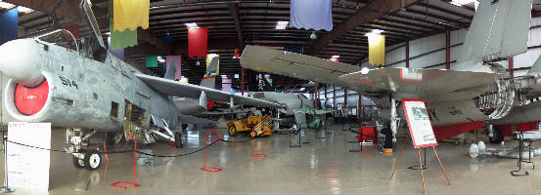
The Air Victory Museum is a great place to go to learn about airplanes, helicopters, and engines to aircrafts. The museum is located in Medford, New Jersey. This museum has a few aircraft that no other museum has, such as the E-2B Hawkeye that is outside. Some of the uniforms they have on displayed such as the Gordan Highlanders, Seabees, US Air Force, Army Air Corp., Marines, Female Marines, U.S. Army, World War II Fighter Pilot leather jacket, USCG “Donald Duck” hat, World War I helmet, and World War II Defense Air Raid Warden Helmet, Baton, and phone.
This museum is a wonderful tribute to the men and women that have fought in the Military. There are great exhibits and people that really know what they are talking about. The museum also has a well -stocked library and gift shop. We have never been to this museum but we are planning on going now. We are not really into planes and aircrafts, but now we are interested into this museum. Hopefully one day you would like to visit Medford, New Jersey to see the aircrafts in the Air Victory Museum.

Bianca & April
Franklin Township School
Quakertown, New Jersey, USA


The Old Barracks in Trenton was originally built in 1758, to protect troops during the French and Indian War. It is best remembered for its role in the 1776 and 1777 battles of Trenton during the Revolutionary War. The Old Barracks were first opened as a museum in 1902 by a group of patriotic women who purchased the building and enlisted the help of numerous patriotic societies to acquire and restore the barracks.
In 1914, the founding women of the Old Barracks deeded the property of the state of New Jersey under the conditions of the Old Barracks Association manage the museum with an annual State Appropriation.

The mission of the Old Barracks Association is to preserve the Old Barracks for future generations, to conserve the historical collections it houses, and to design and educate the public about early American culture, the history of the Colonial and Revolutionary New Jersey and the history of the Old Barracks.
The Old Barracks is around 30 to 40 miles from our school. That means that it is about an hour and a half away. What is special about the Old Barracks is that when you go there the people are dressed in uniform and clothing from the Revolutionary War. The historic interpreters also treat you like you are living in 1776. This site is located in Trenton New Jersey. The best time to visit is in the summer because you have to stand outside for a while. In the winter you can get very cold. At the barracks you can see replicas of the rooms that soldiers slept in, and you can go to the gift shop. It takes about 4 hours to fully visit and experience the museum.

Michael and Blaise
Grade 5
Franklin Township School
Quakertown, New Jersey, USA

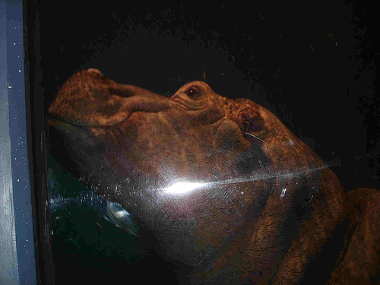

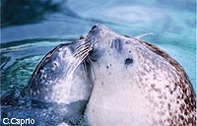
One of the best places to go in New Jersey is the Camden Adventure Aquarium. This aquarium features many exhibits. Such as sharks, seals, penguins, jelly fish, stingrays, an assortment of fish, crabs, dolphins, hippos, and other aquatic animals. It is a great place to go if you have nothing to do.

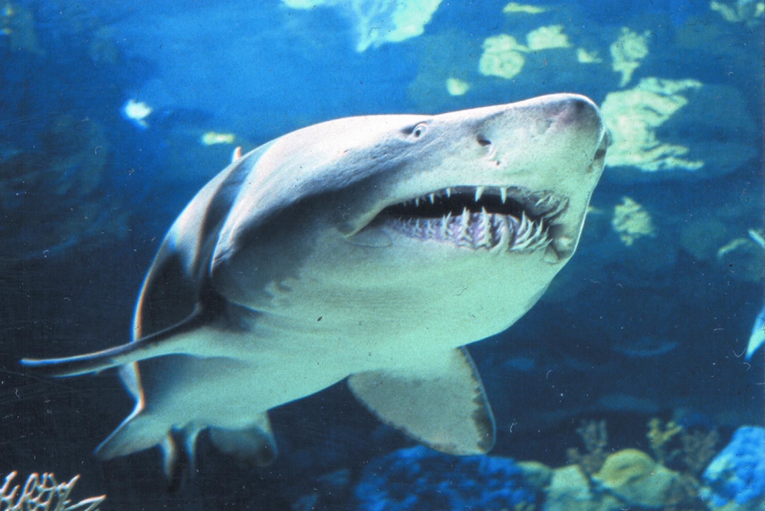
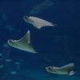
It is a nice place to go with your family. It is fun and interesting. You could learn a lot. The Adventure Aquarium put on shows every hour to an hour and a half. They are very fun to watch. We really like this place. I hope you can go here someday. You will remember it a long time.

Cheyenne

Grade 5

Franklin Township School

Quakertown, New Jersey, USA


