By Lawton Elementary
Students



Gasworks Park
Special thanks to all the students who have helped compile the information and create this beautiful brochure! We couldn’t have done it without you!

This 20 acre point on Lake Union was cleared in 1906 to construct a plant to manufacture gas from coal – later converted to crude oil. Import of natural gas in the 1950’s made the plant obsolete. The city acquired the site for a park in 1962. The park was opened to the public in 1975. The boiler house has been converted to a Picnic Shelter with tables, fire grills and an open area. The former exhauster-compressor building, now a children’s play barn, features a maze of brightly painted machinery.

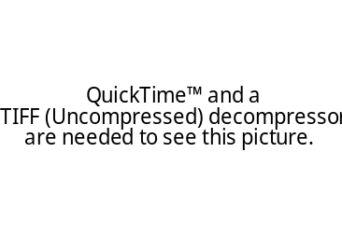

l
Seattle’s Unusual Geographical Features

The Space Needle

The 605-foot (184 meter) Space Needle was designed by Edward E. Carlson for the 1962 World’s Fair in Seattle. The futuristic structure has become a symbol for the city, and is home to festive events such as the annual New Year’s Eve fireworks display.
Carlson’s plan called for a soaring needle topped by a disk reminiscent of a flying saucer. Massive steel beams form the slender legs and upper body. The structure is designed to withstand a wind velocity of 200 miles per hour, but storms occasionally force the facility to close.
The Space Needle was completed in December 1961, and officially opened four months later on the first day of the World’s Fair, April 21, 1962.
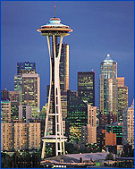

The Frozen Bus Stop People

The statue "Waiting for the Interurban" has been a landmark in the Fremont neighborhood for over 20 years. Designed by artist Rich Beyer, it commemorates the working class people who commuted to their jobs or did their shopping on the now defunct Interurban rail line.
Visitors from all over come to Fremont to see the statue and decorate its figures in celebration of birthdays, anniversaries, and other occasions. They were made out of cast aluminum as an act of love for the community.
Most people don’t notice that the dog peering out from among the people’s legs has a man’s face. There was an honorary mayor of Fremont who opposed the statue. He didn’t like the idea. Stung by the attack, Beyer had the last laugh: He put his face on the mutt’s body.

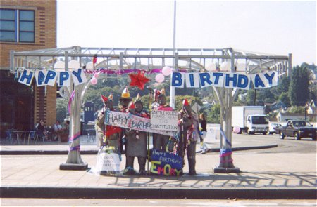

The Troll

The Fremont Troll has been lurking under the north end of the Aurora Bridge since 1990. He was sculpted by four Seattle area artists – Steve Badanes, Will Martin, Donna Walter and Ross Whitehead – for the Fremont Arts Council. The head-and-shoulders sculpture is 18-ft. tall.

The shaggy haired troll glares southward with his shiny metal eye, a hubcap. In his left hand, he crushes an old style Volkswagen beetle, which originally contained a time capsule of Elvis memorabilia. There are plenty of places to pose, and interaction with the troll is encouraged.

