''''HAWAII''''

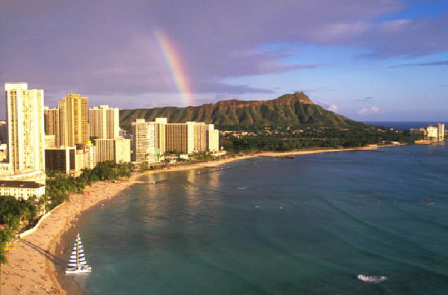
Here is located ‘’Hawaii’’
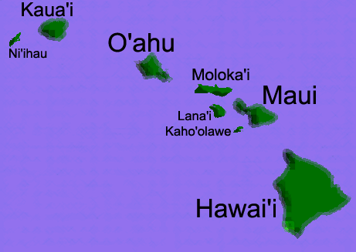
HAWAII HAS DIFFERENTS PLACES FOR EXAMPLE…!
KAUAI, Oahu, MOLOKAI, LANAI, MAUI, AND HAWAII BIG ISLAND.

That city is Kauai.

Kauai is a mix of the timeless and the 21st century has many activities for example: fishing, biking, dinner cruises, golf, surfing, whale watching and other things.

This is Oahu.
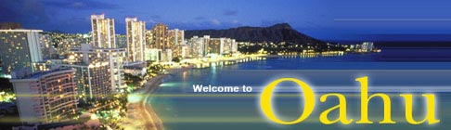
Oahu is a beautiful city Oahu is an island of endless contrasts. Geographically only the third largest of the inhabited Hawaiian Islands, it is nonetheless home to nearly three-quarters of the state's 1.2 million residents. Oahu is believed to be the product of a single "hot spot" in the earth's mantle.

Molokai

Molokai has long been a land of special power. Like all such sanctuaries in Polynesia, Molokai was not protected by physical force, but by mana that is, spiritual power.

Lanai
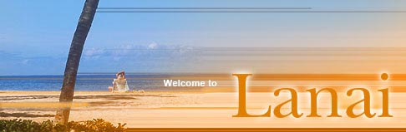
Lanai is home to a mere 5,000 residents — the vast majority of whom live in the cool heights of Lanai City overlooking the vast, red-dirt fields below.

Maui

The demi-god Maui is a household name from Tonga to the Society Islands, to the Marquesas to Hawaii. Something of a trickster, Maui had a place in his heart for mortals and is celebrated throughout the Pacific for such feats as giving fire to humans. Maui is the only deity in Polynesia to currently have a major island named after him. South Maui is home to the island's other main resort district, Wailea; and while the tropical north shore of Maui does not offer hotels, visitors can choose from a collection of bed & breakfasts and rental homes.

BIG ISLAND''HAWAII''

Legend has it that two deities — the volcano goddess Pele and the demi-god Kamapua'a The story's short version is that, after a battle, the pair divided the island in two, with Pele taking the western half and Kamapua'a, the eastern. The Big Island of Hawaii is one of the most fascinating places on earth, and truly worth your time, especially if you like nature and volcanoes. At 95 miles long and 80 miles wide, the Big Island is larger than the other three major Hawaiian Islands combined. In addition, there is plenty for you to see and do.

All about big island, Hawaii is very beautiful and interesting if you want to have a great vacations coming to Hawaii.

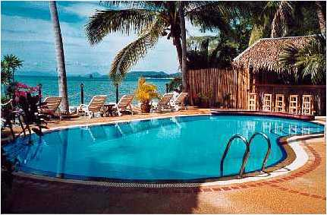
All the places are cute.

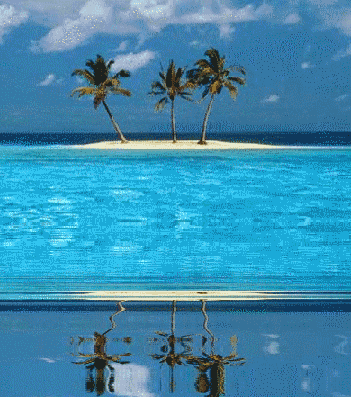

HAWAII FOOD

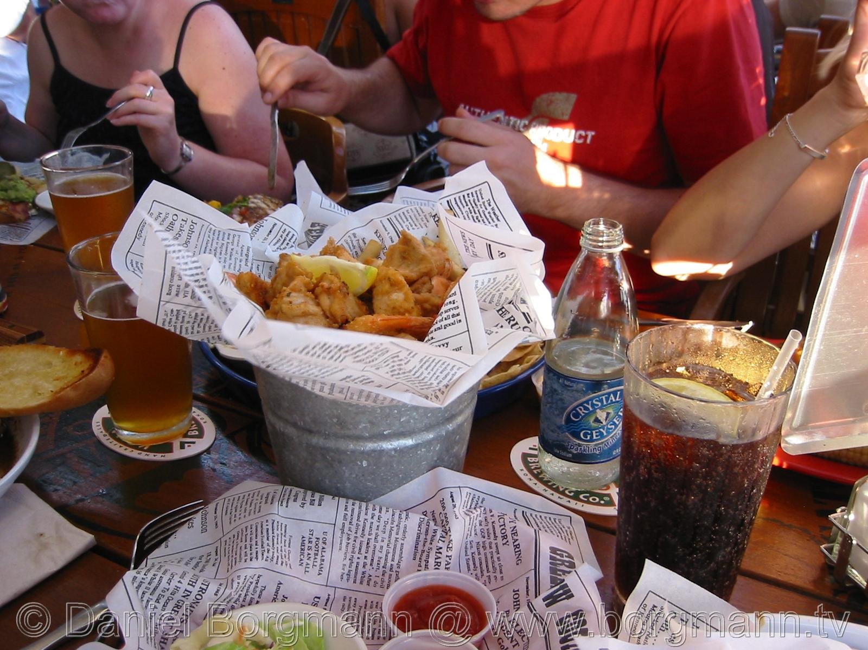

EVERY
FOOD IS
DELICIOUS.
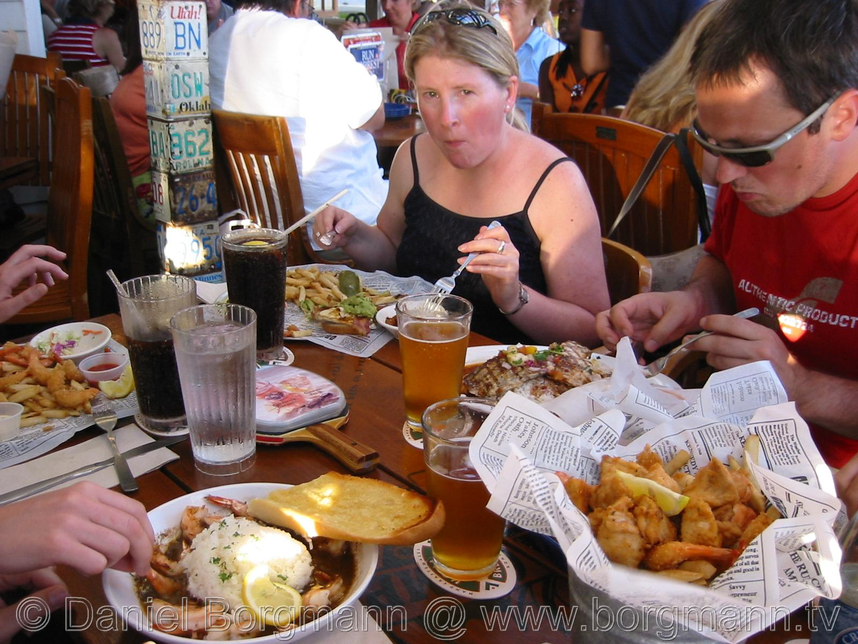

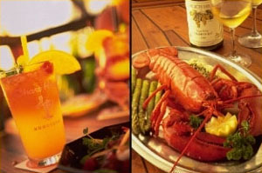
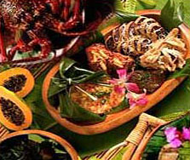

That is some food is Hawaii.
I would recommend four excellent luaus. One is The Ali'i Luau at the Polynesian Cultural Center. This package includes canoe ride, fresh flower lei, and a night show of over 100 performers, delicious Hawaiian food, and more.

HAWAII DESSERT

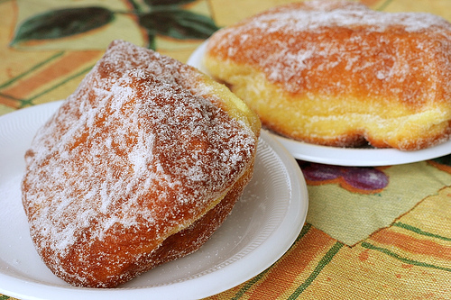

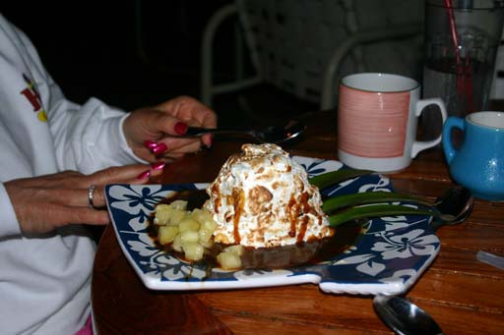
THIS IS DESSERT IN HAWAII
HAWAII PEOPLE


