A HARVEST FESTIVAL OF INDIA

According to the lunar calendar, the sun moves from the Tropic of Cancer to the Tropic of Capricorn, or from Dakshinayana to Uttarayana, in the month of Poush in mid-January.
This end of the winter solstice also coincides with the harvest season and cessation of the northeast monsoon in South India. The movement of the earth from one zodiac sign into another is called Sankranti, and is celebrated as Makar, or Uttarayana, Sankranti, or Lohri, in the North, and as Pongal in the South
In the South Sankranti becomes Pongal. It is a celebration of the harvest which is observed for three days in Tamil Nadu as well as in Andhra Pradesh. The first day is the Bhogi Pongal which is celebrated as a family festival.



- Decorated colourful entrance of the house .

Surya Pongal, the second day, is dedicated to the Sun (surya) when pongal (rice cooked in milk and jaggery) is boiled by women and offered to the sun. .
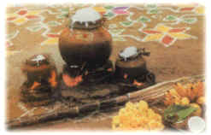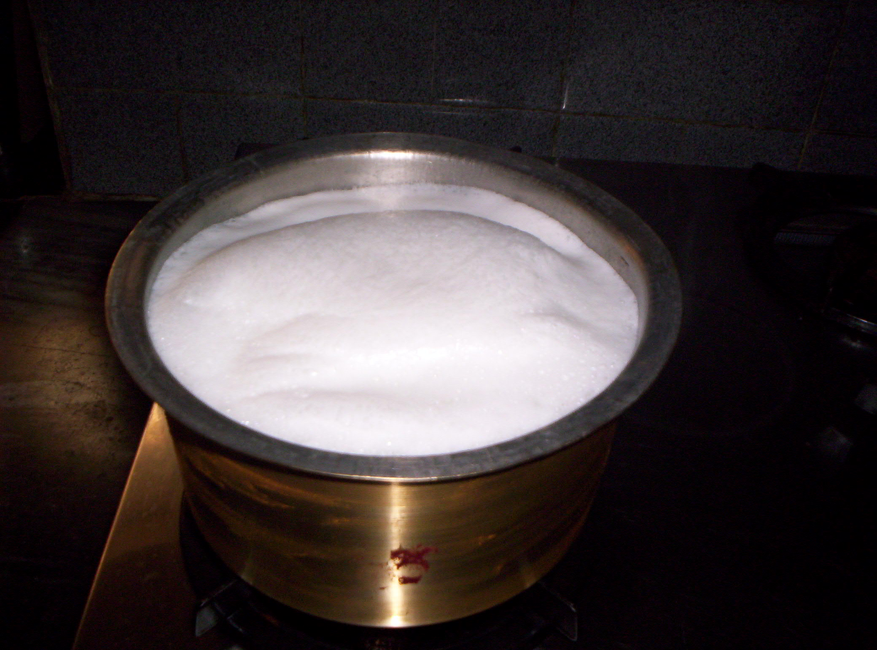
2. Traditional method of cooking Pongal Modern method of cooking Pongal
in clay pot. In brass vessel on LPG Stove
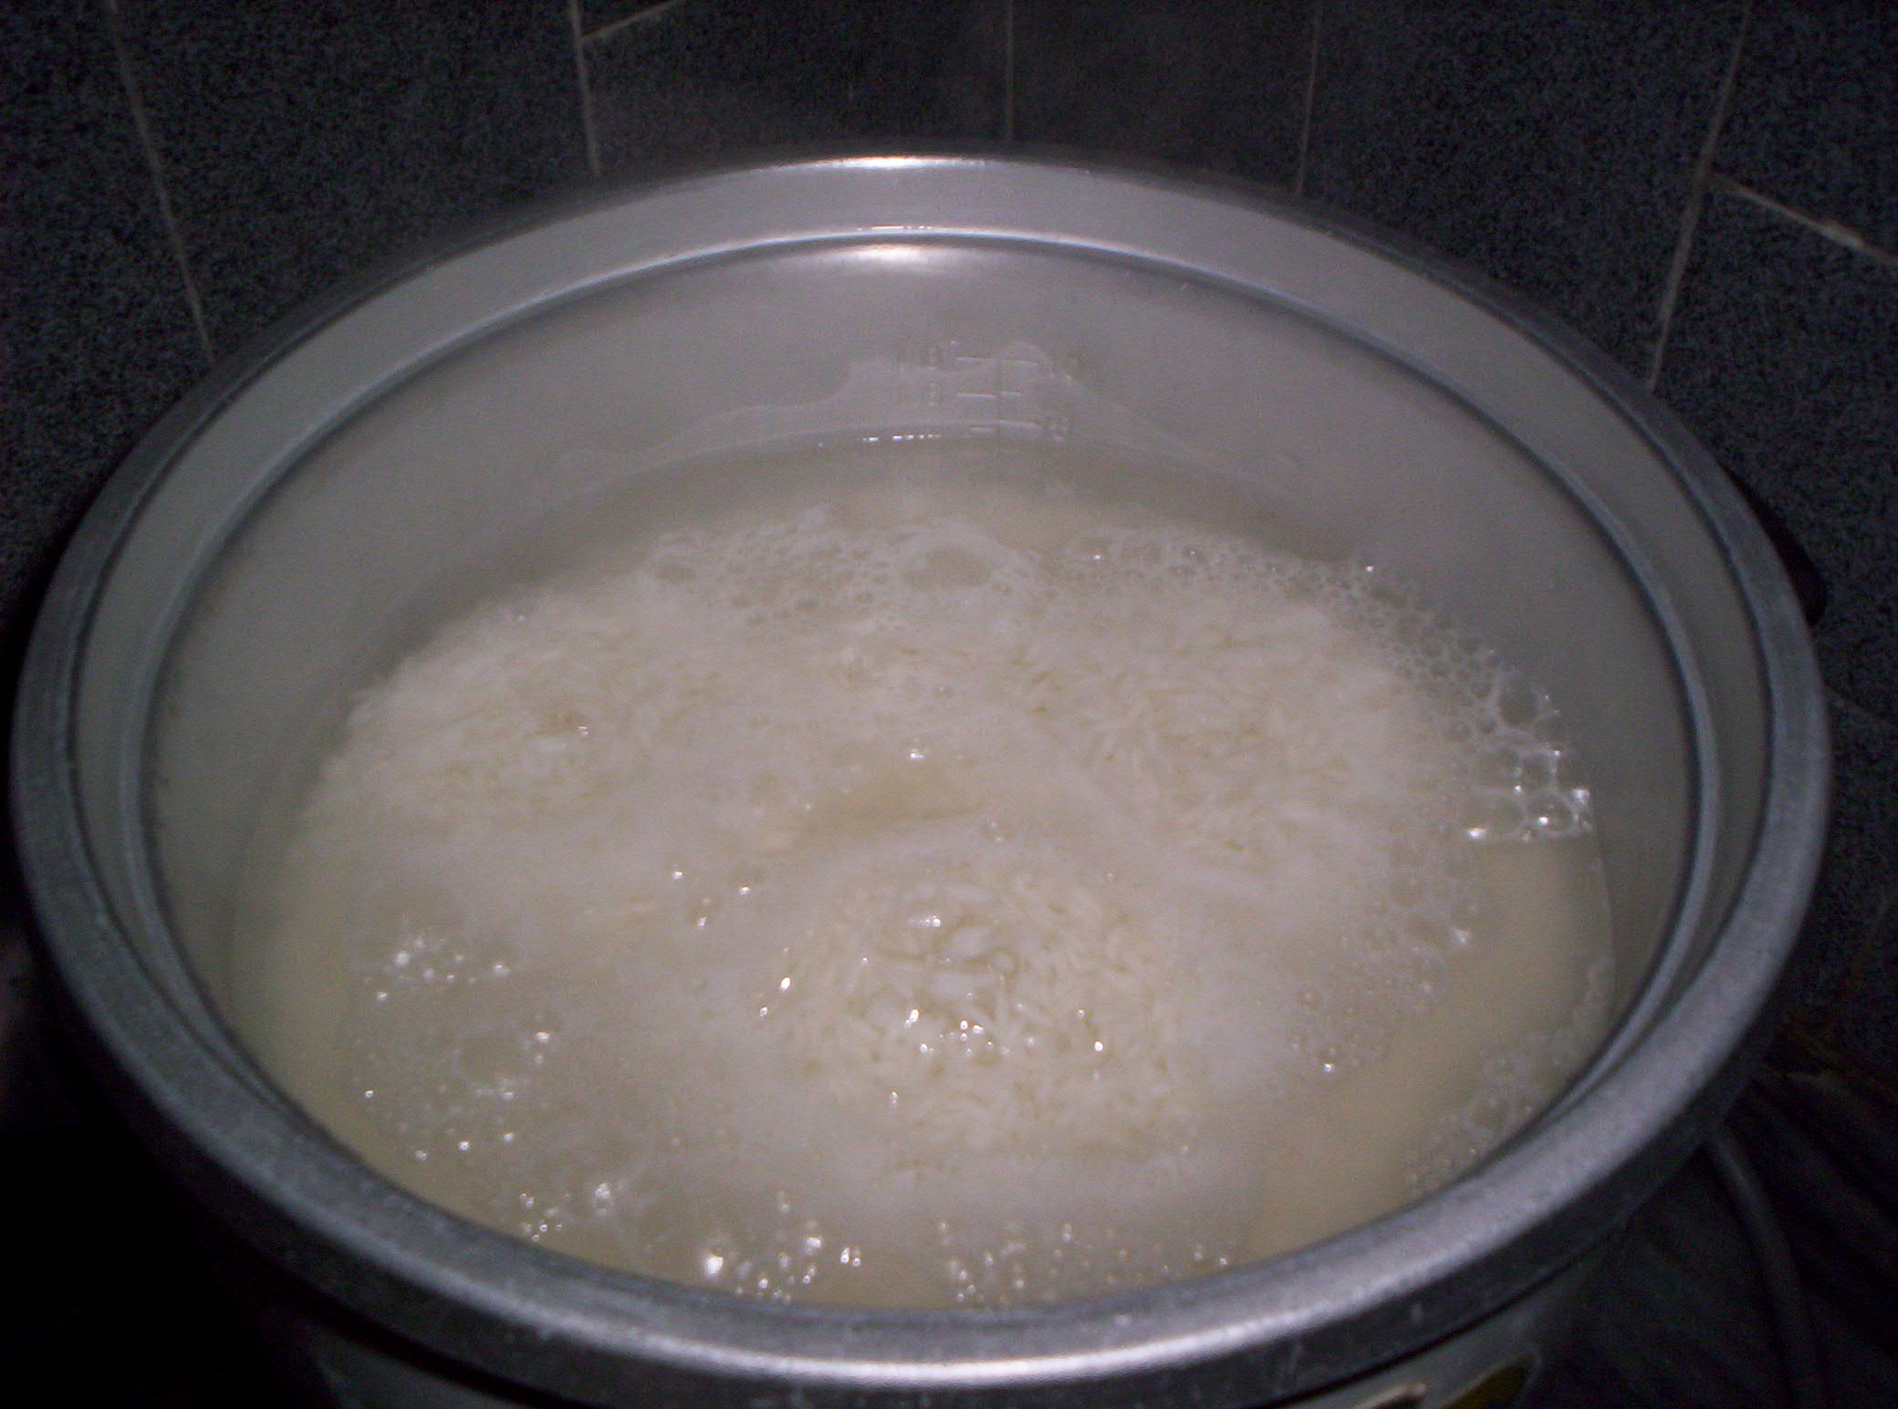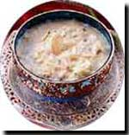

Pongal ready as an offering to Sun God

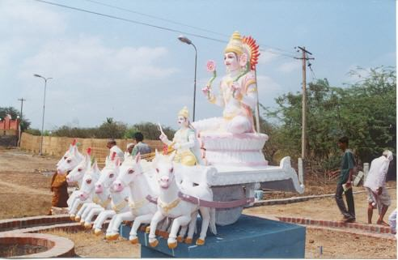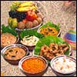
Sun God Depicted riding His Chariot with
Seven White Horses Offerings to Sun God
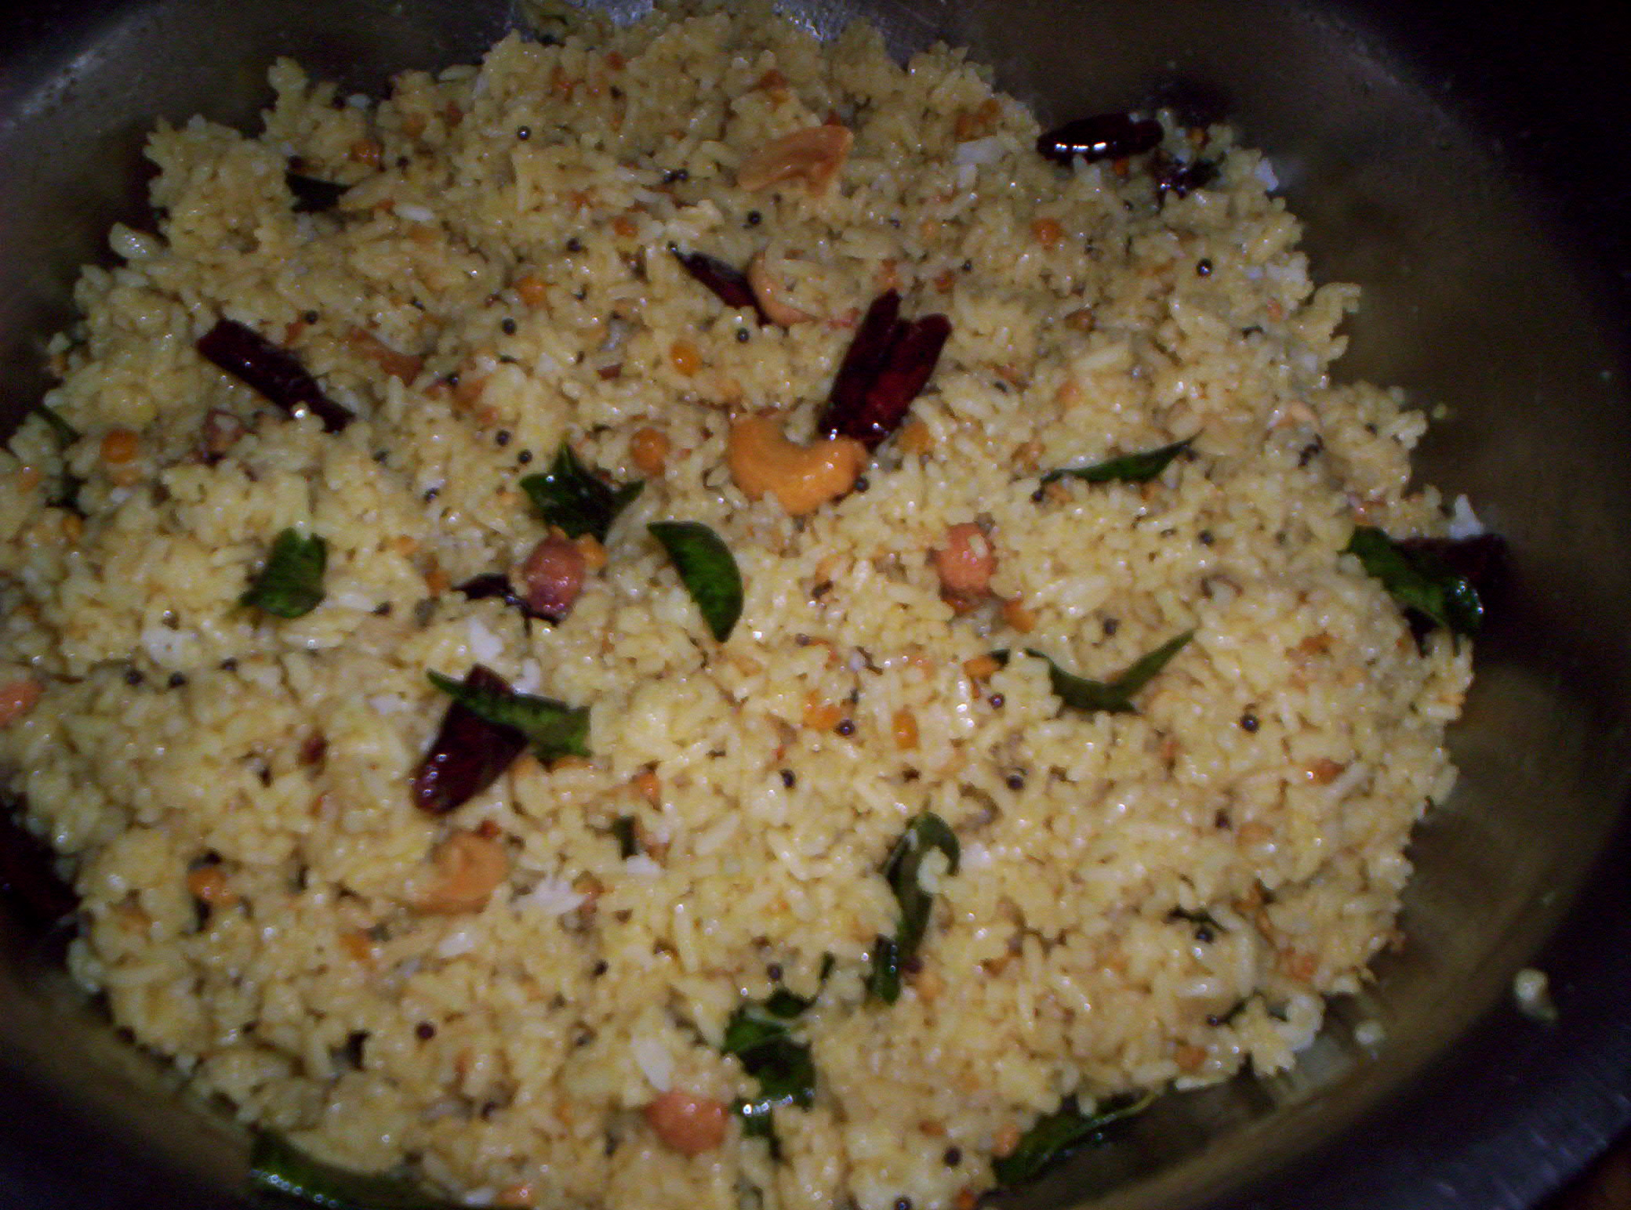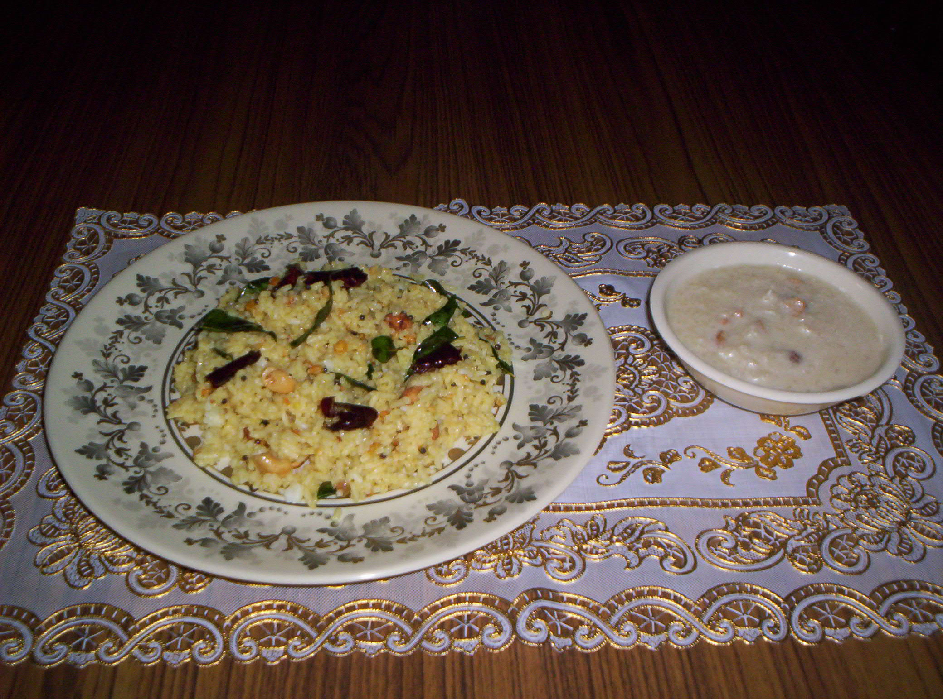
TAMARIND RICE SPECIAL DISH DELICIOUS !!!!!!!!!!!!!!!!!!!!!!!!!!!!!!!!!!!!
OF ANDHRA PRADESH,INDIA

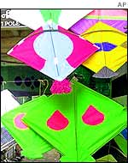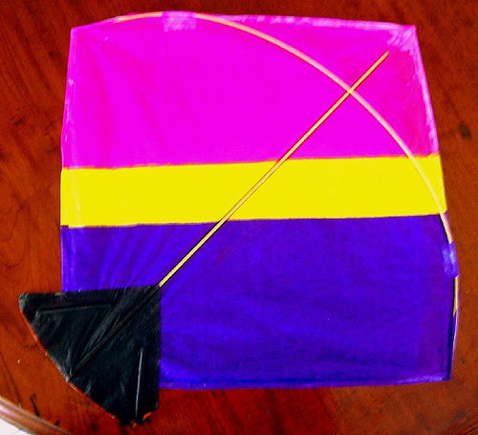

People fly kites of different shapes and sizes.
Kite flying has no barriers of caste, creed, religion and region.

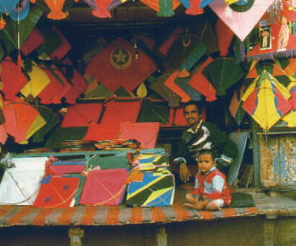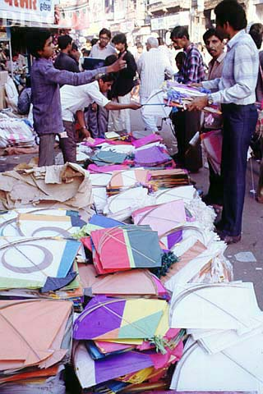

Different varieties of kites

HOPE YOU ENJOYED THIS FESTIVITY !!!!!!!!!!!!!!!!!!!!!!!!!!!!!!!!!!!!!!!!

REGARDS,
Learning Circles partners
Students of class IX
IEARN-INDIA

