Should Children Have the Right To Vote?

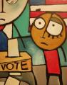
We think that children shouldn’t vote because they can’t think like
adults, and the parents of the child may tell him or her to vote for the
person they want to. Kids may push random buttons in a booth or if they are writing it down they may just write the first candidate they see. That would just spam the voting and the majority of votes will be messed up.
Chase and Trevor
Grade 4
Franklin Township School
Quakertown, New Jersey, U.S.A.

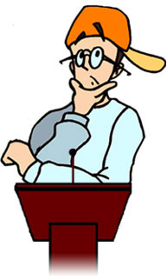
I Think Kids Shouldn’t Vote
I think it’s fair that kids can’t vote. If they could vote it would be terrible because mean parents could force them to vote for someone they didn’t want to vote for. Also a bully could say that if they didn’t vote for a specific person he would kick butt. Plus if kids did vote parents will have to drive them. Also kids don’t watch many speeches or shows about the Presidents (they like cartoons a lot more).
Hugh and Hailey
Grade 4
Franklin Township School
Quakertown, New Jersey, USA

I think that kids should have the right to vote because they go to school. The reason I said that is because we learn about the people who are running to be Presidents, so that we know about the advantages of one candidate and disadvantages of the other. That’s why I think that kids should be able to vote.
Emily and Alicea
Grade 4
Franklin Township School
Quakertown, New Jersey, USA

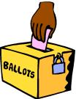
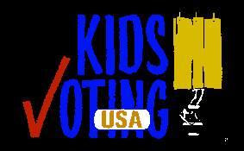
Children Should Have the Right to Vote
Children should have the right to vote because then they can also vote for the person they want to be President of the United States of America. The children should be allowed to vote for the next President of the United States because the new President might have some laws that they might like.
The President could make up a new kind of special law just for the kids. Here are some things he can do while he is the President: He can do a lot of things that we can’t do. He can do these things because he has lots more power then we have. The President can do a lot of cool, odd, and other things that we can’t do because we aren’t the President of the United States of America.
The kids should have the right to vote for a new President because then we could make a decision of what President we want to be the leader of the United States of America.
Megan
Grade 4
Franklin Township School
Quakertown, New Jersey, USA
_________________________________

We think children should vote because, they are young and can’t do stuff that parents can do. Also children need to have more fun doing more things in life. It’s not fare because, what if children want one person more then
the other.

Blaise and Matthew
Grade 4 Franklin Township School
Quakertown, New Jersey, USA

I think children should have the right to vote because they should have a say in who should be the President. If we voted for a kid President and an adult we wouldn’t have any problems. Kids would vote for kids and adults would vote for adults. Kid Presidents
would make up kid rules for kids and adults would make up rules for adults.
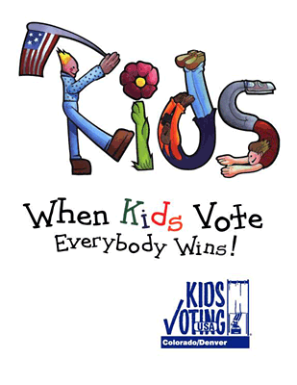
Kids are just important as adults are so I think they should vote. In
school they vote for class presidents and some schools they have a fake vote for the President of the USA. Kids should have the right to vote!
Brianna and April
Grade 4
Franklin Township School
Quakertown, New Jersey, USA
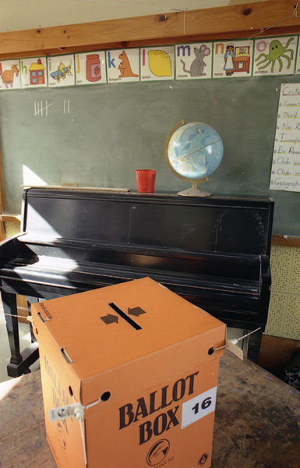

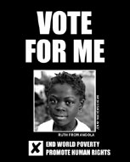
I think that children are capable of voting for who they want to be the President. I think that children can vote because children like to vote at my school. They say that its fun. I think that it is better than waiting in the line at Washington DC. I like to vote for really nice people because they promise to end world hunger and other things like supply stuff for the war. I think that my church would also let the children vote if they could. I hope that kids can vote soon.
Cheyenne and Michelle
Grade 4
Franklin Township School
Quakertown, New Jersey, USA

Children should not have the right to vote because our parents are able to represent our interest.

3 rd Grade B.
Coord. Daniela Dan
GIMNAZIUL DE STAT
“ZAHARIA BOIU”
SIGHISOARA 545400
ROMANIA

Martina says:
It is very good to have the right to vote. I think this because if someone is the leader of something and you don’t like what he or she is doing, then you have a chance to vote him or her out. For example, the President is spending lots of money that the government does not have on the war. All the children now will have to pay off the debt. The President does not care. So we have a chance to vote him out. The same thing with anything else, such as co-captain for a sports team, or who gets to go and do something.

If We Led
Our Country…

If you were the leader of your country, what laws would you change and why?



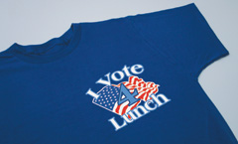
If we were the leaders of our country we would adjust the law a bit. The kids vote and parents don’t! Baseball and hockey would be all year round sports. Adults would have to go to school!!! We would make helmets that kids would put on that give them a proper education in 3.4 seconds. The President would be Zach and the Vice President would be Robert. The leaders of the Supreme Court would be Blaise and Chase. Kids would get
their license at age 10 and cars would be free! Kids could play Pro sports at 9. Junk food any time you want it and everything including the food would be free!! They would make a food called popcorn and candy mix with or without extra butter. About normal food you ask? Well you would get it
whenever you want and it’s free.
Zachary and Robert
Grade 4
Franklin Township School
Quakertown, New Jersey, USA

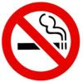
If I was the President I change the that smoking is legal to smoking fine $475,485,747,583,264,572, 657,245,629 smoking fine for people 18 years and younger and for people above 18 years only 1 cigarette a life time.
If I were the President, I would make a law that every thing should be
worth $0.01 during Leap Year (no taxes no bills), and every week kids get
a free ice cream. For more fun every one gets $50.00 each week.
Hugh and Hailey
Grade 4
Franklin Township School
Quakertown, New Jersey, USA

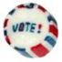
We would probably change everything like: no homework but more so any
school. We would also change all the prices so that they would be 1/4 of a cent. We have about 10 more things to change. Kids get their drivers license when they are 9 and adults get theirs when they are 25 and over. No more health stores, just candy and soda. If parents are naughty they
get a 10-minute time out.
Blaise and Matthew
Grade 4 Franklin Township School
Quakertown, New Jersey, USA

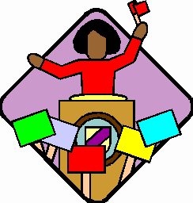
If I was the leader of my country I would change the law of kids can vote or not. Kids can’t run for President. I would also change the law that KIDS CAN’T DRIVE!!! I think kids should be able to vote, because we should have the right to do what grown- ups do. I think this, because if so other people get to vote, why can’t we? That’s why I think kids should able vote.
Andrew and Charles
Grade 4
Franklin Township School
Quakertown, New Jersey, USA If I was the leader and I could change the rules, I would let kids vote because they are important, too. The age of the kids would be from 6 and up to vote. I would also make a rule for driving, you would be able to drive when you are 10 but it has to be a good safe car that was approved by the President. You are aloud to drive motor vehicles on the road, but you have to be 6 and over as in a golf cart. I would also make a rule for driving boats and ether water objects, but you have to be 6 and older. We think it would be cool to be the leader, but it is ok of how they are doing it now.
Brianna and April
Grade 4
Franklin Township School
Quakertown, New Jersey, USA
___________________________

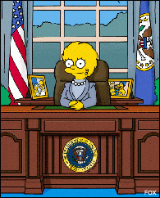
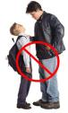
If I were the leader of the United States, I would change these laws. I would have there be no bullies in the United States because I don’t want
anyone’s feelings getting hurt, whether they are adults or kids. It would
make them feel bad. Children should go to school for a shorter amount of
time but learn more because I think that school is too long now, for nine hours. If anyone does something bad they would be put in jail for a lifetime with no food or water to eat or drink because I wouldn’t want any bad things to happen in my country. I would also change the laws to keep my country safe. I would not allow
any strange person into my country without my permission. I would let the military out to help people who are in need and to fight. Every time ten or soldiers die in a war, I would send more and more soldiers out. I would make the candy prices higher and the healthy food prices lower so
that people would want to buy healthier things than junk food. People need to stay healthy so they could live normal lives. I would change the laws to also make sure that everyone gets an education; whether they are home schooled or they go to a public or catholic school. All people should go to school for at least thirteen years. When kids go to school they should be taught not to fight with others or be bad in school.
Another law I would make is that nobody should smoke ever. It could seriously hurt you. When you start to smoke you become addicted to it. That isn’t good. These are the things that I would change if I were the
leader.
Breanna
Grade 4
Franklin Township School
Quakertown, New Jersey, US

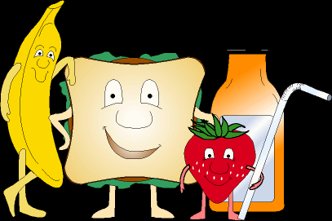
If I were the leader I would make there is only 3 days of school because kids don’t like school that much and we get piled with homework, tests, book reports, and other things. It’s also best for us to get extra exercise. I would make recess longer because we need a lot of exercise and better lunches like sandwiches, fruit, milk, and nutritional snacks. It’s better for us to be healthy so each grade like 1st grade through 4th grade have there on cafeteria and the higher grades to. It would be better for us to. That’s what I would change if I were leader.
Cheyenne and Michelle
Grade 4
Franklin Township School

If we are the leaders of our country we encourage and stimulate that young with the enterprising and innovative spirit.

3rd Grade B,
Coord. Daniela Dan
GIMNAZIUL DE STAT
ZAHARIA BOIU
SIGHISOARA 545400
ROMANIA

The following responses come from students at Lawton Elementary Seattle, WA:

Katie says:
I’d change the smoking law. I would make it illegal to smoke inside and outside. I would also ban the people in the legislative and judicial houses from smoking. Cigarettes and cigars can kill you! That’s how much effort I would put in to this law.

Victor says:
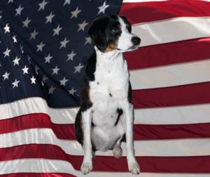
I would change the smoking law to no smoking inside or outside because smoking can kill you! I would change the voting law and allow kids to vote once they are 10, because 18 is a lot of years and 10 is not. I would change that people can have up to 10 cats. I would change that people can have up to 10 dogs. They play with you and they snuggle up to you when you are in bed.

Ruby says:
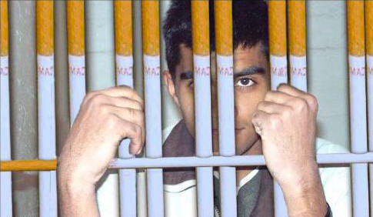I would make smoking illegal inside and outside. If you were caught smoking you would go to jail for 9 years. Also if someone was being cruel to an animal they would go to jail for more than 10 years. 1200 people are being killed everyday from smoking.

Anna says:
If I were the leader of my country I would change the law that you can smoke. I would also say that you could have animals in any house, even rentals. I would continue by saying you can only use bikes, not cars, because they cause pollution in water and other places.

Martina says:
I would make smoking illegal; not just inside but outside too. I would make smoking illegal because some thousand numbers of people die of smoking and 2nd hand smoke each year. So they are not just killing themselves, they are also killing the innocent lives of others. If you smoke you are a murderer and I don’t think you would want to be a murderer. For every cigarette you smoke, you lose one more day off of your life. If you smoke, you are committing suicide.

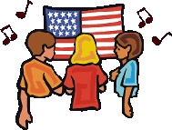

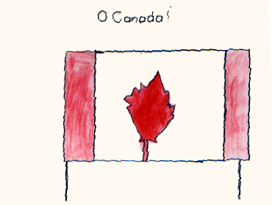

How do well we pledge allegiance?

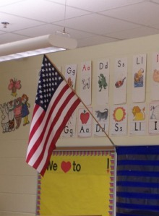
What we do to show the allegiance to our country is respect the country. Some camps have an opening at the beginning of the camp. They raise the
flag and we all sing. Also at the end of each day we raise and they take down the flag. That is only one example. You can do a lot of things to respect your country.
Emily and Alicea
Grade 4
Franklin Township School

Listen to our National Anthems

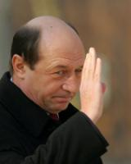
U.S.

Whitney Houston sings the “Star Spangled Banner”

Romania
In the morning we start the first lesson in school singing our national anthem.
http://www.romania.org/romania/anthem.html

3 rd Grade B,
Coord. Daniela Dan
GIMNAZIUL DE STAT ZAHARIA BOIU
SIGHISOARA 545400
ROMANIA

Canada

“Oh Canada”
(Vocal Version)

Trinidad and Tobago

(Instrumental Version)

Who are our Presidents and what do they look like?

Romania's President,
Traian Basescu

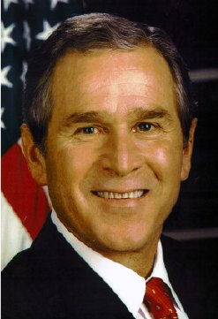

U.S. President,
George Bush

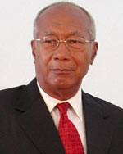

Trinidad and Tobago,
George Maxwell RICHARDS

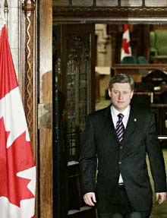
Canadian Prime Minister, Stephen Harper
Governments are Different All around the World!

We have a democratic government. The Romanian Government undertakes and promotes democracy, capitalism and values for the purpose of Romania’s durable economic development, increasing the citizens’ welfare and regaining national dignity.

Citizens have Different Ways of Voting!

In Romania citizens have the right to vote. – 3rd Grade, Romania

There are advantages and disadvantages to our systems?

One disadvantage is the fact that they have to vote list of member of the political teams, not the candidates’ names. - 3rd Grade, Romania

Should all citizens have the right to vote?

Yes, this is the fundamental right in a democratic state. -
3rd Grade, Romania

Ruby from Lawton Elementary School says:

One advantage is that women can vote. Also, colored people can vote too.

More news to come!

Stay tuned for Volume 2 when the SFDS News Crews explore the following questions:

Who makes the laws anyway?

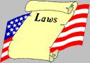
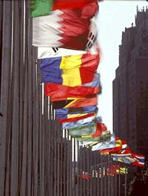

Why is there no United States of the World?

and…

What is citizenship all about? If I Black and born in China, would that make me Chinese?


